1. Perfect Symbiosis of Aesthetic Design and Dynamic Performance.
The New BMW 5 Series Sedan. 2

The New BMW 5 Series Sedan.
Contents.
2. Description in Brief. 5
3. Design:
Bespoke Elegance and Sporting Aesthetics. 11
4. Driving Experience:
Unrivalled Dynamics, Uncompromising Supremacy. 16
5. BMW EfficientDynamics in the New BMW 5 Series:
Good Reasons for More Driving Pleasure. 29
6. BMW ConnectedDrive in the New BMW 5 Series:
Greater Supremacy, Comfort and Safety
through Intelligent Networking. 36
7. Body and Safety:
Supreme Strength is the Benchmark,
Intelligent Lightweight Technology is the Principle. 50
8. History of the BMW 5 Series:
Five Times Around. 55
9. Production:
Supreme Quality through Efficiency and Precision. 62
10. Specifications. 67
11. Power and Torque Diagrams. 73
12. Exterior and Interior Dimensions. 80

The world debut of the new BMW 5 Series Sedan once again marks the epitome of aesthetic design and supreme driving pleasure in the upper midrange segment. Through its sporting and elegant looks, driving dynamics typical of the brand, outstanding efficiency as well as innovative comfort and safety features, the sixth generation of BMW’s executive express convincingly reflects the supreme standard of the world’s most successful manufacturer
of premium cars throughout the entire process of development.
1. Perfect Symbiosis of
Aesthetic Design and Dynamic Performance.
The New BMW 5 Series Sedan.
Design: charismatic, elegant, sporting.
With the longest wheelbase in the segment, a long and sleek engine compartment lid, short overhangs front and rear and a coupé-like, graceful roofline, the new BMW 5 Series Sedan stands out clearly from the competition.
Overall, the aesthetic looks of the car are clearly determined by perfectly balanced proportions. Design features typical of the brand are to be found both at the front with its BMW kidney grille inclined slightly forward and on
the strikingly chiselled engine compartment lid, in the stylish and elegant
side view of the car, and on the muscular rear end.
Within the interior modern function and a superior ambience come together
in perfect harmony, unmistakable style and clear orientation to the driver in the cockpit guaranteeing a truly unique driving and travelling experience.
Driving experience: supreme dynamics and outstanding comfort.
The most advanced drivetrain and suspension technologies ensure
supreme sportiness and an even higher standard of motoring comfort all in one. At the same time optional Dynamic Driving Control enables the driver
to set the suspension individually to his personal requirements. The new
BMW 5 Series Sedan is available with Adaptive Drive encompassing
Dynamic Damper Control and Dynamic Drive stability control, as well as
BMW’s Integral Active Steering.
The new BMW 5 Series Sedan is making its debut with one eight-cylinder and three six-cylinder petrol engines as well as two six-cylinder diesels.
The range is rounded off by a four-cylinder turbodiesel with an aluminium crankcase and common-rail direct injection. Maximum output in this case of 135 kW/184 hp makes the BMW 520d fitted as standard with Auto Start Stop the new efficiency benchmark in its segment. Average fuel consumption in the EU5 test cycle is just 5.0 litres/100 kilometres (equal to 56.5 mpg imp), the CO₂ emission rating is 132 g/km (provisional figures).
The top-of-the-range BMW 550i comes with an eight-cylinder boasting BMW TwinPower Turbo Technology and High Precision Injection for maximum output of 300 kW/407 hp.
The straight-six with BMW TwinPower Turbo, High Precision Injection
and VALVETRONIC in the BMW 535i delivers maximum output of 225 kW/306 hp, while the two straight-six power units featuring High Precision Injection and lean-burn operation develop 190 kW/258 hp in
the BMW 528i and, respectively, 150 kW/204 hp in the BMW 523i.
Straight-six diesels with the most advanced technology give the BMW 530d maximum output of 180 kW/245 hp and the BMW 525d an equally impressive 150 kW/204 hp. Fitted with optional BMW BluePerformance technology, the BMW 530d fulfils the EU6 emission standard. And it almost goes without saying that all versions of the new BMW 5 Series Sedan comply in full with the EU5 standard in Europe.
BMW EfficientDynamics: BMW 5 Series increasing the lead.
All versions of the new BMW 5 Series Sedan are available as an option with BMW’s new eight-speed automatic transmission. The BMW 550i comes as standard with BMW’s automatic transmission optimised for efficiency, just
like EPS Electric Power Steering featured on all models.
BMW EfficientDynamics technologies are naturally featured as standard in appropriate combinations on each model, with features such as Brake Energy Regeneration, a gearshift point indicator, active air flap control, and on-demand operation of ancillary units including a detachable a/c compressor. Intelligent lightweight construction, finally, is ensured by features such as
the doors, engine compartment lid, front side panels and suspension components made of aluminium.
Innovative driver assistance systems with BMW ConnectedDrive.
The driver assistance systems offered for the first time in the context of
BMW ConnectedDrive include a Parking Assistant, Surround View, collision warning with application of the brakes in conjunction with Active Cruise Control plus Stop & Go, and a new Speed Limit Device. Further features
also available are Lane Change Warning, Lane Departure Warning, Speed Limit Info, a Head-Up Display, BMW Night Vision with detection of
individual persons, and a back-up camera.
Joint development and production together with the BMW 7 Series.
The world debut of the new BMW 5 Series Sedan opens up the latest chapter in a truly impressive story of success. In the course of five model generations, overall sales of the BMW 5 Series already amount to more than 5.5 million units. Now the new model is based on a newly developed vehicle architecture also featured in the BMW 7 Series luxury sedans.
Joint production of the BMW 5 Series Sedan and the BMW 7 Series at
BMW Plant Dingolfing, together with the extensive use of shared components, ensures highly efficient production with a supreme standard
of quality following the most demanding benchmarks in the market.

• World debut of the new BMW 5 Series Sedan, the epitome of the sporting but elegant, innovative and driver-oriented executive express. The sixth generation of BMW’s immensely successful four-door stands out through modern aesthetics in design, conveys all of the Sheer Driving Pleasure so typical of BMW, and offers unparalleled efficiency in the
upper midrange segment.
2. Description in Brief.
The premium character of this outstanding Sedan is underscored by features and technologies otherwise to be found only in the luxury class. In the sum total of its features, the new BMW 5 Series Sedan thus represents the outstanding competence in development of the world’s most successful manufacturer of premium cars.

• The sophisticated aesthetics and dynamic looks of the new BMW 5 Series Sedan are the result of perfectly balanced proportions. Again in
the typical style of the brand, the new 5 Series Sedan boasts a long and contoured engine compartment lid, short overhangs, a coupé-like flowing roofline as well as the longest wheelbase in the entire segment.

The charismatic flair of the upright front section and the BMW kidney
grille inclined slightly forward from certain perspectives, the stylish elegance of the side view and the muscular sportiness of the rear
end all come together in typical BMW design language to provide an outstanding look of style and supremacy.

• Within the interior horizontal surfaces and exciting lines create a truly generous and harmonious ambience. The clear structure of the cockpit enhances the high level of driver orientation, while the stylish, modern design of the interior may be further refined by top-quality materials and tastefully composed colour combinations reflecting the individual
choice of the customer.

• Benefiting from BMW EfficientDynamics naturally featured as standard, the new BMW 5 Series Sedan further extends BMW’s leadership in
the segment also when it comes to efficiency. All power units fulfil the EU5 emission standard, the new BMW 530d with optional
BMW BluePerformance technology even comes with EU6. Intelligent lightweight technology is borne out among other things by chassis components as well as the engine lid, front side panels and doors all
made of aluminium.

• The new BMW 5 Series Sedan is entering the market with one eight-cylinder and three six-cylinder petrol engines as well as two six-cylinder diesels. The top model is the BMW 550i powered by a V8 with BMW TwinPower Turbo featuring High Precision Injection (300 kW/407 hp). Then there are the world’s first straight-six petrol engine with TwinPower Turbo, High Precision Injection and VALVETRONIC (225 kW/306 hp) in the BMW 535i as well as two straight-six petrol engines with High Precision Injection and lean-burn technology in the BMW 528i (190 kW/258 hp) and the BMW 523i (150 kW/204 hp).

• The latest generation of straight-six diesels featuring an all-aluminium crankcase and common-rail direct injection develop 180 kW/245 hp
in the BMW 530d and 150 kW/204 hp in the BMW 525d. Due to supplement the model range in the near future, the new BMW 520d comes with a thoroughly upgraded 135 kW/184 hp four-cylinder diesel and features Auto Start Stop as standard. Offering average fuel consumption of just 5.0 litres/100 km (equal to 56.5 mpg imp) in the
EU test cycle and a CO₂ emission rating of 132 g/km, this high-tech power unit sets a new benchmark in its segment.

• Eight-speed automatic transmission comes as an option with all engine variants of the BMW 5 Series and is standard on the BMW 550i. Sports Automatic with shift paddles on the steering wheel is also available as an option. With its innovative gearset configuration, a unique level of inner efficiency and optimised weight, the eight-speed automatic transmission combines outstanding gearshift comfort, dynamic performance and efficiency of the highest level.

• The combination of a double track arm front axle and the Integral-V rear axle ensures supreme driving dynamics and motoring comfort all in one. Further efficiency is provided by EPS Electric Power Steering including Servotronic as standard feature for the first time in the BMW 5 Series. Optional Integral Active Steering, finally, adds a controlled rear axle steering function to the active steering on the front wheels, with a
steering lock of up to 2.5º.

• In its driving behaviour, the new BMW 5 Series Sedan is even more dynamic than before and offers a significant improvement in motoring comfort. In its agility it follows the benchmark set by the BMW 3 Series,
in its supremacy it comes very close to the BMW 7 Series Luxury Performance Sedan. All the car’s driving characteristics may be set and tuned individually by Dynamic Drive Control available in conjunction with the Sports Automatic, Dynamic Damper Control and Integral Active Steering options.

• The clearly structured cockpit and intuitive controls enhance Sheer Driving Pleasure in typical BMW style to an even higher level, at the
same time underlining the sophisticated ambience within the passenger compartment of the new BMW 5 Series. The driver-oriented cockpit in Black Panel technology, the multifunction steering wheel featured as standard, the two highly functional steering wheel columns, and the separation of driving and comfort functions further enhance the feeling
of supremacy at the wheel. An important option for the truly discerning customer is the BMW Head-Up Display optimised once again in terms
of the information provided, image resolution and the size of the image presented.

• The new BMW 5 Series Sedan comes as standard with the latest generation of BMW iDrive control. Both the standard and optional audio, navigation and communication functions are masterminded via the Controller on the centre console and the 10.2- or, respectively, 7-inch Control Display integrated harmoniously in the instrument panel.

• BMW ConnectedDrive offers a unique range of functions for enhanced comfort, safety and infotainment, unparalleled even in this superior segment. For the first time the new BMW 5 Series Sedan comes with
a Parking Assistant, a collision warning and brake initiation function in conjunction with Active Cruise Control and Stop & Go, Surround View
and the Speed Limit Device all available in the new model. Further options
are Lane Departure Warning, Lane Change Warning, Speed Limit Info,
a High-Beam Assistant, BMW Night Vision able to detect even individual persons, Park Distance Control and a back-up camera. And last but certainly not least, BMW ConnectedDrive comes with BMW Online,
BMW Assist, BMW TeleServices, and the option to use the internet
in the car.

• In the interest of enhanced agility and safety, the new BMW 5 Series Sedan boasts a particularly stiff body structure. Appropriate use of high-strength and ultra-high-strength steel increases the mean stiffness of
the new model car by approximately 55 per cent over its predecessor,
at the same time optimising the weight of the car.

• Standard features include three-point inertia-reel seat belts on all seats, frontal and side airbags as well as crash-activated headrests for the driver and front passenger, curtain head airbags at the side, a tyre defect indicator as well as an active engine compartment lid for optimum pedestrian safety. Daytime driving lights, foglamps, two-stage Adaptive Brake Lights and cruise control complete with a brake initiation function
all come as standard, bi-xenon dual headlights, Adaptive Headlights with variable light distribution, adaptive headlight range control and bending lights, as well as an Enhanced Emergency Call function even able to automatically locate the vehicle through BMW ConnectedDrive are all available as options.

• The wide range of sophisticated features offered as standard in the new BMW 5 Series comprise Comfort Start without requiring the driver to
even insert the key, the BMW Professional radio complete with a CD player, an AUX-In plug and six loudspeakers, automatic air conditioning with separate temperature and ventilation control on the driver’s and front passenger’s side, as well as an Integrated Owner’s Manual. The exclusive comfort options clearly oriented to the luxury class, finally, include Comfort Access, a USB plug, a multi-channel audio system, rear seat entertainment systems, four-zone automatic air conditioning, active seats, Soft Close Automatic on the doors, a contoured sliding roof optimised for supreme acoustics, as well as an electrically retractable trailer bar.

• Power units:
BMW 550i
V8 petrol engine with TwinPower Turbo and High Precision Injection
Capacity: 4,395 cc, max output: 300 kW/407 hp from 5,500 – 6,400 rpm
Max torque: 600 Nm/442 lb-ft from 1,750 – 4,500 rpm
Acceleration: 0 – 100 km/h in 5.0 seconds
Top speed: 250 km/h (155 mph)
Average fuel consumption to the EU standard:
10.4 ltr/100 km (27.2 mpg imp)
CO₂ emissions to the EU standard: 243 g/km,
full compliance with the EU5 emission standard.

BMW 535i
Straight-six petrol engine with TwinPower Turbo,
High Precision Injection and VALVETRONIC
Capacity: 2,979 cc, max output: 225 kW/306 hp at 5,800 rpm
Max torque: 400 Nm/295 lb-ft from 1,200 – 5,000 rpm
Acceleration: 0 – 100 km/h in 6.0 seconds
(automatic transmission: 6.1 seconds)
Top speed: 250 km/h (155 mph)
Average fuel consumption to the EU standard:
8.5 ltr/100 km (automatic transmission: 8.4 litres) (33.2 /33.6 mpg imp)
CO₂ emissions to the EU standard: 199 g/km
(automatic transmission 195 g),
full compliance with the EU5 emission standard.

BMW 528i
Straight-six petrol engine with High Precision
Injection and lean-burn mode
Capacity: 2,996 cc, max output: 190 kW/258 hp at 6,600 rpm
Max torque: 310 Nm/228 lb-ft from 2,600 – 5,000 rpm
Acceleration: 0 – 100 km/h in 6.6 seconds
(automatic transmission 6.7 seconds)
Top speed: 250 km/h (155 mph)
Average fuel consumption to the EU standard:
7.8 ltr/100 km (automatic transmission 7.6 litres) (36.2/37.2 mpg imp)
CO₂ emissions to the EU standard: 182 g/km
(automatic transmission 178 g/km),
full compliance with the EU5 emission standard.

BMW 523i
Straight-six petrol engine with High Precision
Injection and lean-burn mode
Capacity: 2,996 cc, max output: 150 kW/204 hp at 6,100 rpm
Max torque: 270 Nm/199 lb-ft from 1,500 – 4,250 rpm Acceleration: 0 – 100 km/h in 7.9 seconds Top speed: 238 km/h (automatic transmission 234 km/h) (148 /145 mph)
Average fuel consumption to the EU standard:
7.6 ltr/100 km (37.2 mpg imp)
CO₂ emissions to the EU standard: 177 g/km,
full compliance with the EU5 emission standard.

BMW 530d
Straight-six diesel with aluminium crankcase,
turbocharger with variable turbine geometry and common-rail direct fuel injection (piezo-injectors, max injection pressure 1,800 bar)
Capacity: 2, 993 cc, max output: 180 kW/245 hp at 4,000 rpm Max torque: 540 Nm/398 lb-ft from 1,750 – 3,000 rpm
Acceleration: 0 – 100 km/h in 6.3 seconds Top speed: 250 km/h (155 mph)
Average fuel consumption to the EU standard: 6.3 ltr/100 km
(automatic transmission: 6.2 litres) (44.8 / 45.6 mpg imp) CO₂ emissions to the EU standard:
166 g/km (automatic transmission 162 g/km),
full compliance with the EU5 emission standard.
BMW 525d
Straight-six diesel with aluminium crankcase, turbocharger
with variable turbine geometry and common-rail direct fuel injection
(piezo-injectors, max injection pressure 1,600 bar)
Capacity: 2,993 cc, max output: 150 kW/204 hp at 4,000 rpm Max torque: 450 Nm/332 lb-ft from 1,750 – 2,500 rpm
Acceleration: 0 – 100 km/h in 7.2 seconds
Top speed: 236 km/h (146 mph)
Average fuel consumption to the EU standard: 6.2 ltr/100 km
(automatic transmission: 6.1 litres) (45.6 / 46.3 mpg imp) CO₂ emissions to the EU standard:
162 g/km (automatic transmission 161 g/km),
full compliance with the EU5 emission standard.

BMW 520d
Straight-four diesel with aluminium crankcase, turbocharger with variable turbine geometry and common-rail direct fuel injection
(magnetic valve injectors, max injection pressure 1,800 bar)
Capacity: 1,995 cc, max output: 135 kW/184 hp at 4,000 rpm Max torque: 380 Nm/280 lb-ft from 1,900 – 2, 750 rpm
Acceleration: 0–100 km/h in 8.1 seconds (provisional),
Top speed: 227 km/h (automatic transmission: 225 km/h)
(141 / 140 mph) (provisional)
Average fuel consumption to the EU standard: 5.0 ltr/100 km
(automatic transmission: 5.2 litres) ( 56.5 / 54.3 mpg imp) CO₂ emissions to the EU standard: 132 g/km
(automatic transmission 137 g/km) (provisional),
full compliance with the EU5 emission standard.
• Dynamic proportions in perfect balance.
3. Design:
Bespoke Elegance and Sporting Aesthetics.
• Charismatic front end, elegant side view, muscular rear end.
• Supreme, modern design with clear orientation to the driver inside the passenger compartment.
Through its design alone, the new BMW 5 Series Sedan offers all the characteristics which make a four-door in the upper midsize range so attractive and – as a BMW – quite unmistakable in this segment. Charismatic presence and stylish elegance in design clearly bear out the uncompromising premium quality of the car as well as the supreme driving comfort this outstanding sedan has to offer.
The sporting driving characteristics of the new 5 Series are also rendered authentically by the car’s dynamic lines and athletic body. Through its bespoke looks the new BMW 5 Series Sedan clearly stands out from
the crowd, convincingly demonstrating its ability to offer the Sheer Driving Pleasure typical of the brand.
The dynamic proportions of the new BMW 5 Series Sedan are borne
out again in typical BMW style by the long engine compartment lid, short overhangs, the long wheelbase and the coupé-like, sleek and flowing
roofline. The slight wedge shape of the body accentuates the sporting, forward-moving character of the new sedan, the new, particularly concise interpretation of the Hofmeister kick at the bottom of the C-pillar again in typical BMW style emphasising the dynamic looks of the car from the side.
The entire silhouette is perfectly balanced, providing a clear indication of
the almost perfect front-to-rear weight distribution on all engine variants. Measuring 2,968 millimetres or 116.9”, the wheelbase of the new
BMW 5 Series is the longest in the car’s segment, while the sculptural
design again so typical of BMW provides a smooth flow of lines from the
front along the side to the rear, creating a body where everything fits
together as if out of one mould.
The precise curvature of the body surfaces creates a smooth, calm and superior impression right from the start. Subtle light and shadow effects become recognisable only from a shorter distance and changing perspectives, revealing the three-dimensional character of the convex
and concave chiselled body panels. Sophisticated details such as design elements in chrome colour with integrated side direction indicators and the door openers embedded in the side contour line accentuate the premium standard of the BMW 5 Series Sedan through their outstanding precision.
Charismatic look:
clear, concentrated focus with forward-pushing motion.
Through design features typical of the brand but interpreted in new style,
the expressive front end of the new BMW 5 Series Sedan convincingly presents the sporting and representative character of the car. The upright BMW kidney grille even appearing from some angles to be leaning forward symbolises the forward-pushing motion of the sedan and, together with
the powerfully flared wheel arches, gives the front end of the car strong charismatic presence.
Four contour lines sweeping down into the kidney grille split up the engine compartment lid into individual sections. The two middle lines come together above the kidney grille, surrounding the BMW logo. The wide air intake with round foglamps positioned far to the outside offers a particularly sporting
note through its division into three sections, with two horizontal bars splitting up the air scoop on either side. These bars extend further on to the inside at
the level of the kidney grille, making the centre section of the air intake one complete, harmonious unit. Together with the contours of the air intake rising up to the outside, they emphasise the sheer width of the front end and guide the view of the beholder on to the wheel arches.
The headlight units extending far into the side panels likewise serve to emphasise the width of the car. The light sources themselves are two cylinder-shaped headlights, with the dual round headlights cut off at the
top by a trim panel creating that concentrated focus so typical of a BMW.
In conjunction with the optional xenon headlights, the daytime driving lights incorporate quite unmistakable LED light rings, while the direction indicators moved far to the outside are made up of ten LED units each. As a final highlight, an LED focus light marks the upper end of each headlight unit.
Side view: typical BMW balance of elegance and sportiness.
In its driving characteristics, the new BMW 5 Series combines superior agility with outstanding comfort. At the same time the overall design of the car offers an appropriate balance of sportiness and elegance particularly clear and convincing from the side.
Above the striking contour line running along the car at the height of the
door openers, a slightly flared shoulder surface, together with the coupé-like roofline and the stretched window surface, gives the glazed section of the passenger cell a light and stretched look despite its size.
Further down the body concave modelled surfaces create lively light and shade effects emphasising the sporting character of the sedan. Greater curvature around the rear wheel arches, finally, bears clear testimony to
rear-wheel drive so typical of a BMW of this kind.
The dynamic lines of the car are further enhanced by the strikingly compact counter-swing at the bottom of the C-pillar. Featuring the smallest radius at this point ever to be seen on a BMW sedan, this re-interpretation of the typical Hofmeister kick underlines the stretched silhouette of the car and gives the passenger cell a light and low appearance.
Muscular look at the rear emphasising the sporting
character of the car.
Running parallel to one another, the contour and sill lines rise up dynamically, the former stretching out from the front wheel arch all the way to the rear lights to create the elegant and dynamic look of the car from the side.
The sculptural shape so typical of a BMW established in this way makes
the side sections and the rear end literally flow into one another.
The contour lines continue into the contours of the rear light clusters and finally come together above the numberplate panel.
Seen from the rear, the new BMW 5 Series Sedan also stands out through the concave surface between the contour line and the wheel arches giving the body a distinctly recognisable waist. The flared wheel arches and the horizontal breakdown of the rear end, in turn, strongly emphasise the powerful stature of the sedan, the wide track and the wheels ending flush with
the wheel arches further enhancing this impression.
The L-shaped rear light clusters again reflect the typical look of a BMW
and provide that unmistakable night design. Three rows of LED lights form the look of homogeneously glowing bodies again quite characteristic of
BMW. And last but not least, the direction indicators and brake lights also come in LED technology.
Characteristic night design ensured by innovative lights technology.
Innovative lights technology gives the new BMW 5 Series Sedan a particularly striking look at night both from the front and from behind. Both the headlights and the rear light clusters, through their clear shapes and precisely defined signalling effect, characterise the new BMW 5 Series Sedan unmistakably
as a BMW even from a distance.
The LED light rings in the dual round headlights also accentuate the typical look of the brand from the front of the car, this time in new, even more striking style. The horizontal rows of lights at the rear extending all the way into the side panels emphasise the sporting appearance of the car, the optimised looks and the signalling effect of LED technology at the same time enhancing the characteristic appearance of the new BMW 5 Series Sedan.
Interior: supreme, modern style and classic orientation to the driver.
The interior design clearly brings out both the active character of the car and the comfort features of the BMW 5 Series Sedan, high-tech functions within an elegant ambience creating a strong impression of superior, modern style. The cockpit is inclined towards the driver at an angle of approximately 7º and the asymmetrically designed centre console likewise emphasises this clear orientation to the driver.
The multifunction buttons on the newly developed steering wheels now
also serve to operate cruise control. All control units and switches as well as the displays in the instrument cluster finished in Black Panel technology are arranged clearly and ensure optimum readability. Information relevant to
the driver as well as the control instruments are arranged on the side of the cockpit facing the driver, while the displays, control units and buttons serving to mastermind comfort functions are positioned more towards the middle
of the car. Measuring up to 10.2 inches in size, the Control Display featured on the iDrive control system obviously coming as standard is integrated harmoniously in the instrument panel.
The horizontal breakdown of the instrument panel underlining the generous feeling of space continues through the door linings all the way to the rear, enabling the passengers to enjoy the motoring experience in a harmoniously balanced setting. The interior trim on the instrument panel and the door linings available in various colours and materials borders at the bottom on a highlight bar in Pearl Gloss Chrome adding a particular touch of style and elegance. At the transition point from the instrument panel to the door
lining further highlight bars merging up in a sweeping line add an exciting
eye-catcher.
Ample storage space, high-quality materials,
attractive colour combinations.
Travel comfort within the new BMW 5 Series Sedan is further enhanced by
a wide range of ergonomically and ideally positioned storage options, boxes
and cupholders. In addition to the spacious glove compartment, a fold-in box on the driver’s side of the instrument panel offers further space and convenience.
The centre console comes in two variants: On cars with a manual gearbox
the console is split into two sections, the black surface surrounding the gearshift lever and the buttons on the optional Dynamic Driving Control opening up towards the driver. A storage box between the gearshift lever
and the a/c controls serves to conveniently take up the key to the car.
On models with automatic transmission, on the other hand, the centre console forms one complete and highly elegant surface, the space between the electronic gear selector lever and the climate control unit offering enough room for two cupholders and a key box, with a further storage box behind the iDrive Controller (where there is another cupholder on models with a manual gearbox). In this case the second cupholder on automatic transmission models comes in the storage compartment beneath the armrest.
The armrest on the centre console opens up smoothly and conveniently
with butterfly flaps extending back in a vertical line, revealing not only
the USB, Aux-In and power connections, but also a very convenient and practical storage compartment.
High-quality materials and superior finish in top craftsmanship underline
the premium ambience of the new BMW 5 Series Sedan. A wide range of colour and upholstery variants, in turn, offers more than ample freedom in customising the car to the driver and passengers. Visible seams on the leather seats, door handles and panels serve to additionally emphasise
the flowing lines of the interior.
Right from the start upon its introduction, the new BMW 5 Series Sedan comes with a choice of no less than seven paintwork colours. Within
the interior there are three upholstery variants in up to five colours each,
three interior colours and five types of interior trim for individual and highly versatile combinations.

• Wide range of engines: four petrol engines, three diesels,
power range from 135 kW/184 hp all the way to 300 kW/407 hp.
4. Driving Experience:
Unrivalled Dynamics, Uncompromising Supremacy
• Cutting-edge suspension technology featured as standard, Dynamic Damper Control and anti-roll stability coming
as an option.
• Unique throughout the entire segment: Integral Active Steering and Dynamic Drive.
The new BMW 5 Series Sedan offers Sheer Driving Pleasure in unique style, remaining faithful to the philosophy of the brand while nevertheless setting new highlights at the same time. The sedan is further enhancing its leading position as the most sporting car in its segment, but also offers even more driving comfort than its predecessor. This double progress in two areas
is ensured by the most advanced drivetrain and suspension technology.
The engine range featured in the new BMW 5 Series Sedan boasts
powerful and fast-revving petrol and diesel engines. Specifically, the range starts at the top with a 300 kW/407 hp V8 petrol unit as well as straight-six power units extending from 150 kW/204 hp all the way to 225 kW/306 hp, with a 135 kW/184 hp four-cylinder diesel rounding off the portfolio from
an early point.
The suspension highlights a double track control arm front axle and the Integral-V rear axle in a combination promoting both agility and driving comfort and giving the car very harmonious anti-roll and transitional behaviour.
Optional Dynamic Driving Control enables the driver to adjust the set-up
of the car to his personal preferences and wishes. As a further option the
new BMW 5 Series Sedan may be fitted with Dynamic Damper Control, electronically controlled Dynamic Drive anti-roll stability management and,
as yet a further innovation in this class, BMW Integral Active Steering.
Top-of-the-range power unit: V8 petrol engine with
BMW TwinPower Turbo Technology.
The top engine in the new BMW 5 Series Sedan is a V8 petrol unit
with outstanding performance characteristics and efficiency all in one.
Displacing 4.4 litres, this supreme eight-cylinder with BMW TwinPower Turbo Technology plus High Precision Injection delivers a supreme 300 kW/407 hp in the speed range between 5,500 and 6,400 rpm.
Torque reaches a peak of 600 Newton-metres/442 lb-ft maintained consistently between 1,750 and 4,500 rpm.
The V8 featured in the new BMW 550i is the most efficient engine of its
kind and, at the same time, the only petrol engine in the world to feature turbochargers and catalytic converters conveniently housed in the V-section between the two rows of cylinders. This alone ensures particularly short distances between the turbocharger and the intake manifold and, together with the water-cooled intercoolers, gives the V8 an exceptionally spontaneous and direct response.
The all-aluminium power unit combines supreme thrust cutting in at an
early point and then continuing throughout a long range with exceptional smoothness and refinement. The BMW 550i accelerates from a standstill
to 100 km/h in just 5.0 seconds and offers adequate power reserves also at higher speeds for a continuing process of smooth and dynamic acceleration. Top speed is limited to 250 km/h or 155 mph by the electronic control unit, average fuel consumption of the BMW 550i in the EU test cycle is
10.4 litres/100 kilometres (equal to 27.2 mpg imp) and CO₂ emissions are 243 grams per kilometre.
Six-cylinder petrol engines: setting the standard for fast-revving response, smoothness, efficiency and innovation.
Modern straight-six petrol engines guarantee up-to-date driving pleasure also in the new BMW 5 Series. The power units in the BMW 535i, the BMW 528i and the BMW 523i all combine spontaneous power and performance with unique revving qualities, outstanding efficiency, and supreme smoothness.
Delivering 225 kW/306 hp and offering a unique technological concept,
the most powerful six-cylinder in the new BMW 5 Series clearly confirms
both the sporting character of the sedan and the innovative power of
BMW’s engine development specialists. Indeed, the 3.0-litre six-cylinder
in the BMW 535i is the first engine to combine BMW TwinPower Turbo Technology, High Precision Injection, and variable VALVETRONIC valve management. The turbocharger system applying the TwinScroll principle
to separate the ducts of three cylinders at a time both in the intake manifold and in the turbocharger itself, as well as VALVETRONIC valve drive developed to an even higher standard, ensure a fascinating response at
all times.
The engine develops its maximum torque of 400 Nm/295 lb-ft all the way from 1,200 to 5,000 rpm, with maximum output at 5,800 rpm. In conjunction with High Precision Injection likewise optimised to an even higher standard, this ensures a balance of performance and fuel economy quite unparalleled
in this power class.
The new BMW 535i accelerates from a standstill to 100 km/h in just
6.0 seconds, its top speed is limited electronically to 250 km/h or 155 mph.
Fuel consumption in the EU test cycle, on the other hand, is 8.5 litres/
100 kilometres (33.2 mpg imp), the CO₂ rating is 199 grams per kilometre.
The six-cylinder power units featured in the BMW 528i and 523i come with an even more sophisticated version of High Precision Injection with an even greater focus on efficiency. Both displacing 3.0 litres, these naturally aspirated engines receive their supply of fuel by direct injection in the lean-burn mode, maintaining this highly efficient injection process with a reduced amount of fuel in the fuel/air mixture throughout a broad load range and also at higher engine speeds. This combines the fast-revving driving characteristics and the dynamic build-up of power so typical of a BMW six-cylinder with particularly low fuel consumption and emissions.
In the new BMW 528i, this technology provides for maximum output
of 190 kW/258 hp at an engine speed of 6,600 rpm and peak torque of 310 Newton-metres/228 lb-ft all the way from 2,600 – 5,000 rpm. Acceleration from a standstill to 100 km/h comes in 6.6. seconds and the top speed of the new BMW 528i is limited electronically to 250 km/h or 155 mph. This sporting performance goes together with average fuel consumption in the EU test cycle of 7.8 litres/100 kilometres (36.2 mpg imp) and a CO₂
rating of 182 grams per kilometre.
The power unit featured in the new BMW 523i delivers maximum output
of 150 kW/204 hp at 6,100 rpm and peak torque of 270 Nm/199 lb-ft all the
way from 1,500 – 4,250 rpm. This kind of power accelerates the sedan to 100 km/h in 7.9 seconds and provides a top speed of 238 km/h or 148 mph. Average fuel consumption of the new BMW 523i in the EU test cycle is
7.6 litres/100 kilometres (equal to 37.2 mpg imp), CO₂ emissions are 177 grams per kilometre.
Six-cylinder diesels: supreme torque and optional BluePerformance technology for the EU6 emission standard.
Representing a brand-new generation of straight-six turbodiesels, the
3.0-litre in the BMW 530d offers even more torque and pulling force, enhanced smoothness and supreme economy. These qualities typical
of a BMW diesel are ensured by an all-aluminium crankcase, the enhanced turbocharger system with variable turbine geometry, and the latest generation of common-rail fuel injection. Fuel is supplied by means of upgraded piezo-injectors now operating at a maximum pressure of 1,800 bar.
The injectors positioned right in the middle and the valves in vertical arrangement ensure a smooth and consistent combustion process, serving
to reduce emissions from the engine right from the start.
This superior six-cylinder diesel develops maximum output of 180 kW/245 hp at an engine speed of 4,000 rpm, with peak torque of 540 Nm/398 lb-ft
from 1,750 to 3,000 rpm. This kind of power accelerates the new BMW 530d to 100 km/h in 6.3 seconds and gives the car a top speed of 250 km/h
or 155 mph. Average fuel consumption in the EU test cycle, in turn, is
6.3 litres/100 kilometres (equal to 44.8 mpg imp), with CO₂ emissions of 166 grams per kilometre.
In standard trim the new BMW 530d – just like all other versions of the
new BMW 5 Series Sedan – fulfils the EU5 emission standard. Equipped
with optional BMW BluePerformance technology available also on this model in conjunction with automatic transmission, the new BMW 530d offers even better emission management from the diesel engine. In this case the diesel particulates filter and the oxidation catalyst housed in the same unit interact with an NO_{X} storage catalyst for further reduction of nitric oxides in the exhaust gas.
This high-tech exhaust gas management in the new BMW 530d already fulfils the requirements of the EU6 standard not coming into force until 2014.
And like the diesel particulates filter, the NO_{X} storage catalyst does not require any maintenance or additional operating media throughout the entire service life of the car. The new BMW 525d is likewise powered by a 3.0-litre straight-six of the latest generation. In this model the all-aluminium diesel develops maximum output of 150 kW/204 hp at 4,000 rpm, while maximum torque increased to 450 Newton-metres/332 lb-ft is maintained consistently between 1,750 and 2,500 rpm.
With this kind of power and muscle, the engine accelerates the new
BMW 525d from zero to 100 km/h in 7.2 seconds and gives the car a
top speed of 236 km/h or 146 mph. Average fuel consumption in the EU
test cycle of 6.2 litres/100 kilometres, equal to 45.6 mpg imp, and a CO₂ emission rating of 162 grams per kilometre, set a new benchmark for efficiency in a six-cylinder diesel.
Four-cylinder diesel:
power up, leadership in efficiency even greater than before.
The engine range featured in the new BMW 5 Series is rounded off by
an upgraded turbodiesel setting new records in terms of efficiency in this segment of the market. The 2.0-litre four-cylinder diesel in the new
BMW 520d combines a composite aluminium crankcase, the latest generation of common-rail direct fuel injection and a turbocharger with variable turbine geometry. The increase in power and efficiency over
the former model ensured in this way results from consistent optimisation
of the combustion chambers, the charge system and the cylinder head,
as well as the new arrangement of the ancillary units helping to reduce
frictional losses to an even lower level than before.
Thermodynamically optimised, the charge system in the four-cylinder diesel engine ensures an optimum flow of power at all speeds and under all loads. An electric adjuster sets the turbine blades in the turbocharger to the current load status of the engine within fractions of a second, the engine thus following the gas pedal immediately both at low speeds and under full load, whenever the driver requires maximum power and performance. The fuel injection system with magnetic valve injectors operating at a pressure of up
to 1,800 bars ensures precise dosage of fuel as well as a consistent, low-emission combustion process.
Maximum power of the four-cylinder is up 5 kW to 135 kW/184 hp at an engine speed of 4,000 rpm. Up by 30 to 380 Newton-metres or 280 lb-ft, maximum torque comes all the way from 1,900 to 2,750 rpm.
This accelerates the new BMW 520d to 100 km/h within just 8.1 seconds and gives the car a top speed of 227 km/h or 141 mph (provisional figures). Average fuel consumption in the EU test cycle of 5.0 litres/100 kilometres (equal to 56.5 mpg imp) and a CO₂ rating of 132 grams per kilometre (provisional) give the BMW 520d even greater leadership than before as
the most efficient car in its segment.
Optimised six-speed manual gearbox with dry sump lubrication featured as standard.
Innovative technology ensures enhanced driving pleasure and optimised efficiency also in transmitting the power of the engine to the rear wheels
of the new BMW 5 Series Sedan. Benefiting from dry sump lubrication, the
six-speed manual gearbox on the BMW 535i, BMW 525d and BMW 520d has significantly lower drag losses and avoids oil splash losses completely in the interest of even greater efficiency.
The new BMW 530d and the BMW 528i and BMW 523i likewise come
with new versions of the six-speed manual gearbox optimised for efficiency with conventional oil supply. The gearshift lever re-designed on all models and the shift bars again upgraded in their standard allow a smooth gearshift with optimum precision and steady shift forces, bringing out the sporting quality of the manual gearshift so typical of BMW to an even greater extent than before.
Significant innovation with unique efficiency:
eight-speed automatic transmission.
The BMW 550i comes as standard with the new eight-speed automatic transmission featured for the first time in the BMW 760i twelve-cylinder Luxury Performance Sedan, which is also available as an option for all other variants of the new BMW 5 Series Sedan. When fitted, this makes the new BMW 520d the first car in the world to combine a four-cylinder power unit with an eight-speed automatic transmission.
This innovative transmission offers a unique combination of gearshift comfort, sportiness and efficiency at a standard never seen before, far superior in every respect to the automatic transmissions and double-clutch gearboxes from the competition.
As yet a further option the new BMW 5 Series Sedan is also available
with a Sport Automatic variant of the eight-speed transmission allowing manual selection of gears by means of shift paddles on the steering wheel. The control logic applied in this case follows the principle already featured
on BMW M Cars, the driver shifting up on the right and down on the left paddle. A further feature of the Sport Automatic is the special design of
the electronic gearshift lever on the centre console.
The eight-speed automatic transmission boasts a particularly innovative gearset configuration, four single gearsets and five shift units interacting
to provide the eight forward gears and one reverse gear. The arrangement
of these components to be seen here worldwide for the first time on an
eight-speed automatic transmission ensures that only two of five clutches
are moved along open in each gear, significantly reducing drag losses in comparison with the automatic transmissions currently in the market.
With the number of gears being increased to eight, gear increments when shifting are smaller than before despite the greater range between the
lowest and highest transmission ratio. While accelerating, the harmonious shift in transmission ratios ensures a particularly smooth and steady increase in speed, short reaction and gearshift times versus six-speed automatic transmission providing even greater comfort and driving dynamics all in one.
A further advantage is that only one clutch has to be opened when shifting up or down, while direct detection of the right gear lane enables the driver to shift the transmission by more than two gears at a time, again with extremely short reaction and gearshift times.
The process of shifting down from eighth to second gear when accelerating spontaneously (kick-down) again comes with a direct gearshift opening up only one clutch.
Sophisticated suspension technology for enhanced
agility and comfort.
The technically sophisticated suspension on the new BMW 5 Series Sedan combines very sporting driving qualities with an even higher level of motoring comfort. The double track control arm front axle made of aluminium allows clear separation of the wheel guidance and damping functions again in the interest of motoring comfort. Hardly influenced in the slightest by lateral forces, the dampers are able to respond particularly sensitively to bumps
or unsmoothness on the road. At the same time the kinematic configuration of the front axle, with the precisely matched wheel camber, keeps the tyres smoothly and consistently on the road for optimum grip, ensuring effective transmission of high lateral forces even without a particularly firm set-up potentially detrimental to motoring comfort.
Yet a further advantage is that adverse forces on the steering are reduced
to a minimum, the car handling even the most dynamic driving situations with high lateral acceleration smoothly and with superior comfort.
The newly developed Integral-V rear axle likewise made of aluminium also offers all the features for enhanced driving dynamics and motoring comfort. Via the wheel supports, the rear axle subframe, the swinging arm and three track arms, the rear axle takes up drive and dynamic forces acting on the suspension with maximum efficiency. Innovative elastokinematic suspension of the swinging arms, in turn, serves to set off longitudinal forces by direct, straight spring action to the rear. Forces acting in radial and axial direction
on the swinging arm rubber mounts are thus clearly separated from one another. And last but not least, the rear axle ensures first-class acoustic
and vibration comfort by effectively separating the suspension from the
road and the drivetrain.
On the new BMW 5 Series Sedan the double track control arm front axle
and the integral rear axle form a roll axis running almost parallel to the road itself. This gives the car exceptionally harmonious and stable behaviour in bends, with the front and rear axle always interacting efficiently in their roll
and transient behaviour.
Adaptive Drive: even more dynamic and with unique comfort.
As an option the new BMW 5 Series Sedan is available with BMW Adaptive Drive comprising Dynamic Damper Control and Dynamic Drive active anti-roll stability management. Controlled electronically, the dampers adjust both
to the road surface and the driver’s style of motoring in order to prevent any undesired movement of the car possibly caused by bumps or high lateral acceleration.
BMW is the world’s first car maker to use the damping system first featured
in the new BMW 7 Series with adjustment of the inbound and rebound strokes both continuous and independent of one another. This offers a unique combination of a firm suspension set-up and a comfortable response to bumps on the road. The driver is able to set the damper control map himself by means of Dynamic Drive Control, choosing from a comfortable,
a normal, and a sporting mode.
Dynamic Drive anti-roll stability reduces side roll of the car in fast bends and
in a sudden change of direction. Depending on driving conditions, sensors determine the current side roll and swivel motors in the anti-roll bars both front and rear quickly and precisely build up appropriate counter-forces. This also shifts the distribution of forces between the front and rear axles, adjusting the car’s steering behaviour and load change according to specific requirements in each situation and as a function of the suspension mode chosen.
Dynamic Damper Control is available as an individual option on the
BMW 520d, BMW 525d, BMW 523i, and BMW 528i.
Precise and efficient: EPS Electric Power Steering making
its debut in the BMW 5 Series.
The new BMW 5 Series Sedan is the first car in its segment to feature EPS Electric Power Steering. This innovative steering system enhances both
the precision and comfort of the steering process, at the same time ensuring the handling typical of BMW with maximum efficiency. Contrary to conventional mechanical/hydraulic systems, steering assistance is provided
in this case by an electric motor activated only when assistance is necessary or desired by the driver. When driving in a straight line or when taking a bend with a steady steering angle, on the other hand, the consumption of energy
is reduced to zero.
Precise, smooth and harmonious set-up of the steering with the feedback typical of BMW ensures maximum steering accuracy at all times. In the Sport mode of Dynamic Drive Control and with DSC switched off, the degree of steering forces is slightly increased in accordance with the style of motoring desired.
EPS serves to control steering feedback from the system with particular precision. At the same time EPS comes as standard on the new BMW 5 Series Sedan with Servotronic gearing steering assistance to the speed
of the car. When parking and steering at low speeds, for example, the driver hardly has to make any effort, while at higher speeds power assistance is intentionally reduced for optimum contact to the road and in the interest
of well-balanced directional stability.
A further point is that EPS eliminates bumps coming from the steering
and any other adverse vibrations very effectively. And by evaluating dynamic driving signals in an appropriate process, EPS gives the driver authentic steering feedback particularly under very dynamic driving conditions.
Integral Active Steering: greater agility in town,
enhanced comfort in a quick lane change.
Available as an option, Integral Active Steering is another innovation
exclusive to the new BMW 5 Series Sedan in the upper midrange segment. IAS combines the Active Steering on the front wheels already available on
the former model with rear-axle steering, the steering angle and steering assistance therefore being controlled for the first time both front and rear
by electric motors.
On models fitted with Integral Active Steering, steering forces are
controlled by Servotronic and the steering angle is masterminded by an additional active steering transmission acting on the front axle, in each case as a function of road speed. At the same time the system also varies the steering angle of the rear wheels through a concentrically arranged motor acting through spindle drive on the rear axle.
Both front and rear, Integral Active Steering adjusts the steering angle through an electric motor masterminded by a control unit receiving data
on wheel rotation speed, movement of the steering wheel, the yaw rate
and lateral acceleration to ensure optimum steering behaviour under all conditions.
Active Steering on the front wheels enables the driver to manoeuvre the
car smoothly and easily at low speeds with just small movements of the steering wheel and without crossing over his hands. At higher speeds, in turn, the same movement of the steering wheel turns the wheel by a smaller angle
for optimum precision when steering into bends. Turning the rear wheels by up to 2.5º, Integral Active Steering further enhances the agility and manoeuvrability of the car in city traffic and on winding mountain roads,
with the rear wheels turning opposite to the steering angle of the front wheels at speeds of up to 60 km/h.
This not only reduces the turning circle by approximately 0.5 metres, but
also increases the driver’s motoring comfort by reducing the steering effort required.
At higher speeds Integral Active Steering gives the car an extremely comfortable and superior response when changing lanes and in bends,
with the rear wheels turning in the same direction as the front wheel,
the BMW 5 Series Sedan therefore following the course set out by the
driver precisely and smoothly in every situation. When changing direction under dynamic driving conditions, the car is therefore able to master a high level of lateral acceleration without the yaw rate increasing to the same extent.
This ensures a significant increase in motoring comfort, with these two factors being kept apart.
Dynamic Drive Control: the ideal set-up for every situation.
The new BMW 5 Series Sedan sets new standards in the upper midrange segment not only in terms of driving dynamics, but also in its driving comfort. Right from the start the suspension technology featured as standard provides a good balance of driving dynamics and comfort. And depending on
driving conditions as well as individual preferences, the driver may place
the emphasis on both the sporting and/or the comfort character of the
new sedan.
All this is made possible by Dynamic Drive Control which, in conjunction with the optional Sport Automatic, Integral Active Steering and Dynamic Damper Control or, respectively, Adaptive Drive, comes as standard on the
BMW 5 Series Sedan.
Dynamic Drive Control masterminds the progressive action of the gas pedal, the response of the engine, the steering assistance map, the thresholds of DSC Dynamic Stability Control and, where fitted, also the dynamic gearshift of the automatic transmission and the control map on Dynamic Damper Control.
The driver is able to set the suspension configuration he prefers simply by pressing a button on the centre console, using a toggle switch to choose among the NORMAL, SPORT and SPORT+ modes. In conjunction with Dynamic Damper Control and, respectively, Adaptive Drive, there is also
the COMFORT mode for a particularly smooth style of motoring.
All this enables the driver to activate a pre-configured, fully harmonised set-up put together individually through appropriate adjustment of the car’s drivetrain and suspension components. On the road the differences between
the individual modes come out very clearly indeed. The SPORT mode,
for example, provides far more direct steering behaviour and a more spontaneous, direct response to the gas pedal. In addition, Dynamic Drive Control enables the driver to choose an individual configuration for the SPORT mode to meet his particular requirements.
Through the iDrive control system, therefore, the driver is able to choose either the normal or the sporting set-up for both the drivetrain and suspension components. Hence, he may if he wishes use the sporting set-up on the drivetrain components even if road conditions would not suggest a harder damper configuration.
Another button clearly recognisable by a pictogram symbolising the reduction of stability enables the driver to choose the appropriate DSC setting. As an example, he may activate a special traction mode for starting off and driving more easily on loose sand or in deep snow. This is done by DTC Dynamic Traction Control, a special mode of DSC, raising the response thresholds in Driving Stability Control. The DTC function for Driving Stability Control is also activated in the SPORT+ mode, intentionally allowing slight slip on the drive wheels in order to take bends in a controlled power slide.
Keeping the additional button pressed down, the driver is able to fully deactivate Driving Stability Control. This DSC-Off mode activates an electronic locking function on the rear axle differential for a more sporting
and ambitious style of motoring, for example when accelerating out of a
bend or hairpin.
To optimise traction a drive wheel spinning when accelerating out of a
tight bend is slowed down appropriately, with pulling forces being maintained through the other, opposite wheel on the axle.
Lightweight brake system: free of fading, precise and comfortable.
Reliable brakes free of fading, offering comfortable and convenient control, and extremely precise dosage help to further enhance the dynamic driving qualities of the new BMW 5 Series Sedan.
The new BMW 5 Series comes with lightweight brakes in swing-calliper technology and with inner-vented brake discs, where the friction ring is riveted on to the aluminium cover. This principle patented by BMW and
now also used by other car makers, together with the aluminium callipers
in frame design on the front axle, serves to significantly reduce unsprung masses.
Depending on the engine, the brake discs measure up to 374 millimetres
or 14.7” in diameter. Together with these large brakes, the wheels fitted as standard are also larger than on the previous model. All versions of the sedan come on light-alloy wheels measuring 18 inches on the new BMW 550i
and 17 inches on all other models. The tyre dimensions, in turn, are 245/45 R 18 on the top model and 225/55 R 17 on the other cars.
The brake system is supported by DSC Dynamic Stability Control with a
wide range of functions. Over and above its stabilising effect, DSC thus incorporates further functions for safe and dynamic motoring at all times. These include the ABS anti-lock brake system, ASC Automatic Stability Control, Trailer Stability Control, CBC Cornering Brake Control as well
as DBC Dynamic Brake Control automatically maximising brake pressure
on the two axles as soon as the system “sees” that the driver wishes to
brake hard. Under extremely high brake temperatures, an appropriate increase in brake pressure prevents any fading, while regular Dry Braking optimises brake performance in the wet and the Brake Standby function builds up moderate brake pressure whenever the driver takes his foot off the brake pedal abruptly. And last but not least, the Start-Off Assistant supports the driver when setting off on a gradient.
Electromechanical parking brake and Auto-Hold function.
The electromechanical parking brake on the new BMW 5 Series Sedan
is activated by pulling the appropriate button on the centre console in one simple process. To release the parking brake, all the driver then has to do
is press the same button while at the same time pressing down the brake pedal itself. This avoids unintended release of the parking brake with the ignition switched off. And while driving, finally, the driver is able to activate
an ABS-controlled emergency braking function by pulling the parking brake button longer than usual.
The electromechanical parking brake comes complete with an Auto-Hold function. This combination quite unique in the market serves in particular to enhance motoring comfort in stop-and-go traffic. As soon as the car comes
to a standstill, Auto-Hold automatically holds the car in position by exerting constant pressure on the brakes also on a gradient, until the driver presses down the gas pedal. So he is not required to keep the brake pedal
pressed down while the car is at a hold.
The Auto-Hold function is activated and deactivated by a separate button
on the centre console.
Driving dynamics intelligently controlled: Integrated Chassis Management and FlexRay technology.
The systems incorporated in the new BMW 5 Series Sedan in the interest
of enhanced driving dynamics are perfectly connected by Integrated Chassis Management (ICM). This high-performance electronic control function analysing the car’s driving behaviour by evaluating numerous sensor signals
at one central point, coordinates the drivetrain and suspension functions within fractions of a second to provide maximum stability under all driving conditions. And even when conditions change suddenly – for example on changing surfaces, when spontaneously turning the steering, accelerating
or applying the brakes abruptly – ICM responds by intervening precisely
in the DSC actuators and, where fitted as an option, by acting on the
Integral Active Steering and Adaptive Drive.
Interaction of the car’s suspension control systems and the drivetrain is equally unique and unparalleled, the high-speed FlexRay data transmission system serving to coordinate all systems and sub-systems fast and reliably. Developed by a consortium of specialist companies to production standard under the guidance of BMW, FlexRay offers a data transfer capacity never seen before, 20 times higher than with a conventional data transmission system. BMW is the world’s first car maker to introduce FlexRay technology
in its production models.

• Supreme all-round economy featured as standard the world over.
5. BMW EfficientDynamics
in the New BMW 5 Series:
Good Reasons for More Driving Pleasure.
• BMW 530d with BMW BluePerformance fulfilling the EU6 emission standard.
• BMW 520d with Auto Start Stop fitted as standard offering the lowest fuel consumption and CO₂ levels in its segment.
The new BMW 5 Series is the epitome of driving pleasure in the upper midrange market. With its superior suspension technology and outstanding comfort including numerous features carried down directly from the
luxury performance class, the new BMW 5 Series is the ideal choice for
the truly discerning motorist who uses his car frequently and with passion
as a sophisticated means of transport.
The many qualities of the new sedan reflect the broad range of competence offered by the world’s leading manufacturer of premium cars, in this case
in particularly concentrated form. The essential features thus also include
an unparalleled balance of fuel economy and driving pleasure resulting
from the BMW EfficientDynamics development strategy featured in the
new BMW 5 Series Sedan worldwide as standard and in a particularly wide
range of equipment and technologies. Outstanding economy and exemplary emission management are therefore further good reasons to enjoy
supreme driving pleasure in the BMW 5 Series.
All drive units available for the new BMW 5 Series Sedan were created
as part of the BMW EfficientDynamics development strategy. Apart from
the petrol and diesel engines optimised for minimum consumption,
various transmissions offering a particularly high standard of efficiency, lightweight construction on a broad scale, refined aerodynamics in every detail, and numerous other efficiency features ensure that every version
of the new BMW 5 Series offers exceptionally low fuel consumption and
emissions in its respective performance class. In this process the new
BMW 520d is increasing its leading position as the most fuel-efficient car
in its segment. In combination with automatic transmission, the BMW 530d
is even available as an option with BluePerformance technology, making this the fourth model within the BMW range to already fulfil the EU6 emission standard today not coming into force until the year 2014.
The petrol engines in the new BMW 5 Series:
a perfect combination of innovations for supreme efficiency.
Offering the spontaneity, fast-revving performance and refinement so
typical of the brand, combined with unparalleled efficiency, the petrol
engines featured in the new BMW 5 Series Sedan come with a standard
quite unparalleled in the market. Both the eight-cylinder power unit in
the top-of-the-range BMW 550i and the three straight-six engines come
with outstanding technical innovations created in the context of
BMW EfficientDynamics. And the specific combination of technologies
gives each of the four drive units its own quite unique characteristics.
The most important feature shared by all petrol engines is fuel supply by means of second-generation direct fuel injection. Already well-known as
High Precision Injection, this advanced system uses injectors positioned
in the middle between the valves and in the immediate vicinity of the spark
plug for the precise dosage of fuel, measurably reducing fuel consumption also in everyday traffic.
A particularly efficient version of High Precision Injection is to be admired in the six-cylinder engines driving the new BMW 528i and the new BMW 523i. Direct injection in the lean-burn mode gives these models particularly good fuel economy. Referred to as stratified charging, this process forms various interacting layers of different fuel/air mixtures within the combustion chamber, the share of petrol in the mixture decreasing continuously with an increasing distance from the spark plug. A particularly rich and therefore ignitable fuel/air mixture is therefore available only in the direct vicinity of the spark plug.
As soon as this mixture is ignited, the leaner layers at a greater distance from the spark plug will also burn in a clean and consistent process.
In the V8 power unit of the new BMW 550i and in the straight-six engine featured in the new BMW 535i High Precision Injection is combined with turbocharging. BMW TwinPower Turbo Technology provides power and performance characteristics a naturally-aspirated engine would only be able
to offer on much larger capacity, making it heavier and obviously consuming more fuel and generating more emissions.
The eight-cylinder with BMW TwinPower Turbo and High Precision Injection is the only petrol engine of its kind with a turbocharger and catalysts arranged within the V-section between the two rows of cylinders, and at the same time it is the world’s most efficient power unit in its performance class. Compared with its predecessor, the new BMW 550i offers 30 kW more power on approximately 5 per cent less fuel.
For the first time the six-cylinder in the BMW 535i combines
BMW TwinPower Turbo Technology and High Precision Injection with fully variable VALVETRONIC valve control. The result is infinite adjustment of valve stroke and valve timing on the intake side, reducing throttle losses in
the charge cycle to a minimum and making particularly efficient use of
the energy in the fuel. A further advantage is the response of the engine optimised to an even higher standard.
Developing 225 kW/306 hp, the power unit featured in the new BMW 535i accelerates this outstanding sedan to 100 km/h in 6.0 seconds, combined with average fuel consumption in the EU test cycle quite unique in this class of just 8.5 litres/100 kilometres, equal to 33.2 mpg imp.
The permanent, ongoing development of drive units in the context of
BMW EfficientDynamics also means the optimisation of weight. Hence,
the drive units in both the new BMW 550i and the new BMW 535i are
made largely of aluminium, while the straight-six engines in the BMW 528i and the BMW 523i come with a composite magnesium/aluminium crankcase again some 24 per cent lighter than a comparable aluminium block.
Such optimisation of weight benefits not only the efficiency, but also the agility of the respective vehicle. All versions of the new BMW 5 Series Sedan come with almost perfect 50:50 weight distribution front-to-rear. In combination with rear-wheel drive, such harmonious axle load distribution
is indeed crucial to the dynamic and, at the same time, superior driving behaviour of the new BMW 5 Series Sedan.
Full of torque, light, efficient: the latest generation of diesel engines.
The diesel versions of the new BMW 5 Series Sedan also offer state-of-the-art drivetrain technology. All-aluminium construction, common-rail direct fuel injection of the latest generation and turbocharging give both the four-
and six-cylinder diesels truly impressive torque and pulling force, supreme smoothness and unparalleled efficiency.
The BMW 530d and the BMW 525d come with two representatives of a
new generation of straight-six diesels – outstanding power units featuring
a wide range of innovations for unusually efficient and clean combustion. Further weight reduction compared with the former engine in each case
also serves to improve the efficiency and agility of both models.
Both engines displace 3.0 litres and come with an optimised turbocharger system with variable intake geometry providing superior power and torque from an early point. Fuel supply through common-rail direct injection of the latest generation is provided by piezo-injectors operating at a pressure
of up to 1,800 bar on the BMW 530d and 1,600 bar on the BMW 525d.
Compared with their respective predecessors, the new BMW 530d and the new BMW 525d offer an increase in engine output by 7 and, respectively,
5 kW, with average fuel consumption in the EU test cycle down by up to
4 per cent.
As an option the new BMW 530d with automatic transmission may be further upgraded by BMW BluePerformance Technology. Offering this unique system, BMW is once again increasing its lead in the introduction of exhaust gas management, substantially reducing nitric oxide emissions (NO_{X}) to an even lower level.
On the new BMW 530d with BMW BluePerformance, the diesel particulates filter and the oxidation catalyst likewise featured as standard are supplemented by an NO_{X} storage catalyst operating without the slightest maintenance throughout the entire lifecycle of the car and not requiring
any additional operating media. As a result, exhaust management of this standard already reduces nitric oxides to the level not required by law until
the introduction of EU6 in 2014.
Consistent enhancement of its four-cylinder diesel also gives the new
BMW 520d yet a further improved balance of performance and fuel economy. Maximum output of this 2.0-litre aluminium engine is up by 5 to 135 kW/184 hp, peak torque is up by 30 to 380 Newton-metres/280 lb-ft. At the same time the new BMW 520d offers average fuel consumption of 5.0 litres/100 kilometres (equal to 56.5 mpg imp) in the EU test cycle and a CO₂ rating of 132 grams per kilometre (provisional figures), thus enhancing its leadership as the most fuel-efficient and lowest-emission car in its segment.
Making its debut in the BMW 5 Series: Auto Start Stop function.
The new BMW 520d comes as standard with an Auto Start Stop function reducing the engine idle period when coming to a short stop at road junctions or in traffic congestion: As soon as the driver moves the gearshift lever to neutral and takes his foot off the clutch pedal, the engine is switched off automatically. Then, once the driver is able to go on, all he has to do is press the clutch to start the engine without the slightest delay.
All manual gearbox versions of the new BMW 5 Series Sedan furthermore come as standard with a gearshift point indicator. An arrow symbol flashing
on in the instrument cluster and specifying the optimum gear shows the driver the ideal point to shift gears. Then, depending on driving conditions,
the electronic engine control unit calculates the optimum point for shifting gears in the interest of maximum fuel economy.
Brake Energy Regeneration including a recuperation display.
Likewise featured as standard, Brake Energy Regeneration, ensuring intelligent management of energy flow in the car, concentrates the generation of electric power for the on-board network on overrun and the application
of the brakes. This takes the usual load off the engine and ensures highly efficient generation of electric energy largely without any additional consumption of fuel. As long as the engine is pulling the car, on the other hand, the generator is generally disconnected in order to provide more power for that Sheer Driving Pleasure so typical of BMW.
In the new BMW 5 Series Sedan the instrument cluster is supplemented by
a recuperation display. This graphic display next to the current consumption indicator at the bottom of the rev counter presents the generation of electric power in overrun and while applying the brakes, the blue arrow being activated as long as Brake Energy Regeneration feeds energy generated without the consumption of fuel into the on-board network.
Electric Power Steering and on-demand management of ancillary units for reduced consumption of energy.
On-demand management of ancillary units and Electric Power Steering
serve to further refine energy management in the car. The coolant pump masterminded as a function of current demand, for example, consumes
far less energy than a conventional system permanently running under full capacity. The pressure-controlled fuel pump, the use of on-demand pump technology on the suspension control system and the map-controlled oil pump on the BMW 528i, BMW 523i and BMW 535i, in turn, also help to maximise the use and consumption of energy.
Introduction of a new steering system for the BMW 5 Series likewise helps to boost efficiency. The servo motor on EPS Electric Power Steering is activated only when power assistance is really required or is desired by the driver.
These technologies reduce the demand for electric energy, with the amount of primary energy converted into electricity by the generator dropping substantially in the process. And with the loss of power on a conventional
a/c compressor also being reduced significantly by intelligent control, the compressor on the new BMW 5 Series Sedan is separated by a magnetic clutch from the drive belt as soon as the air conditioning is deactivated.
Reduction of friction losses is an overriding objective pursued consistently
on all engine units and ancillaries. Use of a special light transmission fluid in conjunction with a reduced amount of fluid in the final drive cuts back both friction and oil splash losses immediately after setting out.
Like the new BMW 7 Series, the new BMW 5 Series Sedan also comes
with its final drive in aluminium, warming up more quickly and reducing thermal loads at high speeds.
The reduction of air resistance also serves to cut back fuel consumption.
As a result, all versions of the new BMW 5 Series Sedan with the exception
of the BMW 550i come with active cooling air flaps opening or closing specifically according to current driving conditions. This further improves the aerodynamic qualities of the car whenever the demand for cooling air remains at a low level, just as the extra-smooth underfloor promotes the flow of air beneath the vehicle.
Efficient power transmission: manual gearbox with dry sump lubrication and eight-speed automatic transmission.
The new BMW 5 Series Sedan features a new generation of six-speed manual gearboxes and, as an option (standard in the BMW 550i), an
eight-speed automatic transmission.
All transmissions stand out through an even higher degree of efficiency, compact dimensions and low weight. The new manual gearbox on the
BMW 535i, the BMW 525d and the BMW 520d comes with dry sump lubrication and a modified gearset concept for even greater gearshift
comfort and even lower drag losses within the gearset. Fully controlled oil supply serves furthermore to avoid oil splash losses otherwise suffered in
the process of distributing large amounts of oil.
The eight-speed automatic transmission also complies in full with the principles of BMW EfficientDynamics, likewise featuring innovative gearset configuration with additional gears and a larger spread of increments versus the former six-speed automatic transmission without any negative effects in terms of size, weight, and the inner efficiency of the system. Shifting gears very quickly and providing direct access to the target gear lane when shifting back for maximum acceleration, the eight-speed automatic transmission
gives the new sedan even greater driving dynamics and performance. At the same time converter slip restricted to the setting-off process and reduced
to a minimum even under such conditions, the high degree of inner efficiency, low frictional losses with only two clutches open at a time, longer transmission ratios in higher gears and transmission management for driving smoothly at low engine speeds, all act together to considerably reduce fuel consumption versus the former six-speed automatic transmission.
Even this is not all: In combination with the eight-speed automatic transmission, the six-cylinder models offer the same or even lower consumption figures and CO₂ ratings than their counterparts with manual gearbox. As an example, average fuel consumption of the new BMW 530d with manual gearbox in the EU test cycle is 6.3 litres/100 km or 44.8 mpg imp, average fuel consumption of the same model with eight-speed automatic transmission is 6.2 litres/100km or 45.6 mpg imp.
Intelligent lightweight construction of even greater fuel economy.
Appropriate choice of the right materials helps to optimise weight also on
the new BMW 5 Series Sedan, enhancing both the agility of the car as well
as its fuel economy and emission rating.
This optimisation of weight comes together with a further increase in
passive safety and is ensured in particular through the appropriate use of high-strength multi-phase steel, ultra-high-strength hot-moulded steel,
and aluminium.
The large share of high-strength and ultra-high-strength steel gives the
safety passenger cell of the new BMW 5 Series Sedan maximum stiffness and stability without the additional use of material. With optimised weight,
the positive properties of the steel used allow an increase in mean body strength and stiffness by 55 per cent over the former model.
The standard of lightweight construction quality defining the torsional stiffness of the vehicle as a function of its footprint and weight has also been significantly improved. Spring supports made of pressure-cast aluminium enhance the driving dynamics of the new BMW 5 Series in two respects, making the entire front section even stiffer and, through their low weight, further improving the overall balance of the car.
For the first time the doors of the BMW 5 Series Sedan are made of aluminium, reducing weight by approximately 23 kg or 50 lb versus a conventional structure. The front side panels, the engine compartment lid
and a large number of the front and rear axle components are also made
of this particularly light metal.
• Unique combination of driver assistance systems
and mobility services.
6. BMW ConnectedDrive in the New BMW 5 Series:
Greater Supremacy, Comfort and Safety through Intelligent Networking.
• Word debut: BMW Parking Assistant and Surround View.
• Further improvement: Active Cruise Control with Stop & Go
and collision warning with brake application function.
Offering a wide range of driver assistance systems and mobility services unique the world over either as standard or optional in the context of
BMW ConnectedDrive, the new BMW 5 Series Sedan sets new standards
in its segment in terms of superior, comfortable and safe motoring.
The range comprises a number of features presented for the first time in
the new BMW 7 Series and now being introduced, again for the first time,
in the upper midrange segment.
The various services of BMW ConnectedDrive are supplemented by further innovations making their world debut in the new BMW 5 Series Sedan, among them the BMW Parking Assistant, Surround View, a collision warning with brake activation function in combination with Active Cruise Control incorporating Stop & Go, and a Speed Limit Device.
BMW ConnectedDrive offers a unique portfolio of features and amenities
in areas such as traffic information, emergency call functions, vehicle, enquiry and office services, travel and leisure time planning, internet services, and driver assistance systems. All of these functions focus consistently on
three targets: to enhance personal comfort, to optimise the safety of all the car’s occupants, and to offer the most modern infotainment standards in
the automobile.
To meet all these requirements, the exchange of information between
the driver, the car itself and the surrounding world is coordinated by BMW ConnectedDrive in a particularly intelligent, target-oriented manner. Whether the task is to handle traffic information, write and receive e-mails, take care of emergency call functions, process websites, offer telephone enquiry services or driver assistance systems based on camera and sensor information, the comfort, infotainment and safety systems on board a
BMW consistently give the driver all the information and services he needs and requires at any time.
To make this possible, BMW ConnectedDrive bundles all innovative offers and technologies in the most appropriate manner, making Sheer Driving Pleasure even more comfortable, safer and intense, while intentionally leaving the task of selecting information and acting appropriately to the driver as the commander in control of all activities.
Benefiting from BMW ConnectedDrive and the innovative driver assistance systems offered in this way, the driver gains greater competence, supremacy and safety in virtually all driving situations.
The innovative BMW Parking Assistant: extra comfort ensured through fully automatic steering and optimum user guidance.
The range of comfort- and safety-relevant driver assistance systems offered by BMW ConnectedDrive is now being supplemented by yet another important innovation: The new BMW 5 Series Sedan is the only car available as an option with the BMW Parking Assistant, a new system supporting
the driver in safely and comfortably manoeuvring into parking spaces running parallel to the road.
The BMW Parking Assistant supports the driver from the start in choosing appropriate parking space. Ultrasound sensors integrated in the side indicator surrounds consistently measure the length and width of possible parking spaces next to the road or on the side lane when travelling at a speed of up
to 35 km/h. The system thus looks for parking space exceeding the length
of the car by at least 1.20 metres or 47”.
Whenever the BMW Parking Assistant is not activated, this measuring process is conducted in the background without emitting any particular signals. But as soon as the driver comes to a stop and shifts to reverse,
the iDrive Control Display informs the driver of a suitable parking space
by presenting an appropriate symbol.
Once the driver has activated the system, all parking spaces sufficient for
the car are presented while driving by.
In both cases the driver simply has to press the Controller to use the Parking Assistant for extra convenience.
From this point on, all the driver has to do is operate the gas and brake pedals and supervise the actual driving manoeuvre, while the Parking Assistant moves the steering wheel appropriately in order to back up precisely into
the parking space available. As the main feature the driver then receives functions guiding him though the parking process.
Acoustic and visual messages from PDC Park Distance Control and from
the Surround View system likewise available for the first time help the driver
in adjusting his distance from other vehicles or obstacles ahead of or behind
the car in the parking space chosen.
Innovative Surround View:
perfect overview in the process of manoeuvring the car.
The new BMW 5 Series Sedan is also available with a back-up camera providing images presented in colour and in an optimum perspective in
the Control Display. Interactive tracking lines show the driver the optimum steering wheel angle for parking as well as the tightest turning circle.
The rear-view camera is particularly helpful when hooking up a trailer, a zoom function serving to enlarge the size of the image around the towbar. Special static lines in the image help the driver in correctly assessing the distance to another vehicle or object, while an interactive docking line geared to the
angle of the steering wheel enables the driver to back up to the trailer towbar smoothly and precisely.
Surround View available for the first time in the new BMW 5 Series Sedan provides an even more comprehensive and complete picture of the car
and its immediate surroundings. In addition to the back-up camera and the PDC sensors, Surround View uses two cameras in the side mirrors, the
data obtained in this way on the car and its surroundings being processed
by a central computer. This serves to provide an overall picture presented
in the Control Display and showing both the car and its surroundings from
a bird’s eye perspective. This clear overview then enables the driver to manoeuvre precisely even in confined space.
Side View is a sub-system of the Surround View option providing specific assistance for the driver in appropriate situations. Side View uses two cameras integrated in the front wings of the cars and serving to monitor traffic moving crosswise to the vehicle. The images obtained in this way are likewise transmitted to the Control Display and not only ensure additional comfort in manoeuvring, but also provide an early overview of traffic conditions to the
left and right of the car, particularly when driving out of a narrow and unclear driveway or car park.
Innovative combination: collision warning with brake activation function combined with Active Cruise Control and Stop & Go.
The new BMW 5 Series Sedan comes as standard with cruise control incorporating an independent brake function. This system controls both
the engine and the brakes and, on cars with automatic transmission, the choice of gears, in order to maintain a specific speed pre-selected by
the driver. Cruise control consistently registers longitudinal and lateral acceleration of the car and, where required, reduces the speed of the
vehicle by intervening in engine management and the brake system in
order to avoid any impairment of comfort in a bend. Where necessary,
cruise control also intervenes in the brakes when driving downhill to
maintain a controlled driving process at controlled speed, also when
towing a trailer.
Active Cruise Control complete with a Stop & Go function available as an option gives the driver even greater support and assistance. This sophisticated system also comprises an automatic distance control function for cruising smoothly in flowing traffic on the autobahn or a country road and maintaining the distance chosen from the vehicle ahead in stop-and-go traffic at a very low speed. As soon as the distance from the vehicle ahead pre-set by the driver is no longer maintained, Active Cruise Control adjusts the
speed of the car by intervening in engine management and building up brake pressure, thus consistently maintaining the right speed in accordance with traffic conditions. Ultimately, this function serves where necessary to slow down the car to a complete standstill and hold it safely in position.
The maximum stopping power generated by Active Cruise Control with
Stop & Go is 4 metres/sec², which is however limited at higher speeds
to a more comfortable 2.5 metres/sec². Should the driver be required to intervene because the driver ahead is applying the brakes extremely hard,
he will be prompted to do so by appropriate optical and acoustic signals.
The release thresholds for the Brake Assistant are lowered at the same
time and the Brake Standby function in the DSC system is activated.
After coming to a halt for more than three seconds, the driver is required when setting off again to briefly press down the gas pedal or press the Resume button on the multifunction steering wheel in order to accelerate
the car. A further point is that with the system active, the driver is able to control his speed himself at any time by pressing down the accelerator or brake pedal, thus retaining his responsibility at all times.
Active Cruise Control with Stop & Go available throughout the road speed range from 30 – 180 km/h (19 – 112 mph) uses the latest generation of radar sensor technology, a full range radar, to perform its function. This
innovative radar sensor is integrated inconspicuously in the front air dam
of the car, does not require any individual adjustment, and is largely immune to contamination or dirt from outside. The measuring beam emitted by the system is sufficiently broad at short distances of up to approximately
50 metres or 165 feet in order to recognise vehicles on adjacent lanes
within certain limits. Whenever another vehicle moves over to the same
lane as the driver’s car, Active Cruise Control with Stop & Go adjusts
the speed of the BMW 5 Series smoothly and softly to the speed of the
new car now ahead.
In combination with Active Cruise Control, the new BMW 5 Series Sedan
is available for the first time with a collision warning incorporating a brake activation function. While both of these systems may be activated independently of one another, they are harmonised and matched to
one another in their functions.
Collision warning with its brake activation function triggers an alarm in two stages. The pre-warning is an optical message presented as a red car symbol in the instrument cluster and, when fitted, also in the Head-Up Display,
telling the driver to increase his distance from the vehicle ahead. As soon as this symbol appears, the brakes are pre-loaded, the release thresholds on
the Adaptive Brake Assistant are lowered, and the Brake Standby function
on DSC Dynamic Stability Control is activated. This ensures rapid build-up
of full brake pressure in an emergency, the shorter stopping distance made possible in this way reducing the risk of a front-to-rear collision.
There is no such pre-warning whenever Active Cruise Control with
Stop & Go is in use, since this sophisticated system automatically maintains and reinstates an appropriate distance at all times.
The second stage in the collision warning process is activated in the event
of an imminent collision (= greater risk), regardless of the operating status
of Active Cruise Control: whenever the driver is required to intervene very quickly, the system sends out an acute warning – in this case not only an optical, but also an acoustic message. It also initiates the braking process required, slowing down the car with stopping power of up to 3 metres/sec²
for a maximum of 1.2 seconds. In combination with a signal flashing on
and off in the instrument cluster or, respectively, in the Head-Up Display and an acoustic warning signal, the driver is urged to act immediately. And with
the brake system again being pre-loaded, the various functions are already
in standby to avoid a collision or, should the worst come to the worst, to significantly reduce the consequences of an impact.
Lane Change Warning monitoring traffic approaching from behind.
Optional Lane Change Warning in the new BMW 5 Series warns the driver
of potentially critical situations when overtaking. Using two radar sensors at the rear end of the car, the system monitors traffic conditions on the adjacent lanes, covering an area extending from the blind angle on the next lane
all the way back about 60 metres or almost 200 feet. A triangular yellow
light symbol integrated in the housing of the driver’s exterior mirror shows
the driver that a vehicle is in the critical range, requiring him to check out
the situation carefully.
Should the driver set the direction indicator nevertheless, indicating that he
is about to change lanes, the LED signal in the light will warn him by flashing on and off. He will also be warned by discreet but unmistakable vibration of the steering wheel.
Lane Departure Warning: camera-based system warning the driver from unintended lane departure even in the dark.
Likewise available as an option, Lane Departure Warning detects unintended departure from the appropriate lane at a speed of at least 70 km/h or 43 mph. This system is made up of a camera fitted near the interior mirror on the windscreen, a control unit for comparing data, and a signal generator making the steering wheel vibrate as in the case of a Lane Change Warning.
Lane Departure Warning operates as a function of road speed. At high speeds the system interacts quickly as soon as the car draws close to
the side of the road. It does not send out a warning signal, however, if the driver has indicated his intention to change lanes or direction by setting
the direction indicator.
The camera incorporated in the Lane Departure Warning system monitors
the road markings on at least one side of the car, a control unit calculating the position of the vehicle in relation to such road markings. The camera is able
to look ahead about 50 metres or 165 feet, and is also able to respond appropriately in bends or on narrow lanes. The system even works in the dark once the headlights have been switched on, making it very helpful under very many everyday driving conditions.
Speed Limit Info and Speed Limit Device.
The camera fitted in the interior mirror also allows the installation of another driver assistance system for extra comfort on the road: Combined with the Professional navigation system, Speed Limit Info helps the driver to keep informed on the speed limit on the route he is currently taking. To provide
this function the camera permanently monitors both the signs along the road and variable speed signs above major routes such as expressways and the autobahn, comparing the data obtained in this way with the data saved in
the navigation system. The camera is indeed even able to consider additional road signs applicable, for example, only in rainy weather, as well as temporary speed limits, for example at construction sites.
The speed limit determined is presented by way of a symbolic speed sign
in the instrument cluster or, as an option, in the Head-Up Display, until the speed limit changes or is lifted altogether.
Relieving the driver of an important chore through its function, Speed Limit Info increases motoring comfort particularly on long distances.
The new BMW 5 Series is available in addition to Speed Limit Info with a
new Speed Limit Device limiting the maximum speed of the car to any maximum figure set in advance between 30 and 230 km/h (19 and 143 mph). The driver operates the Speed Limit Device by buttons on the left spoke of the steering wheel. And should he wish to drive faster even though the speed limit function has been activated, all he has to do is press down the gas pedal hard for a few seconds to override the limit set in advance. As soon as the
car then returns to a speed beneath the limit set, the speed limit function is activated once again.
Sophisticated lights technology with intelligent control.
In conjunction with bi-xenon headlights featured as an option, the new
BMW 5 Series Sedan may be fitted with the latest generation of Adaptive Headlights including Bending Lights for variable light distribution and
adaptive headlight range control.
Adaptive Headlights illuminate the road ahead clearly and brightly under all conditions, following curves and winding routes. In the process the headlights turn in the same direction as the steering wheel, following the steering, the yaw rate and the speed of the car.
The Bending Light function is integrated in the headlights, switching on an additional light beam every time the car takes a bend in order to illuminate
the road ahead in the direction the driver is following.
Adaptive headlight range control also takes the vertical contours of the road into account, with the light beam being lowered or, respectively, raised when driving over crests, through a tunnel or on a steep ramp in order to illuminate the road ahead exactly the right way, without dazzling oncoming traffic.
A further feature of the Adaptive Headlights is variable light distribution optimising the illumination of the road in accordance with current requirements also on a straight route. In this case the innovative control function operating in accordance with road speed automatically enlarges
the driver’s field of vision by enlarging the light beam appropriately.
The optional High-Beam Assistant in the new BMW 5 Series offers additional safety when driving at night. Taking current driving conditions into account, this system switches the high beam on and off automatically as required, consistently giving the driver optimum visibility and at the same time relieving him of the chore to constantly monitor the high beam in the case of oncoming traffic. Processing images generated by a camera integrated in the interior mirror, the High-Beam Assistant recognises vehicles driving ahead in the same direction up to a distance of approximately 400 metres or 440 yards and oncoming vehicles up to a distance of about 1,000 metres or 1,100 yards. A further feature is that the high-beam is switched off automatically as soon as the surrounding light reaches a certain level of intensity and is therefore bright enough.
Greater safety when driving at night:
BMW Night Vision even able to detect individual persons.
BMW is the world’s first car maker to offer a night vision system even able
to detect individual persons. The second generation of BMW Night Vision available in the new BMW 5 Series as an optional extra sets new standards
in avoiding accidents when driving at night. The main feature is a thermal imaging camera fitted at the front end of the car and naturally designed appropriately for the new BMW 5 Series. This camera provides a video image in real time presenting people, animals and other heat-emitting objects in high resolution in the central Control Display, even when they are outside of the headlight beam.
This presentation on the screen is supplemented in the case of BMW Night Vision by the automatic detection of persons on or next to the road. To
provide this function, the video data is analysed by a control unit using intelligent algorithms to find pedestrians and cyclists potentially on collision course with the car.
Once the system detects a possible risk involving such persons, the driver is warned by the Control Display and the optional Head-Up Display. This warning is restricted to pedestrians and cyclists who, on account of the speed, steering angle and yaw rate involved, are on a calculated collision course with the vehicle.
Innovative services from BMW ConnectedDrive.
The range of optional services provided by BMW ConnectedDrive to the benefit of the driver of the new BMW 5 Series Sedan is truly fascinating.
BMW ConnectedDrive ensures appropriate provision of information in accordance with current requirements, thus serving to maximise motoring comfort, optimise the safety of all occupants, and make full use of modern infotainment systems. The range of mobility services offered in the areas
of traffic information, emergency call functions, vehicle, inquiry and office services, travel and leisure time planning, as well as internet services, is
truly unique the world over.
Through BMW Assist, BMW ConnectedDrive offers the driver a wide range
of helpful and user-oriented support in many situations both before setting out, while driving, and at his destination. In all, BMW Assist offers an Enhanced Emergency Call function automatically locating the current position of the car, enhanced traffic information, a comprehensive Enquiry Service and the interactive My Info communication channel including a Send-to-Car function.
BMW TeleServices, in turn, enable the driver, for example, to automatically arrange a service appointment for his car, data determined by the On-Board Condition Based Service diagnostic system on the current condition of components subject to wear and tear being transmitted by telephone to
the customer’s BMW Service Partner. And last but not least, the new remote control functions offered by BMW ConnectedDrive enable the driver to lock and unlock the doors to his car and establish its current location down to
the last metre by telephone, covering the entire world as a global service.
Just in case: emergency call function automatically
locating the current position of the car.
Part of the optional BMW Assist telematics service, the BMW ConnectedDrive Enhanced Emergency Call function makes sure that
in the event of a collision the rescue services are informed in detail on the type of collision and the risk of injury in good time before arriving at the scene of an accident. This allows them to prepare appropriate medical treatment
of the persons injured well in advance as an essential precaution.
Information transmitted to the BMW Call Center by the Enhanced Emergency Call function automatically locating the vehicle specifies not only the exact location, but also the mobile telephone number connected to the car,
the chassis number, type of vehicle, its colour, as well as data compiled by sensors in the car indicating the type and intensity of the collision. Activation of restraint systems as well as the occupancy and belt status on the front seats are also registered. The system is even able to detect head-on, rear-end, side-on or multiple collisions, distinguishing them from one another.
Apart from sending out an automatic emergency call, the Enhanced Emergency Call function enables the driver or passenger to manually activate an emergency call going straight to the BMW Call Center.
Clear operating structure for superior control.
Through its structure, the cockpit of the new BMW 5 Series perfects the driver orientation so typical of the brand, consistently breaking down all functions relevant to driving the car, on the one hand, and enjoying motoring comfort, on the other. Displays and controls for drive functions are arranged on the driver’s side, functions relevant to comfort are positioned in the middle.
The multifunction steering wheels re-designed for the BMW 5 Series also follow this concept, with the function keys for speed control, on the one hand, and the control elements for the audio system and telephone, on the other, also arranged separately from one another, like the controls and displays in the cockpit.
Apart from this horizontal subdivision of control and display units, the vertical structure of the driver’s workplace also ensures fast and intuitive orientation
in the new BMW 5 Series Sedan. All primary displays are in the upper part
of the cockpit on eye level with the driver. The control units such as switches, etc are positioned further down within optimum reach and, thanks to their different size, shape and surfaces, easy to use without even looking. The switches serving to activate various driver assistance systems are arranged in a panel in the immediate vicinity of the light control centre, offering the driver enhanced perception and control of his surroundings.
The power unit of the new BMW 5 Series Sedan is started and stopped simply by pressing the start/stop button as soon as the remote control key
is in the car. Hence, the driver is not required as in the past to actually insert the key into the appropriate opening.
The direction indicators and windscreen wipers are operated by classic levers on the steering column on both sides of the steering wheel .The buttons for adjusting the seats, in turn, are positioned at the outside on the seats, again with perfect ergonomics. The control units for the seat memory function are in the inner door panel, allowing convenient use and activation even before getting into the car.
The new BMW 5 Series Sedan comes with a separate set of switches for activating and controlling the automatic air conditioning, heating, and ventilation. This control panel is positioned on the centre console right below the audio system. Featured as standard, the automatic air conditioning comes with separate temperature control on the driver’s and front passenger’s side, auxiliary ventilation, an anti-mist function, and the use of residual heat. Automatic air conditioning with enhanced functions is available as an option, comprising automatic air recirculation, a sunshine compensation function,
and air distribution controlled separately on the driver’s and front passenger’s side. Four-zone automatic air conditioning with comfort nozzles, air vents in the B-pillar and a separate control unit at the rear is also available as yet a further option.
Instrument cluster in Black Panel technology.
Black Panel technology on the instrument cluster combines classic flair
with the latest innovations in technology. The system is made up of a high-resolution colour display, control and warning lights, as well as four circular dials in the traditional style of a sports car presenting information on the most important driving functions. As an additional feature the display is able to present information on route guidance and even road lane recommendations provided by one of the optional navigation systems.
When not in use the instrument cluster forms a homogeneous black surface presenting only the chrome-coloured surrounds, the gauge needles, the numbers and scale markings on the dials as well as the red warning field
in the rev counter as steady features to be seen permanently. The integrated displays for current fuel consumption, the remaining range on the fuel left
in the tank, the mileage, the time of day, the outside temperature, feedback from the driver assistance systems, Check/Control messages, the gear and shift point indicator as well as the recuperation indicator are shown in a
5.7-inch-wide info display at the lower edge of the instrument cluster
visible only when activated. And last but not least, the display provides
instant feedback when changing the mode in Dynamic Driving Control
and in operating the audio, telephone, or navigation functions.
Head-Up Display: Important information right in front of the driver.
The Head-Up Display available as an option for the new BMW 5 Series Sedan also follows the philosophy of intuitive control providing appropriate information at all times, thus applying the same optimised concept as in
the cockpit. Information relevant to the driver such as his current speed, warnings provided by the driver assistance systems and navigation data is presented by the Head-Up Display directly in the driver’s line of vision, in an ergonomically particularly good and clear position on the windscreen.
The driver is able to take in and use this information without re-focusing his line of vision or taking his eyes off the road.
The intensity of this projection is automatically adjusted to surrounding light conditions, with the additional option to adjust the level of brightness through the iDrive menu. The driver is also able to choose the information he would like to receive on the windscreen in addition to road speed and warnings from the driver assistance systems.
Depending on the level of equipment in the car, such additional information may be High Guiding data from the navigation system as well as information from the Speed Limit Info, Check/Control as well as status reports from the Active Cruise Control with Stop & Go, the collision warning unit and Lane Departure Warning.
The information selected is presented exclusively on the Head-Up Display when activated, and no longer in the instrument cluster.
Given the sheer number and diversity of driver assistance systems available
in the new BMW 5 Series Sedan, the range of information available on the Head-Up Display reaches a standard and level of perfection never seen before.
BMW iDrive with direct selection and favourite buttons.
The new BMW 5 Series comes as standard with the BMW iDrive control system operating all entertainment, information, navigation and telecommunication functions either featured as standard or fitted as an option. In perfect ergonomic position, the Controller allows convenient
and intuitive selection and activation of functions through standardised tipping, turning and pressing motions. A picture of the Controller presented
in the Control Display and the clear menu structure ensure easy orientation
in choosing the next step in operating the system.
Measuring 7 inches in the standard and 10.2 inches on the optional Professional navigation system, the Control Display is integrated in the dashboard at the ideal level and distance from the driver, ensuring superior and safe use and operation, with the driver hardly having to take his eyes
off the road.
Direct selection buttons on the Controller enable the driver to switch very quickly and conveniently among the CD, Radio, Telephone and Navigation functions. The range of such direct selection buttons is rounded off by the MENU, BACK and OPTION keys, while eight favourite buttons on the centre console allow the driver to save and directly select radio stations, telephone numbers and destinations in the navigation system as well as further menu items available through iDrive.
Yet another unique feature of BMW iDrive is multi-mode operation by voice entry and the Controller. The driver is able to switch from one to the other
of these entry modes easily and conveniently while conducting one and the same task, if he wishes leaving the voice detection function in full operation also while making an entry through the Controller, thus using both functions at the same time. Voice entry also allows direct access to music titles as well as verbal entry of complete addresses. The driver is able to read out the place, the name of the street and the number of his destination in one single command, with the system subsequently arranging the individual items in the required order to reach the destination desired.
Navigations system Professional with hard disc memory.
BMW iDrive offers its full benefits also when the car is fitted with one of
the optional navigation systems. On both the Business and Professional navigation system, maps in high resolution are combined with arrows guiding the driver to his destination. Full-screen map presentation on the Professional navigation system furthermore offers an incomparably detailed overview
of the region through which the driver is currently travelling. Both maps and individual symbols may be presented as three-dimensional graphics, and the system is also able to present an elevation map showing the various levels
of altitude. Selected sights along the route are highlighted as true-to-life photo graphics with a pre-view map helping the driver choose his destination.
As an alternative to full-screen presentation, the driver may activate an assistance window in the Control Display presenting either further images/graphics, information from the on-board computer, or data on
the entertainment programme. A special map function serving to highlight traffic conditions offers a clear visual impression of the latest traffic jam
and congestion reports, while the High Guiding function with integrated driving lane recommendations transmits detailed views such as turning requirements at a complicated road junction from the screen directly to
the instrument cluster or, where fitted as an option, straight to the Head-Up Display.
Yet a further function offered by BMW ConnectedDrive is BMW Routes. Before setting out, the driver and his passengers are able to put together
their personal routes with the help of a route planner in the internet, then conveniently transmitting such routes via BMW Online directly into the car
or using a USB stick for direct entry into the navigation system, which will then guide the driver to his destination along the route chosen, offering additional information on interesting sights while following the route selected. The Professional navigation system comes with an 80 GB hard disc saving
all navigation data. Fitted permanently within the car, this data system serves among other things to maintain the driver’s personal music archives, enabling him or any other user to transmit music files from, say, a CD, an external
MP3 player or a USB stick, using the storage capacity available for this purpose on the hard disc of more than 12 GB.
The optional mobile phone preparation kit complete with a Bluetooth interface enables the user to mastermind the car’s telephone functions
via iDrive. And with the music player in the mobile phone being connected
as an additional feature, the MP3 function of Smartphones such as the
Apple iPhone many also be integrated in the car’s control system.
Rear Seat Entertainment systems for maximum
touring comfort also on long journeys.
The new BMW 5 Series Sedan is available as an option with two versions
of the Rear Seat Entertainment system. These systems comprise a DVD player, remote control, the option to connect external MP3 players, game consoles and headsets as well as two high-resolution displays integrated in the front-seat headrests and adjustable for angle. This allows direct access
to all audio and video sources within the car, such as a DVD changer or
the TV function.
The displays featured at the rear measure 8 inches across in the standard version and 9.2 inches on the Professional Rear Seat Entertainment system also allowing individual access to the navigation system as well as full use
of the internet at the rear with the help of BMW ConnectedDrive. A further option is to use the displays in the Professional Rear Seat Entertainment system independently of one another, allowing the two passengers at the
rear to enjoy entirely different functions at the same time.
Unique the world over: the Integrated Owner’s Manual.
The new BMW 5 Series Sedan comes as standard with an Integrated Owner’s Manual absolutely unique the world over. Through the iDrive
system, the Integrated Owner’s Manual gives the driver information whenever required on all the features and functions of his car, presenting operating instructions clearly and understandably by means of visual animation together with sound messages and slide shows.
Short and clear texts as well as interactive graphics, finally, ensure that
the information provided is consistent and easy to understand.
• Mean body stiffness up 55 per cent.
7. Body and Safety:
Supreme Strength is the Benchmark, Intelligent Lightweight Construction is the Principle.
• Appropriate use of high-strength and ultra-high-strength steel; doors, engine lid and spring supports made of aluminium.
• Active engine lid for optimum pedestrian safety.
The exterior design of the new BMW 5 Series Sedan offers a perfect balance of aesthetic looks and sporting dynamics. The body structure, in turn, sets new standards in terms of solidity and intelligent lightweight construction,
use of the most appropriate materials serving to meet the greatest demands in passive safety and at the same time optimise the weight of the car in the interest of enhanced efficiency and driving dynamics.
A wide range of safety components interacting precisely with one another in
a carefully coordinated overall concept guarantees excellent occupant safety whenever a collision is unavoidable.
The safety concept of the new BMW 5 Series Sedan also incorporates fundamental structural and innovative technologies for optimising pedestrian safety on the road, thus adding reliable protection in all conceivable crash situations to the Sheer Driving Pleasure so characteristic of a BMW. Hence, the new BMW 5 Series naturally meets all requirements for achieving excellent results in all crash tests the world over.
The new BMW 5 Series Sedan comes with an extremely stiff passenger
cell, intelligent use of high-strength multi-phase steel and hot-moulded
ultra-high-strength steel giving the safety passenger cell maximum stiffness on relatively low weight. Compared with the former model, mean stiffness
of the body structure is up by approximately 55 per cent in the interest of optimum passive safety and as the foundation for excellent driving dynamics.
The lightweight quality rating, that is torsional stiffness as a function of
the car’s footprint and overall weight, is also absolutely outstanding.
Aluminium doors reducing the weight of the car by 23 kg or 51 lb.
Apart from the engine lid, the front side panels and the front spring supports on the body, the doors of the new BMW 5 Series Sedan are also made of aluminium. Indeed, the use of aluminium doors alone instead of conventional steel components serves to reduce the overall weight of the car by approximately 23 kg.
With its particular moulding requirements, aluminium demands a far more sophisticated production process than, say, steel. A new structural concept developed by BMW nevertheless allows the use of aluminium in the proven shell plate structure, maintaining the design features typical of BMW also when using this extra-light material.
Longest wheelbase in the segment for perfect proportions, harmonious axle load distribution, generous interior space
and maximum occupant safety.
Wheelbase of the new BMW 5 Series Sedan measures 2,968 millimetres
or 116.9”, thus setting a new record in the upper midrange segment. This sets the starting point for the ideal proportions of the car crucial to both its looks as well as its driving characteristics and the high standard of occupant safety provided by the new BMW 5 Series Sedan. Short overhangs and a longer front section than on the former model, with the engine fitted further behind the front axle, provide weight distribution close to the ideal of 50:50
on all variants of the new BMW 5 Series Sedan. At the same time the proportions offer optimum conditions for implementing the demanding
safety concept with maximum occupant safety as well as innovative features
serving to protect pedestrians in the event of a collision.
The seating position has been further optimised over the former model both front and rear, with kneeroom on the rear seats of the new BMW 5 Series Sedan up by 13 millimetres or 0.5”. Luggage compartment capacity is 520 litres or 18.2 cubic feet, and the folding rear-seat backrest available as
an option provides greater flexibility in enlarging the car’s transport capacities. In addition to its 40:60 split, the rear-seat backrest also comes with through-loading and, as yet a further option, a ski-bag for additional convenience.
Contoured sliding roof: more light and harmonious design.
The contoured sliding roof allows a precise flow of fresh air into the car
and bright light within the passenger compartment emphasising the sheer generosity of the ambience inside the car. The contoured sliding roof has been further optimised on the new 5 Series Sedan in terms of both size
and function compared with a conventional glass roof, the glass panel now measuring 60 cm/23.6” in length and 92 cm/36.2” in width, with an opening of 39 cm/15.4”.
A further highlight is the harmonious integration of the glass panel in the
outer skin of the car ensured by the contoured sweep at the front end of
the glass panel following the front edge of the roof.
Precise mechanical alignment ensures a highly accurate connection of
the front edge of the glass roof and the seal on the sliding roof also when the
roof is in vent position, preventing any unpleasant noise caused by air swirl.
The contoured sliding roof is moved to and fro by two electric drive motors, the control unit is integrated in the roof lining together with the buttons for
the car’s interior lights. The sliding roof liner integrated harmoniously into
the interior of the car, finally, also moves to and fro electrically.
Superior occupant safety on all seats.
High-load-resistant bearing structures, generous and exactly defined deformation zones as well as highly efficient restraint systems coordinated
by the car’s high-performance electronic control units set the foundation
for a high standard of passive safety in the new BMW 5 Series Sedan.
Forces generated in a head-on collision are diverted by several load paths in the floorpan, on the side frame, in the bulkhead and in the roof, absorbed by
the deformation zones and thus kept away from the passenger cell.
The load-bearing structures forming the load paths are made largely of multi-phase steel and hot-moulded steel, an additional bumper system around
the front axle serving to spread out the forces acting on the front section of the car.
Reinforced side structures in the B-pillars and the side-sills, extra-strong
door reinforcements and stable crossbars on the seats limit the depth of deformation as well as the speed of intrusion in the event of a collision from the side. With its reinforced pillars and roof supports, the passenger cell
also offers safe survival space for the occupants in the event of a rollover.
Within the new BMW 5 Series Sedan the frontal and hip thorax airbags are supplemented by curtain head airbags at the side for both rows of seats
as a standard feature. Depending on the type and severity of a collision,
the integrated safety electronics determine the restraint effect provided
and the time of release. In accordance with national requirements, finally,
the frontal airbags come with a single or two-stage gas generator.
All seats feature three-point inertia-reel seat belts and belt force limiters,
with an additional belt latch tightening function on the front seats. To prevent cervical spine injury in the event of a collision from behind, the front seats come as standard with crash-activated headrests. Masterminded by the car’s safety electronics, these headrests move up instantaneously in the event of
a collision, closing the gap between the front end of the headrest and the occupant’s head by up to 60 cm or 24” front-to-rear and up to 40 cm/16” in
a vertical direction. The occupant’s head is therefore very close to the headrest even before being moved back by the forces acting on the car. This enhances the stabilising and protective function of the headrests and reduces the risk of injury or hyperextension around the occupant’s cervical spine.
Both ISOFIX child seat fastenings at the rear and the option to deactivate
the front passenger’s airbag naturally come as standard. The safety steering column on the new BMW 5 Series, in turn, comes with a load-related deformation element as well as an extra-large spacer unit protecting the driver additionally from collision forces coming out of the engine compartment.
Active engine lid for optimum pedestrian safety.
To optimise the high standard of passive pedestrian safety, the new
BMW 5 Series Sedan comes, depending on national specifications,
with an active engine compartment lid automatically moving up in a collision with a pedestrian. The pyrotechnical release mechanism is activated at speeds between 20 and 55 km/h (12 - 34 mph) as soon as data acquired
by sensors at the front of the car indicate a collision with a pedestrian, lifting up the engine lid 30 mm/1.18” at the front and 50 mm/1.97” at the rear.
This provides additional deformation travel beneath the engine lid, such absorption of impact energy serving to reduce the risk of injury or at least
the consequences of an accident.
Optimum visibility: bi-xenon headlights, LED daytime driving lights and Adaptive Headlights with variable light distribution.
The dual round headlights on the new BMW 5 Series Sedan so typical of
the brand ensure excellent illumination of the road in the dark and in the
case of poor visibility on account of bad weather. On the standard headlights,
LED light rings serve as positioning lights, again in typical BMW style, forming a clear and consistent light circle.
Further standard features are the foglamps and the light sensor
automatically activating the low beam as a function of ambient brightness.
A rain sensor determining the intensity of precipitation and thus allowing automatic adjustment of the screenwipers is likewise fitted as standard.
The new BMW 5 Series Sedan is available as an option with bi-xenon headlights in which case the LED units in the characteristic light rings may
be operated in two stages. Dimmed to approximately 10 per cent of their
full power, they serve as positioning lights. Switched to 100 per cent, in turn,
they provide a daytime light function in typical BMW style.
The rear lights on the new BMW 5 Series Sedan generate their strong
effect and clear visibility through three-dimensional, homogeneously glowing light bodies. The taillights, brake lights and direction indicator come in LED technology.
To avoid collisions from behind, the new BMW 5 Series Sedan, like other models from BMW, features a special warning system for motorists following the car. This is a further development of the Adaptive Brake Lights introduced by BMW as the world’s first manufacturer to offer such a feature.
When applying the brakes particularly hard and when ABS is activated,
drivers following from behind are immediately alerted by the brake lights conspicuously flashing on and off, prompting them to brake equally hard.
And after the car has come to a standstill following particularly powerful application of the brakes, the hazard warning flashers are automatically activated.

• 1972: debut of the BMW 5 Series succeeding the New Range.
8. History of the BMW 5 Series:
Fives Times Around.
• More than 5.5 million units of the 5 Series produced in five model generations.
• Gaining increasing status as the most dynamic, active and innovative car in its segment.
Sales of the BMW 5 Series already amount to more than 5.5 million units
in five model generations – and now a new chapter is starting in the highly successful story of the BMW 5 Series Sedan.
While the sixth generation naturally follows the great heritage of its predecessors, its roots go back much further. As early as in the 1960s,
BMW developed a strong and distinctive profile as a manufacturer of sporting but elegant, powerful and technically innovative midrange four-door sedans. Introducing a four-door notchback body, engines fitted lengthwise at the front, rear-wheel drive and an elaborate suspension, BMW established a classical principle at the time which remains highly attractive and fully endorsed to this very day.
It was at that time that the BMW 1500, the BMW 1800 and the BMW 2000 entered the market as the “New Range”, establishing the most successful model series BMW had ever seen up to that point. The competence in the development and production of saloons demonstrated by BMW with these models gave the Company a worldwide breakthrough as a manufacturer of modern and highly desirable automobiles with very individual characteristics.
Switching from the New Range to the BMW 5 Series in 1972, BMW introduced not only new nomenclature, but also a new era in design.
Indeed, the number “5” immediately became the synonym for unmistakable driving pleasure in this segment. Ever since, the BMW 5 Series has stood
for sedans which, through their design, offer particularly harmonious balance
of sportiness and elegance authentically reflecting a unique combination
of driving dynamics and motoring comfort ensured by superior drivetrain
and suspension technology. The BMW 5 Series therefore offers a particularly concentrated rendition of the outstanding competence in development
of this leading car maker from Munich.
1972: the BMW 5 Series makes its debut.
The BMW 520 and the BMW 520i with four-cylinder power units developing 115 and, respectively, 130 hp were presented at the 1972 Frankfurt Motor Show as the successors to the New Range. The model designation introduced a new concept determining the nomenclature of BMW cars to
this very day, with the ”5“ at the beginning specifying the series as such and the two following numbers indicating the displacement of the respective model. At the same time these model designations brought back memories of legendary BMWs in the 1950s such as the BMW 501 “Baroque Angel” and the iconic BMW 507 sports car.
In its design, the first BMW 5 Series stood out from the start through its stretched and sleek lines, large windows and low waistline. As design elements typical of the brand, the dual headlights and the Hofmeister kick in the C-pillar were re-interpreted in new style and technology, French designer Paul Bracq thus setting the foundation for the design language of BMW
so characteristic in the 1970s. To precisely calculate the car’s deformation
zones in the interest of superior occupant safety, BMW’s engineers for the first time used superior computer technology to a large extent.
Introduction of the BMW 525 in the second year of production hailed the entry of the first six-cylinder into the market. The powerful and, at the same time, refined engine featured in this top model delivered an impressive
145 hp. This wish for additional power became one of the most important reasons for expanding the model range also in the years to come, BMW Motorsport GmbH established in 1972 providing particularly spectacular input by presenting the BMW M535i with its 160 kW/218 hp six-cylinder in 1980.
1981: second generation, first diesel.
Accounting for sales of almost 700,000 units, the first generation of the
BMW 5 Series more than doubled the success of the New Range in the market. The next model launched in 1982 then continued this story of success, remaining faithful in its design to the principle of clear lines and
large windows.
With its even more striking design front and rear, the new BMW 5 Series, despite its exterior dimensions remaining almost identical, offered far greater presence and flair on the road. Engineering refinements and intelligent lightweight technology provided more space within the interior, optimum weight and improved occupant safety. The newly developed suspension
with its double-joint front axle and semi-trailing arm rear axle served in particular to enhance the motoring comfort offered by the new model. Modern electronic systems were also introduced into the BMW 5 Series
at this point, ranging from anti-lock brakes via an on-board computer all the way to electronic fuel injection.
Right from the start upon its introduction into the market, the new sedan came with a broad model range and engines extending from 90 to 184 hp.
A particularly sporting version was introduced in 1984, even though the 218 hp BMW M535i was not the last word from Motorsport GmbH this time. Instead, Motorsport GmbH proudly presented the very epitome of the Sports Sedan
at the 1985 Frankfurt Motor Show, the BMW M5. Hardly distinguishable from
the other models when considered from outside, the BMW M5 was optimised throughout beneath its sheet metal for uncompromising driving dynamics. Power came from a straight-six boasting four-valve technology and no less
than six throttle butterflies. Output of this drive unit derived from the legendary
BMW M1 was 286 hp, developing supreme thrust and performance previously offered by only the most thoroughbred sports cars.
The decision taken by BMW in 1983 to enter the fiercely contested diesel market with the BMW 524td was almost a revolution. To offer the character so typical of the brand also with a diesel, the only option was obviously to
give the car a powerful and refined turbodiesel engine. The 2.4-litre straight-six developing maximum output of 115 hp fulfilled these requirements in
a truly ideal manner, the BMW 524td offering the best performance of all diesels in its segment and, at the same time, the highest standard of fuel efficiency. Clearly, even diesel sceptics were impressed by this innovative combination of superior muscle and equally outstanding economy.
Entry into the diesel market was not the only option for BMW to bring together sporting performance and superior economy. On the contrary – precisely at this time BMW had already completed a large number of studies and innovations in developing particularly fuel-efficient technologies and looking for alternative sources of energy. Many of these innovations went
into series production in the course of time, others set the foundation for long-term research projects. One example is the hydrogen-powered test
car presented as early as in 1976 on the basis of the first-generation
BMW 5 Series.
Apart from the turbodiesel, a particularly efficient petrol version of the
BMW 5 Series proved suitable for series production right from the start:
The BMW 525e was powered by a six-cylinder designed and built consistently for superior traction and economy all in one. Displacing 2.7 litres, the power unit named after the Greek letter “eta” also known as the symbol for efficiency developed maximum output of 125 hp at an engine speed of 4,250 rpm, with peak torque of 240 Newton-metres/177 lb-ft at just 3,250 rpm. New engine electronics, optimised weight and a five-speed transmission with an overdrive economy function were further features helping to give this model outstanding efficiency.
The second generation of the BMW 5 Series was replaced after seven years of production. By this time sales had amounted to more than 722.000 units, again setting a new record.
1988: third generation of the BMW 5 Series –
for the first time also as the Touring.
With BMW having started the introduction of catalyst technology back in 1984, the third-generation BMW 5 Series was fitted from the start exclusively with this high standard of emission management. The first models available from
the beginning in 1988 were the BMW 520i, the BMW 525i, the BMW 530i,
the BMW 535i, and the BMW 524td) – all with six cylinders and electronic
fuel injection. The power range extended from 115 all the way to 211 hp.
A new BMW M5 was also introduced at an early point, with engine output
of 315 hp further increased to 340 hp in 1992.
The two eight-cylinder BMW 530i and BMW 540i followed in 1992, with the BMW 518i being introduced in 1993 as the entry-level model with a four-cylinder power unit. In the meantime, the six-cylinder engines, benefiting from four-valve technology and variable Vanos camshaft management, had gained even greater power, torque and efficiency.
With its precisely defined deformation zones and even stiffer passenger cell, the third generation of the BMW 5 Series set new standards in the area of occupant safety. As an option the elaborately refined suspension was available with electronically controlled dampers, a further option being speed-related Servotronic steering assistance.
ASC Automatic Stability Control was also available for the first time in addition to the anti-lock brake system.
The first BMW 5 Series with electronically all-wheel drive was launched in 1991, the concept of fully variable power distribution from front to rear,
together with a rear axle differential lock, proving right from the start in the first comparative tests to be superior to all four-wheel-drive systems available so far.
Compared with its predecessor, the third-generation BMW 5 Series was significantly longer and came with a lot more space inside, also thanks to its brand-new design. Indeed, the new sedan created under the guidance of
Chief Designer Claus Luthe combined sporting elegance and flowing lines
with a distinctive wedge shape. This stylish character was then carried over by the designers to the first BMW 5 Series Touring, this unique five-door revealed at the 1992 Frankfurt Motor Show offering a brand-new look and brand-new features behind the B-pillar.
With sound insulation being given particular significance, the level of sound within the body was virtually the same as in the sedan even though the generous space inside obviously formed an ideal resonance body for acoustic effect and disturbance.
The BMW 5 Series Touring was fitted from the start with self-levelling on
the rear axle.
The Touring model was available with nearly all the engines also offered
on the sedan, and as an option also came with all-wheel drive. A BMW M5 Touring joined the range in 1992, successful sales of this five-door clearly confirming BMW’s concept to combine additional practical value with
attractive design: Overall sales of the BMW 5 Series Touring up to 1996 amounted to approximately 125,000 units, and total sales of the third-generation BMW 5 Series were more than 1.3 million units the world over.
1995: the fourth generation –
for the first time with light-alloy suspension.
The fourth generation of the BMW 5 Series made its debut at the 1995 Frankfurt Motor Show, offering an evolutionary development through its design of the former model with its sporting and elegant style. A particular feature at the front was the dual round headlights behind a glass cover,
with the light rings for the positioning and daytime driving lights so typical
of BMW being added in the year 2000.
Both the sedan and the Touring introduced in 1997 once again offered
even more space within the passenger compartment. Boasting features
such as a multifunction steering wheel, a navigation system, active seats
and Dynamic Stability Control, the BMW 5 Series was acknowledged as
a particularly outstanding high-tech representative of its segment.
In the interest of enhanced driving dynamics and safety, the body came
with a significant increase in torsional stiffness over the former model,
and the fourth-generation BMW 5 Series was the first large-scale production
car worldwide made almost completely of light alloy. The newly developed
all-aluminium power units also helped to significantly reduce the weight of
the car.
The new model entered the market with straight-six power units delivering maximum output from 150 to 193 hp. Technical innovations gave both
the petrol and diesel engines even more power on further reduced fuel consumption. Two V8 engines were introduced once again in 1996,
with the new BMW M5 entering the market in 1998 with the most powerful production engine built by BMW up to that time: this 294 kW/400 hp power unit came, among other highlights, with features such as oil supply controlled for centrifugal forces and electronically controlled individual throttle butterflies.
The fourth generation of the BMW 5 Series once again set up a new sales record accounting for 1.47 million units sold up to the end of production
in early 2004.
2003: the fifth-generation BMW 5 Series – progressive and efficient.
From the start, the fifth generation of the BMW 5 Series introduced in 2003 stood out through its impressive design and innovative technology. Once again, both the sedan and the Touring launched in 2004 set new standards in terms of active safety, driver assistance systems, and efficiency. BMW’s typical design language with convex and concave surfaces as well as flowing transitions
from the front and side to the rear gave the fifth edition of the BMW 5 Series
a particularly characteristic note, the interior with its clear-cut functions highlighting above all the iDrive control system featured as standard.
Engines with an aluminium or, respectively, a composite aluminium/magnesium crankcase as well as the lightweight aluminium front section of the car ensured a particularly good balance of weight front-to-rear. Another important component newly developed at the time was the integral rear axle likewise made of aluminium
DSC Dynamic Stability Control was yet another significant innovation contributing to the car’s excellent suspension technology, particularly through its enhanced range of functions. The same superiority was provided for the first time by Active Steering and Adaptive Drive with electronic damper adjustment and anti-roll stability management. As highlights in the area of driver assistance, the fifth-generation BMW 5 Series also featured cutting-edge technologies such as the Head-Up Display and BMW Night Vision, Active Cruise Control with Stop & Go and Lane Departure Warning introduced as new systems in
the car.
The range of engines in the BMW 5 Series was expanded to six petrol and
four diesel engines extending from 125 kW/170 hp in the BMW 520i all the way to 270 kW/367 hp in the BMW 550i. The BMW M5 and the BMW M5 Touring, in turn, came with a 5.0-litre V10 high-speed power unit boasting individual throttle butterflies and dynamic oil supply, with maximum output of 373 kW/507 hp.
Starting in 2007, all versions of the fifth-generation BMW 5 Series were enhanced as standard through a wide range of BMW EfficientDynamics technologies varying appropriately from one model to another. Innovations such as Brake Energy Regeneration, a gearshift point indicator, active air flap control and on-demand ancillaries gave all models in their respective class an unparalleled balance of performance and fuel economy. The ultimate benchmark for efficiency in the upper midrange segment was in particular
the BMW 520d returning average fuel consumption in the EU test cycle of
5.1 litres/100 kilometres (equal to 55.4 mpg imp) and a CO₂ emission rating
of 136 grams per kilometre as record figures in this segment despite engine output of 130 kW/177 hp.
Offering striking design, innovative technology and outstanding efficiency,
the fifth generation of the BMW 5 Series consistently continued the victorious history of this model family. From 2005 to 2008, the BMW 5 Series was
the best-selling car in its segment for four years in a row, with worldwide sales
of this model generation amounting to more than a million units by the
end of 2007. Just a bit later, in January 2008, BMW Plant Dingolfing was able to celebrate a particularly impressive anniversary, with five million
BMW 5 Series having come off the production line in Dingolfing since 1973.

• New BMW 5 Series Sedan built together with the BMW 7 Series and the BMW 5 Series Gran Turismo at BMW Plant Dingolfing.
9. Production:
Supreme Quality through
Efficiency and Precision.
• Use of shared components among several models guarantees efficient production and the same high standard of quality as
in the luxury class.
• Innovative production technology going straight into large-scale production volume.
The sixth generation of the BMW 5 Series Sedan is based on the same newly developed vehicle architecture also featured in the BMW 7 Series Luxury Sedan. Joint production of the BMW 5 Series Sedan, the BMW 5 Series
Gran Turismo and the BMW 7 Series at BMW Plant Dingolfing, together with the joint use of components, ensures a highly efficient production process and a supreme level of quality meeting the most demanding standards.
The BMW Dingolfing Plant in Lower Bavaria has been part of BMW’s
global production network since 1967 – a network now embracing no
less than 24 production plants in 13 countries. In 1973 the production of
car components in Dingolfing was joined by the production of complete
BMW cars at BMW’s new Plant 2.4.
Numerous prizes and awards confirm the supreme standard of the largest BMW Plant the world over. In all, more than 7 million BMWs have been built
in Dingolfing so far, clear proof of a more than 40-year story of success. Today the Plant employs almost 19,000 BMW associates, more than
12,000 thereof working in automobile production at Plant 2.4.
The model history of the BMW 5 Series is also closely connected with
BMW Plant Dingolfing. Shortly after the start of production of the first
model generation in 1972, the BMW 5 Series was moved from BMW’s original plant in Munich to the new plant in Dingolfing – and since then all generations of the BMW 5 Series have been built in Lower Bavaria.
Apart from all versions of the BMW 7 Series, the BMW 6 Series as well
as the BMW 5 Series Gran Turismo are currently built in Dingolfing – and
now the new BMW 5 Series Sedan is also being integrated into the local production process.
Representing the largest production volume at the Plant, the BMW 5 Series accounts for up to two-thirds of the total production capacity. Flexible use
of the production facilities allows continuous, ongoing adjustment of the individual model series within overall production at the Plant, thus ensuring both consistent use of production capacity and rapid delivery of new cars
to the customer. A further advantage is the many options provided in this
way to increase the efficiency of the production process.
Greater efficiency and quality through common
vehicle architecture and modular components.
The BMW 7 Series, the BMW 5 Series Gran Turismo and the new
BMW 5 Series Sedan share many features and joint processes in
both development and production. Indeed, the joint architecture of these vehicles developed in a common process sets the foundation for integrated production allowing a flexible response to customer demands.
The modular system of vehicle components provides further synergy effects. These components share the same basic concept and are used in model-specific and modified variants also for the new BMW 5 Series Sedan. In their function and quality, these components follow the same supreme standards already applied to the luxury sedan in the BMW 7 Series. One example is
the development of the axle subframes as an overriding construction on both model series, with appropriate fastening and attachment openings for the track of each model. Another example is the seats of the new BMW 5 Series Sedan, the BMW 5 Series Gran Turismo and the BMW 7 Series, which again share the same structure but differ from one another through their stitching and leather upholstery.
The technology required for the air conditioning, to mention yet another example, comes in various modules beneath the surface, then being fitted in accordance with the customer’s wishes both in the BMW 5 Series Sedan,
the BMW 5 Series Gran Turismo, and the BMW 7 Series.
Permanent progress in production.
The latest know-how gained in the development of modern production processes is applied at BMW Plant Dingolfing in the production of cars.
An important example of such new processes is the modular process concept: Proceeding from the use of shared vehicle components on the BMW 7 Series, the BMW 5 Series Gran Turismo, and BMW 5 Series Sedan, the production specialists apply standardised production processes combining supreme quality in the production of various models on one line with standardised production planning bringing all models together.
Examples of such modular processes are the installation of the car’s seats, the process of fitting the chassis supports, and the actual process of body production in the Bodyshop.
Further progress in production is ensured in the creation of value along
the production line and in logistics. BMW’s objective in all cases is to ensure
a clear-cut flow of individual parts – the one-piece flow process – all the way from the supplier to the actual completion of the car itself.
Innovative production processes in the Bodyshop.
Innovative production technologies have been developed for the production of several models in correspondingly high numbers. One example is the production of aluminium doors with the support of the BMW’s Aluminium Competence Centre in Dingolfing. The know-how gained in the research processes conducted here, as well as the innovative developments made possible in this way, benefit all of the BMW Group’s brands.
The large share of aluminium in the body components of the new
BMW 5 Series Sedan enables the experts in Dingolfing to contribute
even more of their outstanding competence in this technology. The new aluminium processing technology developed at BMW Plant Dingolfing,
for example, sets the foundation for the precise modelling of sophisticated design features such as the character line on the side doors. The large
load-bearing aluminium plate shells within the doors, in turn, ensure a high standard of all-round stiffness. And to join the individual components with
one another, the Plant uses both laser welding and structural bonding.
BMW Plant Dingolfing also uses innovative processes in the production
of steel panel components. Two new steel panel presses involving an investment of approximately Euro 50 million will serve in future to give
the body components of the new BMW 5 Series Sedan a unique standard
of quality.
BMW is the world’s first car maker to use hard-pressing technology at
Plant Dingolfing, with hot-galvanised steel plate first being moulded cold
and subsequently heated to a temperature of 900º C or 1,650º F. Then the components are cooled down in a pressing tool with integrated water-cooling to approximately 70º C or 160º F within a few seconds, being hardened in
the process with maximum efficiency. This gives the components involved three to four times the stiffness of conventional steel plate.
The ProgDie rapid-action press also new in the production process likewise offers an exceptionally high standard of efficiency in production and the use
of energy. Among the world’s largest presses of its kind, the ProgDie press integrates several steps in production and is able to turn out up to 160 components in 40 strokes per minute. Up to 21 work processes are conducted at the same time, from the first stamping process through
various elongation processes all the way to the final insertion of stamped components.
In ProgDie production the individual strips of material come straight off the steel plate cylinder and are consistently moved through the die in each step. This ensures particularly efficient use of material and a reduction in the consumption of energy. Compared with conventional pressing processes,
this saves approximately 5 million kilowatt hours of electricity each year.
Supreme quality right from the outset.
To fulfil BMW’s strict quality standards right from the start when launching
a new model such as the BMW 5 Series, BMW not only conducts many tests and examinations with pre-series cars, but also applies the so-called cubing method: More than a year before the start of production, the quality and accuracy of more than 800 parts and modules are tested at the plant on
a completely accurate body model. Weighing approximately three tonnes,
this model is milled according to the car’s development data out of massive, shrinkage-free special aluminium down to an accuracy of 0.1 millimetres.
In several iterations on this model, first the prototypes and then the first components are fitted in position together with the various suppliers to
check the precise dimensions and perfect fit of components with one
another and on the body as a whole prior to the start of series production.
Modular strategy serving to promote customer-oriented production.
A highly sophisticated system referred to as the Customer-Oriented
Sales and Production Process (COSP) ensures that each car ordered by
the customer is completed exactly on time and fully in accordance with the customer’s specific wishes and requests.
COSP is also ensured by highly flexible production based not only highly developed logistics but also on the most efficient processes. Particularly
the processes conducted on the assembly line benefit from the use of
pre-assembled modules delivered as a whole straight to the production line.
The complete front-end, for example, is one single module delivered just-in-sequence to the line, where subsequently only a few final steps are required.
The bodies-in-white for the various models are built in any random order
and combination according to the data provided by production management. In conjunction with modular supply, this allows highly flexible and very lean production taking up minimum storage space and enabling the BMW Plant
to respond quickly to the customer’s wishes and any subsequent changes.
Emission-free foundry
The new BMW 5 Series Sedan comes with petrol and diesel engines
featuring cylinder heads and crankcases from the world’s first emission-free foundry in Landshut about 60 km north-east of Munich. To avoid emissions
in the casting process, the light-alloy foundry at the BMW Plant is converting
the production of sand cores in the die-casting process, replacing conventional organic binding agents by inorganic binding agents particularly friendly to the environment. This reduces emissions potentially harmful to
the environment to almost zero.
Introducing this innovative production method, the light-alloy foundry is reducing emissions from combustion residues in general by 98 per cent.
This ultra-low-emission production process is being introduced in Landshut initially for the aluminium crankcases and cylinder heads of BMW’s six-cylinder diesel engines. And currently the process of inorganic sand core production
is being carried over step-by-step to the entire range of production in the light-alloy foundry.

10. Specifications.
BMW 523i Sedan,
BMW 528i Sedan.
 |  | BMW 523i |  |  | BMW 528i
Body
No of doors/seats |  | 4 / 5 |  |  | 4 / 5
Length/width/height (unladen) | mm | 4899 / 1860 / 1464 |  |  | 4899 / 1860 / 1464
Wheelbase | mm | 2968 |  |  | 2968
Track, front/rear | mm | 1600 / 1627 |  |  | 1600 / 1627
Ground clearance | mm | 141 |  |  | 141
Turning circle | m | 11.95 |  |  | 11.95
Tank capacity | app ltr | 70 |  |  | 70
Cooling system incl heater | ltr | 9.0 |  |  | 9.0
Engine oil¹⁾ | ltr | 6.5 |  |  | 6.5
Weight, unladen, to DIN/EU | kg | 1625 / 1700  (1650 / 1725) |  |  | 1635 / 1710  (1655 / 1730)
Max load to DIN | kg | 610 |  |  | 610
Max permissible | kg | 2235 (2260) |  |  | 2245 (2265)
Max axle load, front/rear | kg | 1070 / 1265  (1070 /1270) |  |  | 1070 / 1265  (1070 / 1270)
Max trailer load (12%),  braked/unbraked | kg | 1900 / 750  (2000 / 750) |  |  | 2000 / 750
Max roofload/max towbar dwnl | kg | 100/90 |  |  | 100/90
Luggage comp capacity | ltr | 520 |  |  | 520
Air resistance | Cd x A | 0.28 x 2.35 |  |  | 0.28 x 2.35
Power Unit
Power Unit
Config/No of cyls/valves |  | Straight-six / 4 |  |  | Straight-six / 4
Engine technology |  | Direct fuel injection  (High Precision Injection), lean-burn |  |  |  | Direct fuel injection  (High Precision Injection), lean-burn
Capacity, effective | cc | 2996 |  |  | 2996
Stroke / bore | mm | 88.0 / 85.0 |  |  | 88.0 / 85.0
Compression ratio | :1 | 12.0 |  |  | 12.0
Fuel grade |  | min RON 91 |  |  | min RON 91
Max output | kW/hp | 150 / 204 |  |  | 190 / 258
at | rpm | 6100 |  |  | 6600
Max torque | Nm/lb-ft | 270/199 |  |  | 310/228
At | rpm | 1500-4250 |  |  | 2600-5000
Electrical System
Battery/installation | Ah/– | 80 (90) / luggage comp |  |  | 80 (90) / luggage comp
Alternator | A/W | 210 / 2940 |  |  | 210 / 2940
Driving Dynamics and Safety
Suspension, front |  | Double track control arm axle with separate lower track arm level, aluminium, small steering roll radius, anti-dive
Suspension, rear |  | Integral-V multi-arm axle, aluminium, with steering function, anti-squat and  anti-dive, double acoustic separation  (air suspension with self-levelling standard on long-wheelbase version)
Brakes, front |  | Single-piston aluminium swing-calliper disc brakes in frame structure
Diameter | mm | 330 x 24 / inner-vented |  |  | 348 x 30 / inner-vented
Brakes, rear |  | Single-piston aluminium swing-calliper disc brakes
Diameter | mm | 330 x 20 / inner-vented |  |  | 330 x 20 / inner-vented
Driving stability systems |  | Standard: DSC incl ABS and DTC Dynamic Traction Control, CBC Cornering Brake Control, DBC Dynamic Brake Control, Dry Braking function, Fading Compensation, Start-Off Assistant; optional: Adaptive Drive
Safety equipment |  | Standard: airbags for driver and front passenger, side airbags for driver  and front passenger, head airbags for front and rear seats, three-point  inertia-reel belts on all seats with belt stopper, belt tightener and belt force limiter at the front, crash-activated headrests at the front, crash sensors,  Tyre Defect Indicator
Steering |  | Electric Power Steering (EPS) with Servotronic;  optional: Integral Active Steering
Steering transmission, overall | :1 | 17.1 |  |  | 17.1
Tyres, front/rear |  | 225/55 R17 97W |  |  | 225/55 R17 97W
Rims, front/rear |  | 8J x 17 light-alloy |  |  | 8J x 17 light-alloy

 |  |  |  | BMW 523i |  |  |  | BMW 528i
BMW ConnectedDrive
Comfort |  |  |  |  |  | Optional: BMW Assist including Enquiry Service, remote-control functions and V-Info+, BMW TeleServices, integration of mobile terminals
Infotainment |  |  |  |  | Optional: access to the internet, BMW Online including Parkinfo, National Info, Google Directory Service, News, Weather Realtime and BMW Routes
Safety |  |  |  |  | Optional: Adaptive Headlights with Bending Lights, variable light distribution and adaptive headlight range control, High-Beam Assistant, Park Distance Control, back-up camera, Surround View including Side View and Top View, BMW Night Vision with detection of persons, Head-Up Display, Parking Assistant, collision warning with brake activation function in combination with Active Cruise Control with Stop & Go, Lane Change Warning, Lane Departure Warning, Speed Limit Info, Speed Limit Device, Automatic/Enhanced Emergency Call
Transmission
Type of gearbox |  |  | Six-speed manual (optional: eight-speed automatic with Steptronic)
Gear ratios I |  | :1 | 4.323 (4.714) |  |  |  |  |  | 3.498 (4.714)
II |  | :1 | 2.456 (3.143) |  |  |  |  |  | 1.984 (3.143)
III |  | :1 | 1.659 (2.106) |  |  |  |  |  | 1.313 (2.106)
IV |  | :1 | 1.230 (1.667) |  |  |  |  |  | 1.000 (1.667)
V |  | :1 | 1.000 (1.285) |  |  |  |  |  | 0.809 (1.285)
VI |  | :1 | 0.848 (1.000) |  |  |  |  |  | 0.701 (1.000)
VII |  | :1 | – (0.839) |  |  |  |  |  | – (0.839)
VIII |  | :1 | – (0.667) |  |  |  |  |  | – (0.667)
R |  | :1 | 3.938 (3.295) |  |  |  |  |  | 3.300 (3.295)
Final drive |  | :1 | 3.231 (3.385) |  |  |  |  |  | 4.100 (3.385)
Performance
Power-to-weight ratio | kg/kW |  | 10.8 (11.0) |  |  |  |  | 8.6 (8.7)
Output per litre | kW/hp |  | 50.1/68.1 |  |  |  |  | 63.4/86.2
Acceleration 0–100 km/h | sec |  | 7.9 (8.2) |  |  |  |  | 6.6 (6.7)
Standing-start km | sec |  | 28.5 (29.0) |  |  |  |  | 26.5 (26.6)
In 4th gear 80–120 km/h | sec |  | 9.0 (–) |  |  |  |  | 7.0 (–)
Top speed | km/h |  | 238 (234) |  |  |  |  | 250
BMW EfficientDynamics
BMW EfficientDynamics, standard features |  |  | Brake Energy Regeneration with recuperation display, gearshift point indicator (on manual gearbox models), intelligent lightweight construction, on-demand operation of ancillary units, air flap control, Electric Power Steering (EPS), detachable a/c compressor, tyres with reduced roll resistance
Fuel Consump in EU Cycle
Urban | ltr/100 km |  | 10.5 (10.5) |  |  |  |  | 10.4 (10.4)
Extra-urban | ltr/100 km |  | 5.9 (5.9) |  |  |  |  | 6.3 (6.0)
Combined | ltr/100 km |  | 7.6 (7.6) |  |  |  |  | 7.8 (7.6)
CO₂ | g/km |  | 177 (178) |  |  |  |  | 182 (178)
Emission rating |  |  | EU5 |  |  |  |  | EU5
Specifications applicable to ACEA markets, data relevant to homologation applicable in part only to Germany (weight)
Figures in brackets apply to automatic transmission models

¹⁾ Oil change

BMW 535i Sedan,
BMW 550i Sedan.
 |  | BMW 535i |  |  | BMW 550i
Body
No of doors/seats |  | 4 / 5 |  |  | 4 / 5
Length/width/height (unladen) | mm | 4899 / 1860 / 1464 |  |  | 4899 / 1860 / 1464
Wheelbase | mm | 2968 |  |  | 2968
Track, front/rear | mm | 1600 / 1627 |  |  | 1600 / 1627
Ground clearance | mm | 141 |  |  | 141
Turning circle | m | 11.95 |  |  | 11.95
Tank capacity | app ltr | 70 |  |  | 70
Cooling system incl heater | ltr | 9.3 |  |  | 11,4
Engine oil¹⁾ | ltr | 6.5 |  |  | 8,5
Weight, unladen, to DIN/EU | kg | 1685 / 1760  (1700 / 1775) |  |  | 1830 / 1905
Max load to DIN | kg | 610 |  |  | 600
Max permissible | kg | 2295 (2310) |  |  | 2430
Max axle load, front/rear | kg | 1100 / 1275 |  |  | 1195 / 1310
Max trailer load (12%),  braked/unbraked | kg | 2000 / 750 |  |  | 2000 / 750
Max roofload/max towbar dwnl | kg | 100/90 |  |  | 100/90
Luggage comp capacity | ltr | 520 |  |  | 520
Air resistance | Cd x A | 0.29 x 2.35 |  |  | 0.30 x 2.35
Power Unit
Power Unit
Config/No of cyls/valves |  | Straight-six / 4 |  |  | V90 / 8 / 4
Engine technology |  | BMW TwinPower Turbo, direct fuel injection  (High Precision Injection), fully-variable valve control (VALVETRONIC) |  |  |  | BMW TwinPower Turbo, direct fuel injection  (High Precision Injection)
Capacity, effective | cc | 2979 |  |  | 4395
Stroke / bore | mm | 89.6 / 84.0 |  |  | 88,3 / 89,0
Compression ratio | :1 | 10.2 |  |  | 10.0
Fuel grade |  | Min RON 91 |  |  | min RON 91
Max output | kW/hp | 225 / 306 |  |  | 300 / 407
at | rpm | 5800 |  |  | 5500-6400
Max torque | Nm/lb-ft | 400/295 |  |  | 600/442
at | rpm | 1200-5000 |  |  | 1750-4500
Electrical System
Battery/installation | Ah/– | 80 (90) / luggage comp |  |  | 90 / luggage comp
Alternator | A/W | 170 / 2380 |  |  | 210 / 2940
Driving Dynamics and Safety
Suspension, front |  | Double track control arm axle with separate lower track arm level, aluminium, small steering roll radius, anti-dive
Suspension, rear |  | Integral-V multi-arm axle, aluminium, with steering function, anti-squat and  anti-dive, double acoustic separation  (air suspension with self-levelling standard on long-wheelbase version)
Brakes, front |  | Single-piston aluminium swing-calliper disc brakes in frame structure
Diameter | mm | 348 x 36 / inner-vented |  |  | 374 x 36 / inner-vented
Brakes, rear |  | Single-piston swing-calliper disc brakes
Diameter | mm | 345 x 24 / inner-vented |  |  | 345 x 24 / inner-vented
Driving stability systems |  | Standard: DSC incl ABS and DTC Dynamic Traction Control, CBC Cornering Brake Control, DBC Dynamic Brake Control, Dry Braking function, Fading Compensation, Start-Off Assistant; optional: Adaptive Drive
Safety equipment |  | Standard: airbags for driver and front passenger, side airbags for driver  and front passenger, head airbags for front and rear seats, three-point  inertia-reel belts on all seats with belt stopper, belt tightener and belt force limiter at the front, crash-activated headrests at the front, crash sensors,  Tyre Defect Indicator
Steering |  | Electric Power Steering (EPS) with Servotronic;  optional: Integral Active Steering
Steering transmission, overall | :1 | 17.1 |  |  | 17.1
Tyres, front/rear |  | 225/55 R17 97W |  |  | 245/45 R18 96Y RSC
Rims, front/rear |  | 8J x 17 light-alloy |  |  | 8J x 18 light-alloy

 |  |  | BMW 535i |  |  |  | BMW 550i
BMW ConnectedDrive
Comfort |  |  |  |  | Optional: BMW Assist including Enquiry Service, remote-control functions and V-Info+, BMW TeleServices, integration of mobile terminals
Infotainment |  |  |  | Optional: access to the internet, BMW Online including Parkinfo, National Info, Google Directory Service, News, Weather Realtime and BMW Routes
Safety |  |  |  | Optional: Adaptive Headlights with Bending Lights, variable light distribution and adaptive headlight range control, High-Beam Assistant, Park Distance Control, back-up camera, Surround View including Side View and Top View, BMW Night Vision with detection of persons, Head-Up Display, Parking Assistant, collision warning with brake activation function in combination with Active Cruise Control with Stop & Go, Lane Change Warning, Lane Departure Warning, Speed Limit Info, Speed Limit Device, Automatic/Enhanced Emergency Call
Transmission
Type of gearbox |  |  |  | Six-speed manual (optional: eight-speed automatic with Steptronic) |  |  |  |  | Eight-speed automatic with Steptronic
Gear ratios I |  | :1 |  | 4.110 (4.714) |  |  |  | 4.714
II |  | :1 |  | 2.315 (3.143) |  |  |  | 3.143
III |  | :1 |  | 1.542 (2.106) |  |  |  | 2.106
IV |  | :1 |  | 1.179 (1.667) |  |  |  | 1.667
V |  | :1 |  | 1.000 (1.285) |  |  |  | 1.285
VI |  | :1 |  | 0.846 (1.000) |  |  |  | 1.000
VII |  | :1 |  | – (0.839) |  |  |  | 0.839
VIII |  | :1 |  | – (0.667) |  |  |  | 0.667
R |  | :1 |  | 3.727 (3.295) |  |  |  | 3.317
Final drive |  | :1 |  | 3.231 (3.077) |  |  |  | 2.813
Performance
Power-to-weight ratio | kg/kW |  |  | 7.5 (7.6) |  |  | 6.1
Output per litre | kW/hp |  |  | 75.5/102.7 |  |  | 68.3/92.9
Acceleration 0–100 km/h | sec |  |  | 6.0 (6.1) |  |  | 5.0
Standing-start km | sec |  |  | 25.2 (25.6) |  |  | 23.2
In 4th gear 80–120 km/h | sec |  |  | 5.9 (–) |  |  | –
Top speed | km/h |  |  | 250 |  |  | 250
BMW EfficientDynamics
BMW EfficientDynamics, standard features |  |  |  | Brake Energy Regeneration with recuperation display, gearshift point indicator (on manual gearbox models), intelligent lightweight construction, on-demand operation of ancillary units, air flap control (BMW 535i),  Electric Power Steering (EPS), detachable a/c compressor, tyres with reduced roll resistance (BMW 535i)
Fuel Consump in EU Cycle
Urban | ltr/100 km |  |  | 11.8 (11.9) |  |  | 15.4
Extra-urban | ltr/100 km |  |  | 6.6 (6.4) |  |  | 7.5
Combined | ltr/100 km |  |  | 8.5 (8.4) |  |  | 10.4
CO₂ | g/km |  |  | 199 (195) |  |  | 243
Emission rating |  |  |  | EU5 |  |  | EU5
Specifications applicable to ACEA markets, data relevant to homologation applicable in part only to Germany (weight)
Figures in brackets apply to automatic transmission models

¹⁾ Oil change

BMW 520d Sedan,
BMW 525d Sedan,
BMW 530d Sedan.
 |  | BMW 520d | BMW 525d |  | BMW 530d
Body
No of doors/seats |  | 4 / 5 | 4 / 5 |  | 4 / 5
Length/width/height (unladen) | mm | 4899 / 1860 / 1464 | 4899 / 1860 / 1464 |  | 4899 / 1860 / 1464
Wheelbase | mm | 2968 | 2968 |  | 2968
Track, front/rear | mm | 1600 / 1627 | 1600 / 1627 |  | 1600 / 1627
Ground clearance | mm | 141 | 141 |  | 141
Turning circle | m | 11.95 | 11.95 |  | 11.95
Tank capacity | app ltr | 70 | 70 |  | 70
Cooling system incl heater | ltr | 7.0 | 8.0 |  | 8.0
Engine oil¹⁾ | ltr | 5.2 | 7.2 |  | 7.2
Weight, unladen, to DIN/EU | kg | 1640 / 1715  (1645 / 1720) | 1690 / 1765  (1705 / 1780) |  | 1715 / 1790  (1720 /1795)
Max load to DIN | kg | 610 | 610 |  | 610
Max permissible | kg | 2250 (2255) | 2300 (2315) |  | 2325 (2330)
Max axle load, front/rear | kg | 1060 / 1275 | 1100 / 1280  (1100 / 1285) |  | 1125 / 1195
Max trailer load (12%),  braked/unbraked | kg | 2000 / 750 | 2000 / 750 |  | 2000 / 750
Max roofload/max towbar dwnl | kg | 100/90 | 100/90 |  | 100/90
Luggage comp capacity | ltr | 520 | 520 |  | 520
Air resistance | Cd x A | 0.28 x 2.35 | 0.28 x 2.35 |  | 0.28 x 2.35
Power Unit
Power Unit
Config/No of cyls/valves |  | Straight-four / 4 | Straight-six / 4 |  | Straight-six / 4
Engine technology |  | Common-rail direct fuel injection, turbocharger with variable intake geometry | Common-rail direct fuel injection, turbocharger with variable intake geometry |  |  | Common-rail direct fuel injection, turbocharger with variable intake geometry
Capacity, effective | cc | 1995 | 2993 |  | 2993
Stroke / bore | mm | 90.0 / 84.0 | 90.0 / 84.0 |  | 90.0 / 84.0
Compression ratio | :1 | 16.5 | 16.5 |  | 16.5
Fuel grade |  | Diesel | Diesel |  | Diesel
Max output | kW/hp | 135 / 184 | 150 / 204 |  | 180 / 245
at | rpm | 4000 | 4000 (3750) |  | 4000
Max torque | Nm/lb-ft | 380/280 | 450/332 |  | 540/398
at | rpm | 1900-2750 | 1750-2500 |  | 1750-3000
Electrical System
Battery/installation | Ah/– | 80 (90) / luggage comp | 90 / luggage comp |  | 90 / luggage comp
Alternator | A/W | 180 / 2520 | 180 / 2520 |  | 180 / 2520
Driving Dynamics and Safety
Suspension, front |  | Double track control arm axle with separate lower track arm level, aluminium, small steering roll radius, anti-dive
Suspension, rear |  | Integral-V multi-arm axle, aluminium, with steering function, anti-squat and  anti-dive, double acoustic separation  (air suspension with self-levelling standard on long-wheelbase version)
Brakes, front |  | Single-piston aluminium swing-calliper disc brakes in frame structure
Diameter | mm | 330 x 24 / inner-vented |  | 330 x 24 / inner-vented | 330 x 24 / inner-vented
Brakes, rear |  | Single-piston swing-calliper disc brakes
Diameter | mm | 330 x 20 / inner-vented |  | 330 x 20 / inner-vented | 330 x 20 / inner-vented
Driving stability systems |  | Standard: DSC incl ABS and DTC Dynamic Traction Control, CBC Cornering Brake Control, DBC Dynamic Brake Control, Dry Braking function, Fading Compensation, Start-Off Assistant; optional: Adaptive Drive
Safety equipment |  | Standard: airbags for driver and front passenger, side airbags for driver  and front passenger, head airbags for front and rear seats, three-point  inertia-reel belts on all seats with belt stopper, belt tightener and belt force limiter at the front, crash-activated headrests at the front, crash sensors,  Tyre Defect Indicator
Steering |  | Electric Power Steering (EPS) with Servotronic;  optional: Integral Active Steering
Steering transmission, overall | :1 | 17.1 | 17.1 |  | 17.1
Tyres, front/rear |  | 225/55 R17 97W | 225/55 R17 97W |  | 225/55 R17 97W
Rims, front/rear |  | 8J x 17 light-alloy | 8J x 17 light-alloy |  | 8J x 17 light-alloy

 |  |  | BMW 520d |  |  | BMW 525d |  |  | BMW 530d
BMW ConnectedDrive
Comfort |  |  |  |  | Optional: BMW Assist including Enquiry Service, remote-control functions and V-Info+, BMW TeleServices, integration of mobile terminals
Infotainment |  |  |  | Optional: access to the internet, BMW Online including Parkinfo, National Info, Google Directory Service, News, Weather Realtime and BMW Routes
Safety |  |  |  | Optional: Adaptive Headlights with Bending Lights, variable light distribution and adaptive headlight range control, High-Beam Assistant, Park Distance Control, back-up camera, Surround View including Side View and Top View, BMW Night Vision with detection of persons, Head-Up Display, Parking Assistant, collision warning with brake activation function in combination with Active Cruise Control with Stop & Go, Lane Change Warning, Lane Departure Warning, Speed Limit Info, Speed Limit Device, Automatic/Enhanced Emergency Call
Transmission
Type of gearbox |  |  |  | Six-speed manual (optional: eight-speed automatic with Steptronic)
Gear ratios I |  | :1 |  | 4.110 (4.714) |  | 4.110 (4.714) |  |  | 5.080 (4.714)
II |  | :1 |  | 2.248 (3.143) |  | 2.248 (3.143) |  |  | 2.804 (3.143)
III |  | :1 |  | 1.403 (2.106) |  | 1.403 (2.106) |  |  | 1.783 (2.106)
IV |  | :1 |  | 1.000 (1.667) |  | 1.000 (1.667) |  |  | 1.260 (1.667)
V |  | :1 |  | 0.802 (1.285) |  | 0.802 (1.285) |  |  | 1.000 (1.285)
VI |  | :1 |  | 0.659 (1.000) |  | 0.659 (1.000) |  |  | 0.835 (1.000)
VII |  | :1 |  | – (0.839) |  | – (0.839) |  |  | – (0.839)
VIII |  | :1 |  | – (0.667) |  | – (0.667) |  |  | – (0.667)
R |  | :1 |  | 3.727 (3.295) |  | 3.727 (3.295) |  |  | 4.607 (3.317)
Final drive |  | :1 |  | 3.385 (2.929) |  | 3.154 (2.471) |  |  | 2.563 (2.471)
Performance
Power-to-weight ratio | kg/kW |  |  | 12.1 (12.2) |  | 11.3 (11.4) |  |  | 9.5 (9.6)
Output per litre | kW/hp |  |  | 67.7/92.1 |  | 50.1/68.1 |  |  | 60.1/81.7
Acceleration 0–100 km/h | sec |  |  | 8.1 (8.1)²⁾ |  | 7.2 (7.2) |  |  | 6.3 (6.3)
Standing-start km | sec |  |  | 29.0 (29.0)²⁾ |  | 27.7 (27.8) |  |  | 26.5 (26.5)
In 4th gear 80–120 km/h | sec |  |  | 6.9 (–)²⁾ |  | 6.3 (–) |  |  | 5.0 (–)
Top speed | km/h |  |  | 227 (225)²⁾ |  | 236 (236) |  |  | 250 (250)
BMW EfficientDynamics
BMW EfficientDynamics, standard features |  |  |  | Brake Energy Regeneration with recuperation display, Auto Start Stop  (BMW 520d with manual gearbox) gearshift point indicator (on manual gearbox models), intelligent lightweight construction, on-demand operation of ancillary units, air flap control, Electric Power Steering (EPS), detachable a/c compressor, tyres with reduced roll resistance
Fuel Consump in EU Cycle
Urban | ltr/100 km |  |  | ³⁾ |  | 8.1 (7.8) |  |  | 8.0 (7.8)
Extra-urban | ltr/100 km |  |  | ³⁾ |  | 5.1 (5.1) |  |  | 5.3 (5.3)
Combined | ltr/100 km |  |  | 5.0 (5.2)²⁾ |  | 6.2 (6.1) |  |  | 6.3 (6.2)
CO₂ | g/km |  |  | 132 (137)²⁾ |  | 162 (161) |  |  | 166 (162)
Emission rating |  |  |  | EU5 |  | EU5 |  |  | EU5⁴⁾

Specifications applicable to ACEA markets, data relevant to homologation applicable in part only to Germany (weight)
Figures in brackets apply to automatic transmission models

¹⁾ Oil change
²⁾ Provisional figures
³⁾ Not yet available
⁴⁾ EU6 with optional BMW BluePerformance technology

BMW 550i Sedan
11. Power and Torque Diagrams.
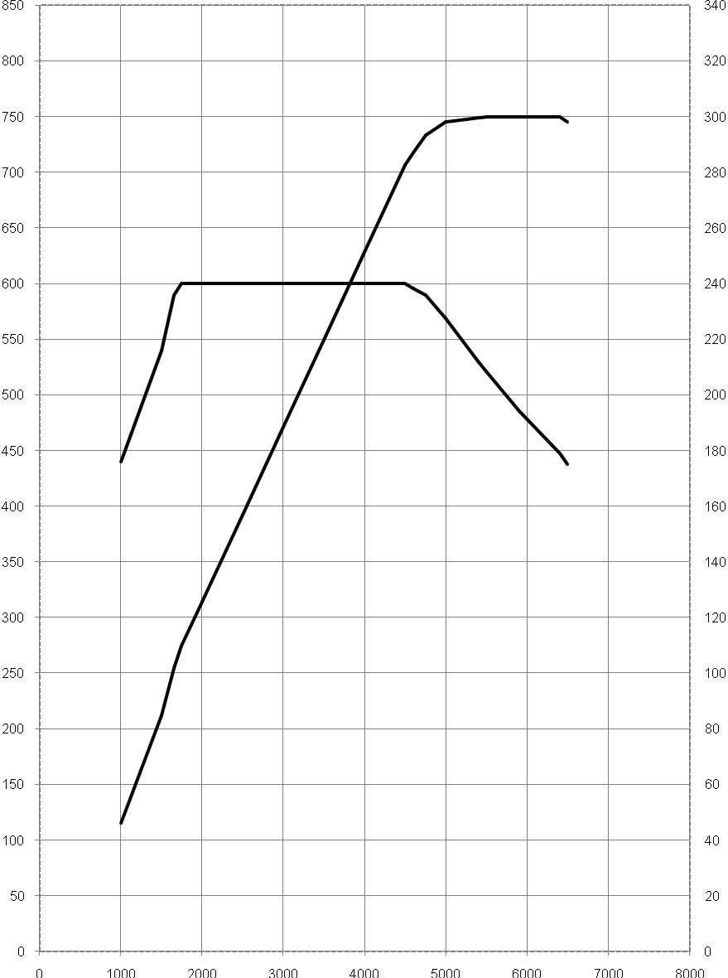

300 kW @ 5500-6400 min ⁻¹

600 Nm @ 1750-4500 min ⁻¹

Output [kW]

Torque [Nm]

0 1000 2000 3000 4000 5000 6000 7000 8000
Engine speed [min⁻¹]

BMW 535i Sedan
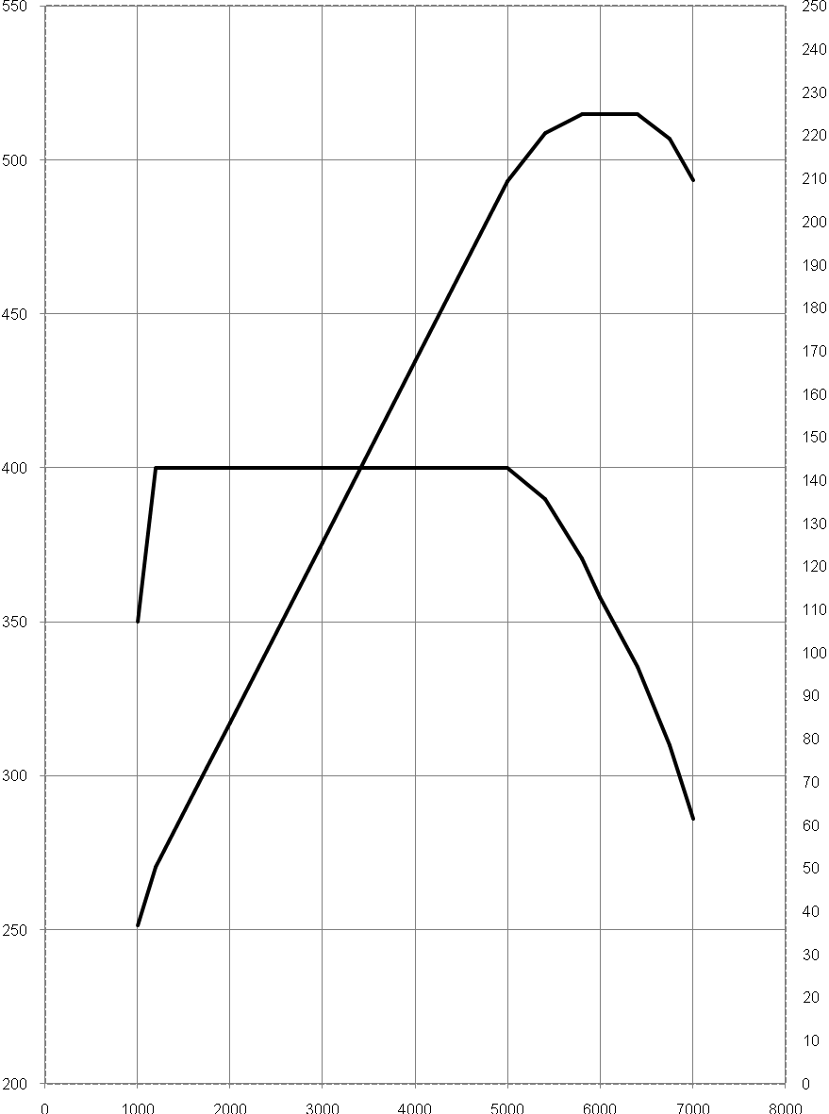

225 kW @ 5800 min ⁻¹

400 Nm @ 1200-5000 min ⁻¹

Output [kW]

Torque [Nm]

0 1000 2000 3000 4000 5000 6000 7000 8000
Engine speed [min⁻¹]

BMW 528i Sedan
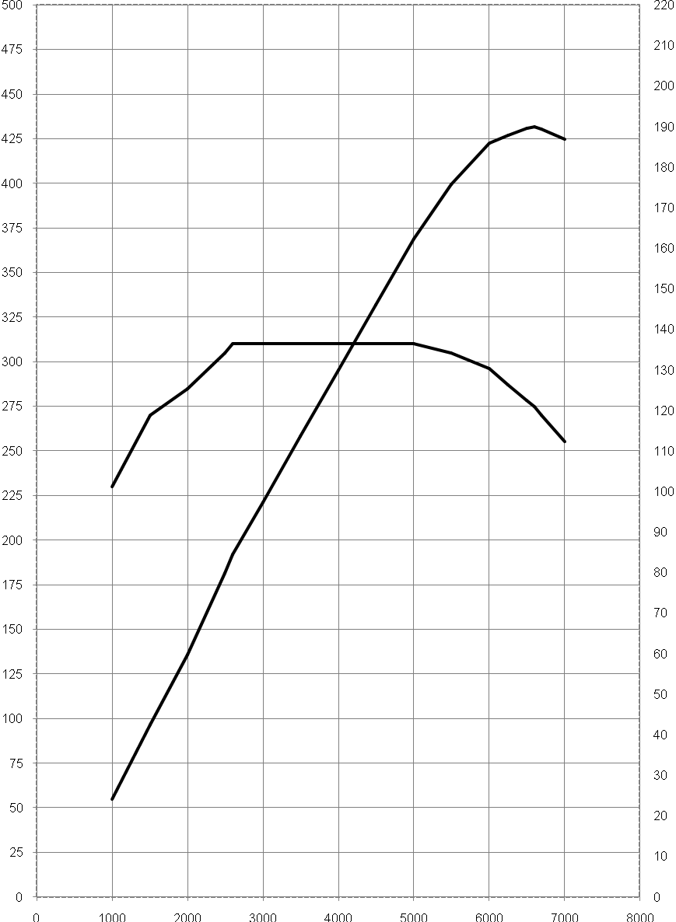

190 kW @ 6600 min ⁻¹

310 Nm @ 2600-5000 min ⁻¹

Output [kW]

Torque [Nm]

0 1000 2000 3000 4000 5000 6000 7000 8000
Engine speed [min⁻¹]

BMW 523i Sedan
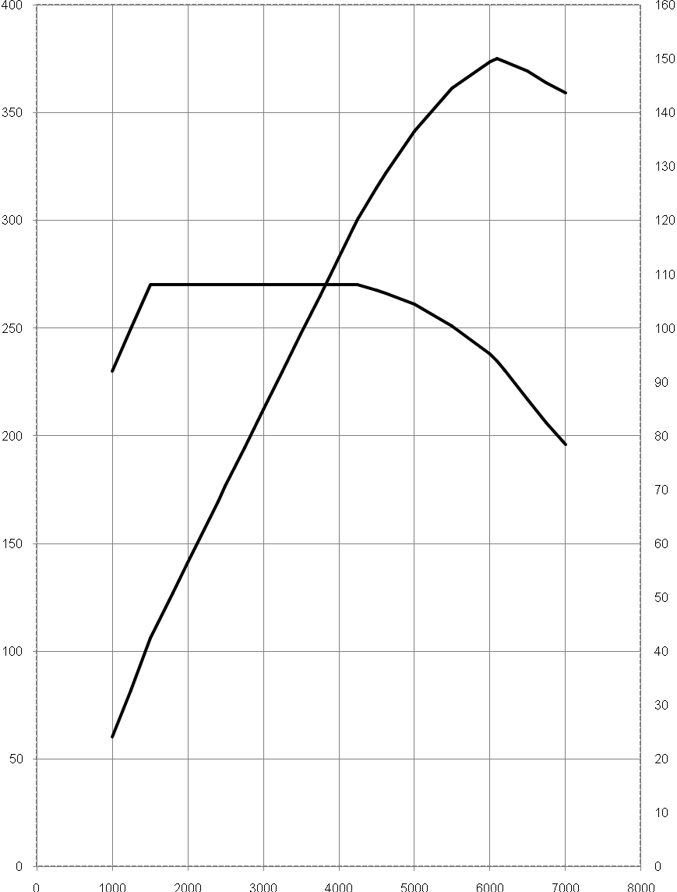
150 kW @ 6100 min ⁻¹

270 Nm @ 1500-4250 min ⁻¹

Output [kW]

Torque [Nm]

0 1000 2000 3000 4000 5000 6000 7000 8000

Engine speed [min⁻¹]

BMW 530d Sedan
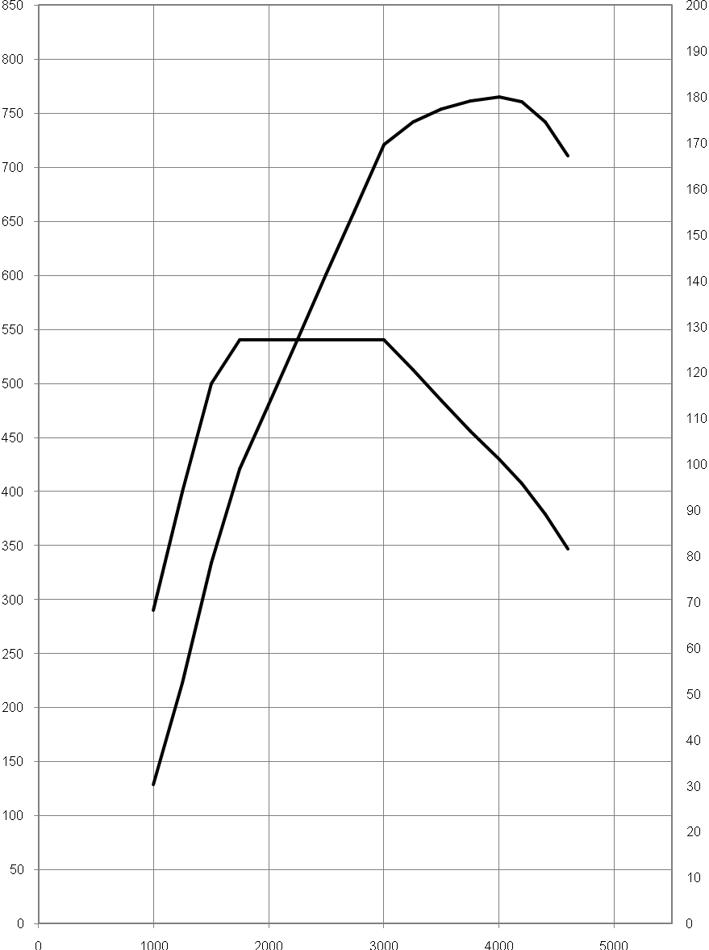

180 kW @ 4000 min ⁻¹

540 Nm @ 1750-3000 min ⁻¹

Output [kW]

Torque [Nm]

0 1000 2000 3000 4000 5000
Engine speed [min⁻¹]

BMW 525d Sedan
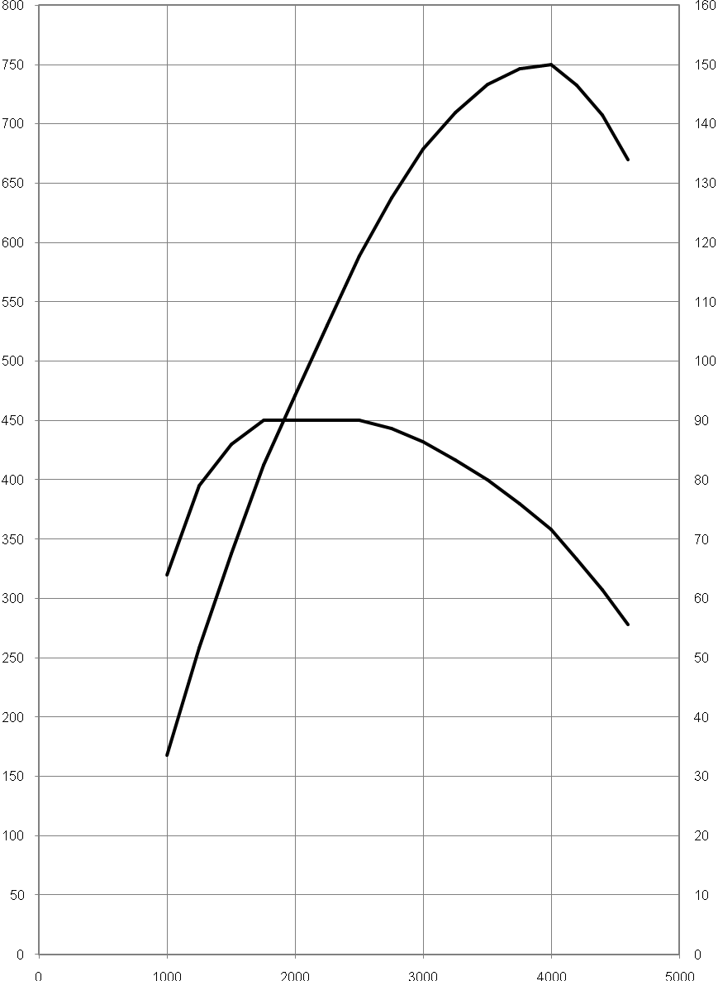
150 kW @ 4000 min ⁻¹

450 Nm @ 1750-2500 min ⁻¹

Output [kW]

Torque [Nm]

0 1000 2000 3000 4000 5000
Engine speed [min⁻¹]

BMW 520d Sedan
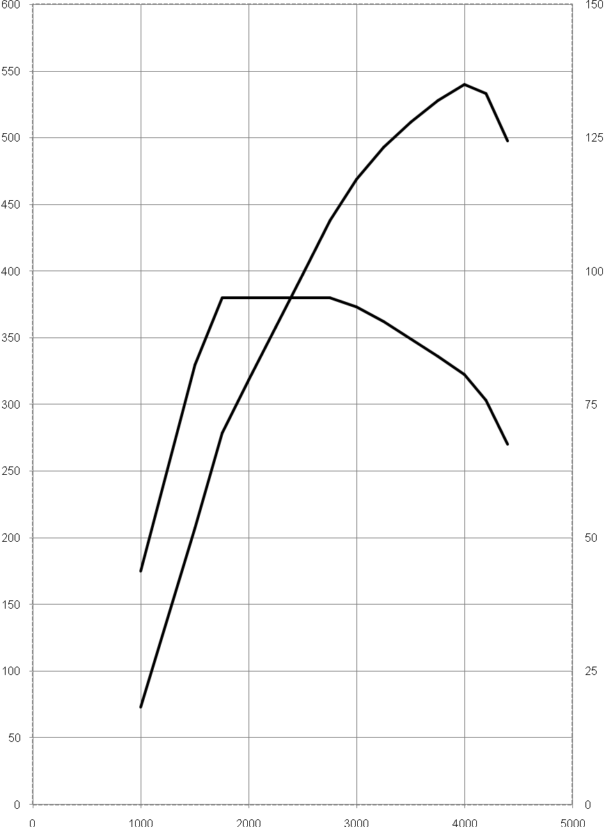

135 kW @ 4000 min ⁻¹

380 Nm @ 1750-2750 min ⁻¹

Output [kW]

Torque [Nm]

0 1000 2000 3000 4000 5000
Engine speed [min⁻¹]

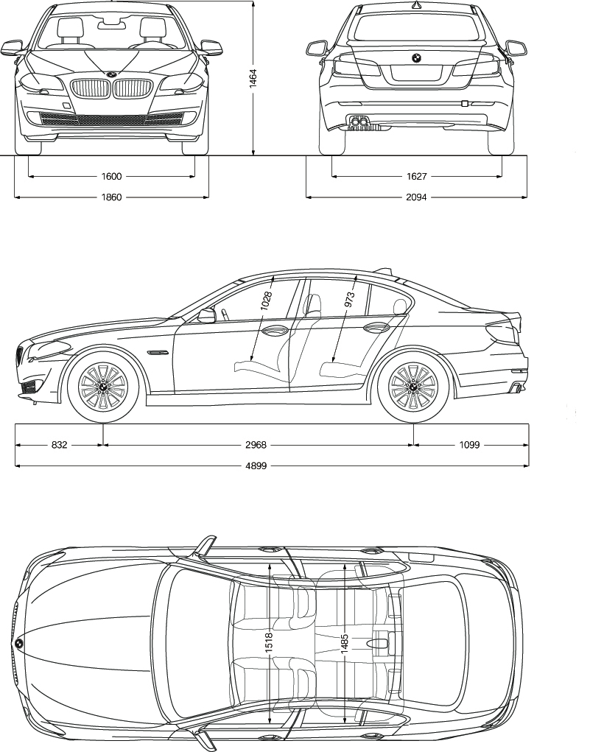
12. Exterior and
Interior Dimensions.

