
BMW M3 CSL.
Contents.
The New BMW M3 CSL:
Intelligent Lightweight Technology
and Supreme Driving Dynamics.
(Short version) 3
From the Lightweight Concept to the Production Car:
BMW M3 CSL.
(Long version) 7
Specifications.
BMW M3 CSL. 17
Interior and Exterior Dimensions of the BMW M3 CSL. 18
Torque and Output Diagram
BMW M3 CSL. 19

The New BMW M3 CSL:
Intelligent Lightweight Technology
and Supreme Driving Dynamics.
(Short version)
A new sports car now embodies the very core of the BMW brand in its most original style – the M3 CSL. Taking up the heritage and legendary success
of BMW’s famous lightweight coupés which gained fame in touring car racing back in the ’70s, the engineers of BMW M have once again created a
purist, thoroughbred sports car consistently designed and built to the highest standard of excellence.
In recognition of the fact that the weight spiral constantly going up can only be brought to a halt by radically reducing all moving masses, BMW M’s engineers, in developing this new car, have turned a thrilling lightweight concept into reality. For the new BMW M3 CSL is not only more powerful than the already very dynamic M3, but is also a lot lighter and therefore even more nimble.
In developing the M3 CSL, however, BMW M did not focus on the radical reduction of weight alone. On the contrary – the task the designers
and development engineers gave themselves was to create a car full of purist driving dynamics, a car absolutely pure in every respect, down to the very
last component. And the result, finally, is unique, absolutely unmarred driving dynamics and a purist character.
The BMW M3 CSL thus combines supreme agility with the ultimate driving experience. With its outstanding power-to-weight ratio of only 3.85 kg/bhp, this new car moves into an entirely new dimension. So the engineers at
BMW M are quite sure that this sports car is able to break the 8-minute sound barrier on the legendary Northern Circuit of Nurburgring, the ultimate benchmark in driving dynamics.
Intelligent lightweight technology enhancing driving dynamics
to a new dimension.
The formula BMW M’s specialists have followed in creating this dynamic driving machine is “intelligent” lightweight technology: This means consistent reduction of weight by using the most appropriate materials at the right
point. Carbon-fibre-reinforced plastic, one of the most important materials in Formula 1, for example, not only reduces the overall weight of the car (weighing approximately 110 kg (243 lb) less than the standard M3, the M3 CSL has an overall weight of just 1,385 kg (3,054 lb), but also allows even higher speeds in bends particularly through the use of this lightweight material at the extreme ends of the car.
Right from the front the M3 CSL, through its newly designed, muscular
front air dam made of carbon-fibre-reinforced plastic (CFP) with an additional engine air intake on the driver’s side demonstrates clearly that it is built
for supreme performance of the highest calibre. Flaps also clearly visible from outside serve additionally to reduce front axle lift by a significant margin.
At the other end of the car the newly designed rear lid made of sheet moulding compound (SMC), together with the integrated spoiler, also serves
in conjunction with the CFP rear diffuser to significantly reduce lift forces.
Innovative materials right where they are required.
The intelligent lightweight technology so typical of the M3 CSL is demonstrated very clearly by the roof also made of carbon-fibre-reinforced plastic easily recognisable as such. This large component built by specialists
at BMW’s Landshut Plant is not only some six kilos lighter than a conventional roof, but also, through its exposed position, lowers the car’s centre of gravity.
Focusing on their quest to reduce weight, the engineers at BMW M took a close look at virtually every component of the M3, in each case using the
most suitable materials in order to save weight. As a result, the M3 CSL even comes with glass-fibre plastics otherwise used for aerospace applications such as endless-glass-fibre thermoplastics serving as the structural material for the through-loading system and on the rear bumper supports.
Another example is the paper-honeycomb sandwich panel used on the floor of the luggage compartment. And like the M3, the M3 CSL also comes
with an aluminium engine compartment lid and features a special rear window made of extra-thin glass.
Just right for fast motoring: the extra-powerful engine of the M3 CSL.
The significant increase in power and performance is however not only the result of intelligent lightweight engineering. Rather, the straight-six power unit already renowned for its high engine speeds has been enhanced to an even higher standard, BMW M’s engineers boosting maximum output to 360 bhp (265 kW) at 7,900 rpm from 3.2 litres capacity, that is a sensational output-
per-litre figure of 111 bhp. Maximum torque, in turn, is 370 Nm (273 lb-ft) at 4,900 rpm.
Even the engine of the M3 CSL follows the principle of minimum weight,
with the walls on the exhaust emission system being even thinner than usual and the air collector being made of carbon fibre. The characteristic sound of motorsport, in turn, results from the new air intake with its modified flow of air.
Featuring an extremely large intake air opening and a large air collector made of carbon fibre, this new intake air system enables the engine to breathe in even more air than usual, which is why the camshafts come with longer valve opening periods.
Air intake and volume is calculated according to the same principles
as in Formula 1. And to facilitate the outgoing flow of exhaust emissions,
the M3 CSL comes with optimised exhaust valves, a modified exhaust emission manifold and funnel-shaped pipes leading into the air silencer.
With features and improvements of this kind, the BMW M3 CSL accelerates from 0–100 km/h in just 4.9 seconds, reaching 200 km/h in 16.8 seconds.
Top speed is limited electronically to 250 km/h (155 mph).
Shifting gears like in Formula 1 with the M3 CSL’s special gearbox.
It almost goes without saying that the M3 CSL comes with BMW M’s most sporting and dynamic transmission, the Sequential M Gearbox with Drivelogic. Also based on Formula 1 technology, the SMG/Drivelogic transmission ensures an ultra-fast gearshift in just 0.08 seconds on all six gears, providing
a direct and consistent flow of power at all engine speeds.
With the driver being able furthermore to choose between the sequential and an automated gearshift mode and benefitting from Drivelogic, he has no
less than eleven different gearshift options at his disposal. And last but not least, SMG Drivelogic has been re-designed and re-adjusted completely
for the M3 CSL.
A special feature certainly worth mentioning in this context is the launch control modified for the M3 CSL and its particular character: Whenever he wishes to take off perfectly from a standstill, the driver, choosing the acceleration assistant, can accelerate all the way to the top speed of the car without intervening himself, SMG shifting gears automatically shortly
before the speed limit in each gear.
As precise and nimble as a racing car.
Wider front track and modified suspension geometry give the M3 CSL
a standard of dynamic driving performance otherwise only a thoroughbred racing car is able to offer. These modifications include specially made
springs and dampers as well as the car’s newly aligned steering for supreme, cutting-edge handling. The brakes have also been modified for even
more stopping power and faster deceleration, allowing the M3 CLS to reach
a standstill from 100 km/h in less than 34 metres. And for special
purposes on the race track, the car is also available with sports brake linings.
The tyres of the M3 CSL are also very special: The Michelin Pilot Sport Cup tyres developed specifically for this car measure 235/35 ZR 19 at the front and 265/30 ZR 19 at the rear and run on 8½ J x 19 (front) and 9½ J x 19 (rear) aluminium wheels also developed especially for this car. With their asymmetric tread, these special tyres offer truly outstanding grip on the road, again in the interest of dynamic performance.
Sporting and functional: the cockpit of the M3 CSL.
Inside, the M3 CSL again follows the concept of supreme function and minimum weight wherever it makes sense. Reflecting the purist standard of motorsport, the car does without electric seat heating or a navigation
system, and both the radio and air conditioning are only available as an option. A special feature on the clear-cut dashboard is the CFP covers on top, the centre console, door and side linings also being made of the same material.
The glass-fibre-plastic bucket seats finished in a combination of Amaretta
and fabric not only give the driver and front passenger optimum side support, but also tilt forwards conveniently to provide easy access to the two individually contoured seats at the rear. For reasons of weight, seat adjustment for length and height is manual.
A special feature in driving dynamics: the M Track Mode.
The rim of the M steering wheel featured as standard is finished in Alcantara providing a very good and secure grip. Right behind the steering wheel
are the paddles for the SMG Drivelogic gearbox and the switch for the unique M Track Mode is on the right spoke of the steering wheel. This special function of Dynamic Stability Control (DSC) conceived especially for motorsport allows the driver of the M3 CSL to achieve the highest conceivable standard of longitudinal and lateral acceleration on the race track, going to the very limits of physical performance thanks to the new optical signal emitted
in the instrument panel whenever the system is activated. In this case DSC will intervene only when the car is driven to its absolute limit.
Developing the new M3 CSL, BMW has redefined the limits to dynamic motoring. And to provide a visible sign of this supreme standard,
this uncompromising car comes in only two exterior colours, Silver Grey Metallic and Black Sapphire Metallic.
From the Lightweight Concept
to the Production Car:
BMW M3 CSL.
(Long version)
Everything started with a simple law of physics –
leaving out the superfluous.
There are two fascinating sides to the world of physics not everybody may realise right away: First, physics provide a clearly defined foundation for
all driving processes in a car; second, nobody can go beyond the laws of physics, which are the same at all times and in all places.
Setting out to develop a new and truly thrilling sports car, the M3 CSL, the engineers at BMW M focused from the start precisely on these straightforward laws and principles. Reminiscent of a long tradition at BMW, the abbreviation “CSL” stands for Coupé, Sport and Lightweight. The legendary 328 Mille Miglia Coupé, for example, dates back all the way to the year 1938 and features an all-aluminium skin. Then, in the ’70s, a lightweight sports car was built in small numbers on the basis of BMW’s 3.0-litre coupé.
After taking up this theme once again at the Frankfurt Motor Show in 2001 with the first M3 CSL Concept Car and receiving overwhelming feedback from customers and the public at large, BMW subsequently decided to build the M3 CSL as a production car. Whilst not quite as elaborate for reasons of cost as the extremely light Concept Car shown in Frankfurt, the road model naturally lives up in full to the myth of the CSL with supreme performance, thrilling agility and outstanding driving precision all combined in one.
The definition of dynamics goes back 300 years.
What is so special about the letter L in the abbreviation CSL and what does
it mean in terms of physics? The answer is clear and convincing: Back in the 17th century, Sir Isaac Newton, the English physicist and astronomer,
discovered and expressed the basic equation of dynamics: F = m x a. In simple terms, this means that force F is the product of mass m times acceleration a. Now, looking at this formula from the perspective of a, meaning that a = F/m, we see that acceleration – a – increases or becomes faster with every increase in force F and every reduction of mass m.
Both simple and easy to understand, this means in the case of a car that
every kilo of superfluous weight deprives the car of its power and performance in accelerating. So the engineers building highly dynamic cars such as
the BMW M models are able to follow two possible approaches in practice: They either improve acceleration by increasing F, the force or power
that drives the car, or – and this is far more difficult – they reduce mass m.
It is fair to say that even the “standard” M3 does not have any lack of
power, the car’s high-speed engine concept derived from Formula 1 providing maximum output of 343 bhp (252 kW) at 7,900 rpm.
The far more interesting and challenging option is to optimise mass m, since, with customers expressing increasing demands in terms of motoring comfort and with cars therefore being equipped to an ever-increasing standard, even thoroughbred sports cars have in the meantime “put on a bit of fat”. So now the engineers and other specialists creating the M3 CSL seek to make a
clear departure from this upward weight spiral and introduce a new philosophy.
More power alone is not the solution providing better dynamics.
Whilst an increase in the power or force factor F, that is the philosophy most manufacturers follow in the market, serves primarily to improve a car’s longitudinal dynamics, that is its straight-ahead acceleration, a decrease in mass m offers advantages in both longitudinal and lateral acceleration.
A simple comparison: Increasing only the power of a car versus the regular or standard model, we are able to improve the car’s straight-ahead or longitudinal dynamics, meaning that the car will now accelerate faster in a straight line and may also achieve a higher top speed.
Reducing the overall weight of a car, on the other hand, and possibly increasing engine output in the same process, we are able to significantly improve the car’s lateral dynamics as well as its positive and negative longitudinal dynamics. On the road, this means that the car not only accelerates faster, but is also able to achieve a far higher speed in bends and come to a standstill more quickly when the driver applies the brakes. Precisely this is the approach taken by the engineers at BMW M with the new M3 CSL, creating the foundation for a truly unique, purist driving experience.
Nurburgring and motorsport –
two of the M3 CSL’s most significant genes.
The Northern Circuit of Nurburgring, probably the most demanding and challenging race track in the world, plays a very special role in achieving
such a high standard of driving dynamics. After all, this 20.8-kilometre circuit through the Eifel Mountains has always been a significant test track in developing and consistently enhancing the driving dynamics of every M Car. This is where, in the “home” of the M3 CSL, all criteria in driving dynamics
are put to the test. This is where the supreme stand out clearly from the mediocre and even the good, since the interplay of all car components can be measured in terms of simple and straightforward lap times.
This is also where a genuine sports car is able to demonstrate its purist standard of driving dynamics, its thoroughbred character as a genuine driving machine. What makes the difference is the way a car “feels”, the feedback it gives the driver from the chassis, suspension and steering.
This dynamic driving experience reaches its supreme standard in motorsport where absolutely no compromises are required, say, in terms of comfort, where weight is consistently reduced in the interest of dynamic performance.
Weight reduction is therefore the name of the game – and there are several ways to reduce the weight or mass of a car. The first option is simply to leave out a number of parts and components – a purist, but rather limited approach. The second option is to use especially light and/or high-quality materials instead of conventional parts made of conventional materials in a conventional car. But relying on one single lightweight material would not have been
a genuine BMW M solution, which is precisely why the M3 CSL follows a philosophy rightly referred to as “intelligent” lightweight technology.
Intelligent lightweight technology is the answer.
Intelligent lightweight technology BMW M-style means using the right material in the car at the right point. In other words, the most suitable material is
used for each part and component of the car, since every material has specific features and properties to be taken into account. In particular, these
are physical properties such as heat resistance, elasticity, flexural strength or stiffness. But criteria such as quality and ease of production must of course also be considered.
First and foremost, the M3 CSL uses materials such as carbon-fibre-reinforced plastic (CFP), glass-fibre plastics carried over from aerospace,
aluminium and other lightweight materials wherever they are most appropriate. For comparison, steel, still the material used most often in automobile production, has a density of approximately 7.8 kilos per cubic decimetre, whilst aluminium (2.8 kilos per cubic decimetre) or carbon-fibre-reinforced
plastic (1.8 kilos per cubic decimetre) have a much lower level of density.
Benefitting from this consistent reduction of weight, the M3 CSL weighs just 1,385 kg (3,054 lb), equal to a power-to-weight ratio of 3.85 kg/bhp.
This improvement by approximately ten per cent over the “standard” M3 lifts the M3 CSL into a new dimension of dynamic performance.
The M3 CSL simply exudes agility and driving dynamics at very first sight. Even from the front, when viewed for the first time, the CSL stands out clearly from its more “civilian” M3 counterpart through its completely different carbon-fibre-reinforced plastic front air dam serving also as a support element and featuring a very dominant intake air opening for the engine on the
driver’s side (measuring 9 cm or 0.35´´ in diameter) as well as two individually exchangeable flaps visibly finished in CFP. These flaps alone reduce
lift forces at the front versus the standard M3 by more than 50 per cent.
Innovative materials at exactly the right points.
With the new rear diffuser made of CFP clearly visible at first sight, the new rear lid of the M3 CSL with its integrated spoiler made of SMC (sheet moulding compound) is equally outstanding. The engine compartment lid, in turn,
is made of aluminium, as on the M3. The front bumper support – like the front air dam – is made of carbon-fibre-reinforced plastic and therefore also
serves an important weight-reducing function even if it is hidden away out of sight. The rear bumper support, on the other hand, is made of endless-
glass-fibre-reinforced plastic, to be specific a glass-fibre thermoplastic material carried over from aerospace applications.
The roof made of carbon-fibre-reinforced plastic again visible at first sight is particularly conspicuous, representing one of the most attractive signs of distinction on the new M3 CSL which will catch your eye at first sight. Indeed, this is where intelligent lightweight technology serves to raise driving dynamics to a very high standard, the carbon-fibre roof not only being six kilos lighter than the conventional steel roof of the M3, but also helping to significantly lower the car’s centre of gravity thanks to this reduction of weight where it really counts.
The roof of the M3 CSL is built at BMW’s Landshut Plant.
BMW builds this carbon-fibre-reinforced roof itself at the Landshut Plant, where, at the home of BMW’s lightweight technology experts, specialists acting as highly competent system suppliers make the roof of the M3 CSL out of several layers of this expensive material. The in-house suppliers at
the Landshut Innovation and Technology Centre (LITZ) therefore not only contribute their particular skill and competence in this way, but also
ensure fast and flexible action in implementing the most sophisticated innovations in lightweight technology.
Even parts and components normally quite insignificant within the body
structure as a whole were carefully considered for any possible reduction of weight. Focusing on the floor of the luggage compartment, for example,
the engineers at BMW M opted for a paper-honeycomb-sandwich structure. The through-loading facility, in turn, made of steel on the “standard” M3,
is made of a sandwich endless-glass-fibre mixture of thermoplastics and foam on the M3 CSL. And the rear window is made of extra-thin glass.
The body shell of the M3 CSL is still made of steel panels varying in strength and thickness quite simply because in some cases it hardly makes sense
to replace steel by another material. Here, therefore, steel continues to prove its qualities and advantages also in terms of stability.
A top performer with outstanding agility.
It goes without saying that a car as thrilling as the new M3 CSL requires
the right kind of chassis and suspension. After all, the driver should really feel the agility of this car, agility should be an important part of the CSL driving experience. So in developing this dynamic suspension and chassis system, the engineers at BMW M again focused on motorsport, which is no
surprise considering the very long list of racing wins and achievements
by BMW touring cars in more than four decades.
The most important parameters in this context are of course the wheel suspension as such, the steering and brakes – and the tyres also play a very important role in providing a supreme standard of driving dynamics
on the road.
The significant but very tempting challenge the engineers at BMW M were happy to accept was to leave the outstanding chassis and suspension of the M3 unchanged in its basic philosophy, but to thoroughly refine many
features and the general set-up in view of the change in weight. In this process of optimisation starting at a very high level, each individual component was
put to the test in every respect, being carefully examined for every possible improvement. Now the result is a chassis, which from the very beginning simply feels different from the “regular” chassis in the BMW M3, offering an even higher standard of precision and agility on the road.
The same precision as a racing car.
To provide this kind of experience, the front springs are one winding shorter and both the spring and damper rates have been re-tuned all round in view of the car’s lighter weight, both the compression and rebound strokes being modified in the process. Like the front track control arms on the “standard” M3, the rear track control arms are now also made of aluminium and come with ball instead of rubber bearings for even better lateral dynamic
guidance (uniball joints). In all, these improvements give the M3 not only uncompromising directional stability under all conditions, but also extremely good cornering qualities with very little body sway. And at the same time they significantly reduce the weight of all chassis and suspension components.
This new dimension of agility is borne out in particular by the modified steering of the M3 CSL. Benefitting from an even more direct overall transmission
ratio of 14.5:1 (versus 15.4:1 on the M3), the rack-and-pinion steering provides much more direct response and steering behaviour and offers cutting-
edge precision in bends. Any comparison with a racing car is by no means exaggerated and it is fair to say that only very few road cars are able to
offer the same kind of dynamic driving experience of the highest, most puristic standard.
A fast car needs fast brakes.
Driving at high speeds, the lucky man or woman at the wheel of the M3 CSL also needs fast – that is highly efficient and professional – brakes. So it is
no surprise that the M3 CSL comes with particularly strong brakes taking action very quickly and forcefully whenever required. At the front the grey-cast-iron brake discs are somewhat larger in diameter than on the standard M3 (M3 CSL 345 x 28 millimetres (13.58 x 1.10´´ ) versus the “standard” M3 with
325 x 28 millimetres (12.80 x 1.10´´ ), whilst at the rear the brake discs on
both cars measure 328 x 20 millimetres (12.91 x 0.78´´ ). The brakes themselves feature BMW M’s proven compound system with single-piston swing callipers.
To minimise the thermal load transmitted from the brake discs to the brake housing, which might impair the service life of the cross-drilled and inner-vented discs, the discs are connected with the aluminium brake housing by steel pins in floating design.
For use on public roads the M3 CSL comes with conventional brake linings, for driving on the race track or in motorsport events BMW M is able to
supply special brake pads for racing offering particular strength and resistance.
This gives the new M3 CSL a brake system of the highest calibre not only reflecting the car’s truly outstanding performance, but also providing
brake response and stopping power previously regarded as quite impossible. In practice this means that the driver applying the brakes all-out and under appropriate conditions at a speed of 100 km/h will bring the M3 CSL to
a standstill in less than 34 metres (111 feet) and within 2.5 seconds, with maximum average retardation of more than 11 metres/sec².
Last but certainly not least, the ABS anti-lock brake system featured as standard on the M3 CSL has been re-tuned to reflect the change in overall performance and the higher frictional coefficient the tyres are able to provide.
Very special wheels and tyres for a very special car.
Clearly, the M3 CSL comes on very special aluminium wheels as another exclusive touch, with 8½-inch rims at the front and 9½-inch rims at the rear. These new, specially developed 19-inch wheels also help to save weight,
the four wheels and tyres on the M3 CLS weighing eleven kilos less than the 19-inch wheels available as an option on the M3.
The Michelin Pilot Sport Cup tyres have also been developed especially for this outstanding car. Measuring 235/35 ZR 19 at the front and 265/30 ZR 19 at the rear, these tyres provide an exact match for the M3 CSL, again contributing to the car’s optimum grip and road holding. Similar in design and structure to genuine racing tyres, these special road-going tyres, thanks to their
very heat-resistant rubber compound, make a very significant contribution to the M3 CSL’s excellent driving characteristics. They are designed and conceived for ultimate performance in the dry and offer a far greater potential in longitudinal and lateral acceleration, and in their steering precision, than comparable production tyres. Indeed, this sporting performance is borne out at very first sight by the asymmetric tread with its large share of negative
tread elements.
The purchaser of an M3 CSL often required to drive on wet roads may also opt for the forged 19-inch wheels featured on the standard M3.
The ultimate in M Power ensured by high engine speeds.
The straight-six power unit already featured in the “standard” M3 owes its exceptional performance to BMW’s high-speed engine concept.
This concept allows a particularly short transmission ratio giving the car superior power and performance throughout the entire speed range,
six individual throttle butterflies ensuring that the engine responds perfectly
to the gas pedal whenever required.
Also revving up easily and smoothly all the way to 8,000 rpm, the power
unit of the M3 CSL offers an even higher standard of all-round performance.
An all-new air intake system with an extra-large air collector made of carbon-fibre-reinforced plastic ensures an ample flow of air to the 3.2-litre power unit, the intake manifolds with a much large diameter taking in fresh air through
the large air scoop on the left-hand side of the front air dam enabling the engine to breathe even more freely, without the slightest throttle effect.
The usual air mass metre has been dropped on the M3 CSL for precisely
this reason, the mass of air drawn in by the system being calculated by the engine’s “brain” like in Formula 1. Indeed, this is one of the reasons why
the DME memory is twice as big as before, with an increase in computer speed by 25 per cent.
The camshafts with their longer valve opening times also help to boost the power of the engine to an even higher level than before. To reduce the forces required for removing burnt combustion gas from the combustion chamber and thus increase the useful engine load accordingly, the exhaust valves have been modified once again in their geometry, the flow of gas also benefitting from the funnel-shaped pipe intakes leading into the rear silencer. And again reflecting the lightweight philosophy of the CSL, the entire exhaust system
is made of pipes with even thinner walls at the side.
The result of this successful fine-tuning is maximum output of 360 bhp
(265 kW) at 7,900 rpm, with maximum torque of 370 Nm (273 lb-ft) at
4,900 rpm. This equals output per litre of no less than 111 bhp, an extremely high figure for a normal-aspiration power unit and, incidentally,
the highest output per litre of any production six-cylinder in the world.
The sports button in the centre console of the M3 CSL serves to significantly modify throttle butterfly control and management: In the sports mode
the engine responds even more spontaneously to the accelerator pedal and the M3 CSL offers an even higher standard of performance throughout
the entire engine speed range.
Talking about performance, the refinements describe enable the M3 CSL
to accelerate from 0–100 km/h in a mere 4.9 seconds, then continuing
to 200 km/h in 16.8 seconds. Top speed is limited electronically to 250 km/h
(155 mph).
The M3 CSL gearbox: shifting gears like in Formula 1.
To provide an ultra-fast gearshift with a smooth, uninterrupted surge of power, the new M3 CSL comes exclusively with BMW M’s Sequential M Gearbox with Drivelogic. An in-house development by BMW M, this special gearbox based directly on Formula 1 technology is naturally an integral part of the
car’s overall concept. Which is no surprise considering that under optimum conditions SMG is able to shift gears in just 0.08 seconds.
The well-known benefits of SMG Drivelogic include the option to shift gears either through the shift lever or through paddles on the steering wheel,
the option to change over from the sequential to the automatic mode, and the choice of no less than eleven gearshift modes tailored to specific requirements
on the road.
This modern transmission also offers a wide range of additional, practical functions such as launch control. Also referred to as the acceleration assistant, this function enables the driver to set off perfectly from a standstill with the gearshift lever in a specific position chosen in advance, thus benefitting from the car’s full potential when accelerating. And now this function has
been refined to an even higher standard in the new M3 CSL: Once the driver activates the acceleration assistant, he no longer has to shift gears himself when subsequently sprinting from zero to the top speed of the car, since SMG Drivelogic “sees” what the driver plans to do and shifts the six gears
itself at exactly the right point shortly before the engine reaches the rev limit.
A special innovation by BMW M: the M Track Mode.
Apart from the SMG paddles, the driver of the M3 CSL will find another
special feature in the three-spoke M sports steering wheel with its rim finished in Alcantara to provide a perfect grip – the M Track Mode switch on the right-hand side. Pressing this switch, the driver activates an additional DSC function presented clearly by a new signal in the instrument panel.
This special DSC Dynamic Stability Control mode allows the driver to use all the car’s longitudinal and lateral acceleration up to the physical limit,
for example on the race track. In this case stability control will only intervene when the M3 CSL reaches the absolute limit, an optical signal telling
the driver that the system has become active (as is the case with DSC).
Concentrating on the essential: the cockpit of the M3 CSL.
The interior design of the M3 CSL also follows the “CSL Formula”, that is the combination of intelligent lightweight technology and purist driving dynamics – this is the ambience of a genuine racing car. Reflecting the world of
motor racing, the interior comes neither with a navigation system nor with seat heating, the engineers at BMW M avoiding even the slightest dilution of the CSL philosophy. Indeed, even the floor carpets come with a weight-optimised layer of foam at the bottom.
Both the driver and front passenger enjoy the benefits of perfectly contoured glass-fibre-plastic-reinforced bucket seats offering optimum side support even in fast bends. And to provide convenient, comfortable access to the rear,
these GFP bucket seats can be tilted to the front and are adjustable manually for both height and length. The seat upholstery comes in a combination of Amaretta and fabric.
The rear-seat passengers likewise enjoy the comfort and sporting style of specially contoured single seats integrated in the lightweight through-loading. Here again, the seat upholstery comes in a combination of Amaretta and fabric.
Limited list of options and special equipment.
The instrument panel of the M3 CSL is extra-clear and straightforward in design, featuring carbon-fibre-reinforced plastic covers as standard. With the range of fitments being reduced considerably versus the M3, neither air conditioning nor a radio come as standard, the creators of the M3 CSL thus making a clear statement in the interest of low weight and the purist
driving experience conveyed by the car. A radio and air conditioning are however available as an option at no extra cost.
The M3 CSL comes as standard with a centre console as well as the door
and side linings made of clearly visible CFP, a regular heating and ventilation system with rotary knobs serving to control the climate inside the car.
Whilst the M3 CSL is fitted with steering wheel, front passenger and frontal head airbags, it intentionally does without thorax airbags, the special design of the bucket seats at the side efficiently absorbing minor impacts.
The handbrake lever and SMG gearshift lever, in turn, feature appliqués made of Alcantara.
Again revealing its commitment to genuine purism, the new M3 CSL is available in only two paintwork colours: either Silver Grey Metallic or
Black Sapphire Metallic. Further signs of distinction on this exclusive sports
car are the M3 CSL model designations at the rear, on both door cut outs,
and on the air intakes at the side.
The objective:
To lap the Northern Circuit of Nurburgring in less than eight minutes.
The results of all these improvements is a car offering driving pleasure
characteristic of BMW in its purist form. Through its uncompromising harmony of virtually every feature and component, the M3 CSL guarantees driving dynamics of the highest standard enabling the car to break a “sound barrier” previously regarded as quite impossible: to lap the Northern Circuit of Nurburgring in a production car in less than eight minutes.
Given its outstanding power-to-weight ratio, its supreme agility and
driving precision, the new M3 CSL not only enters a new dimension of dynamic motoring, but also opens up the door for new solutions
in technology, convincingly presenting a unique synthesis of intelligent lightweight technology and high performance – a modern sports car
which, through the sum total of its truly outstanding features, lives out the innermost world of the BMW brand: sheer driving pleasure in its purest form.
Specifications.
BMW 3 M3 CSL.
Body
d

Anzahl Türen / s
No. of doors/seats |  |  |  | 2/4
Length/width/height (unladen) |  |  | mm | 4,492/1,780/1,365
Wheelbase |  |  | mm | 2,729
Track, front/rear |  |  | mm | 1,518/1,525
Turning circle |  |  | m | 11.0
Tank capacity |  |  | approx. ltr | 63
Cooling system incl. heater  l |  |  | ltr | 10.7
Engine oil  Getriebeöl |  |  | ltr | 7.0
Transmission fluid |  |  | ltr | 1.9
Final drive fluid |  |  | ltr | 1.2
Unladen weight, EU¹ |  |  | kg | 1,385
Max. load to DIN standard |  |  | kg | 415
Max. permissible weight to DIN |  |  | kg | 1,800
Max. axle load, front/rear |  |  | kg | 880/1,020
Max. trailer load²
Braked (12%)/unbraked |  |  | kg | –
Max. roof load/max towbar download |  |  | kg | –/–
Luggage compartment to VDA st. |  |  | ltr | 410
Air drag |  |  | c_{X} x A | 0.683
Power unit
Configuration/cylinders/valves |  |  |  | Straight/6/4
Engine management |  |  |  | MSS 54HP
Capacity |  |  | cc | 3,246
Bore/stroke |  |  | mm | 87.0/91.0
Compression ratio |  |  | :1 | 11.5
Fuel |  |  | RON | 98
Output |  |  | kW/bhp | 265/360
at |  |  | rpm | 7,900
Torque |  |  | Nm (lb-ft) | 370 (273)
at |  |  | rpm | 4,900
Electrical system
Battery/location |  |  | Ah/– | 55/luggage comp
Alternator |  |  | A/W | 120/1,680
Suspension
Front |  |  |  | Single-joint spring strut axle with displaced castor;
 |  |  |  | small positive steering roll radius, compensation of transverse forces, anti-dive
Rear |  |  |  | Central-arm axle with longitudinal control arms and double track control arms,
 |  |  |  | anti-squat and anti-dive
Brakes, front |  |  |  | Single-piston swing-calliper disc brakes
Diameter |  |  | mm | 345 x 28, vented
Brakes, rear |  |  |  | Single-piston swing-calliper disc brakes
Diameter |  |  | mm | 328 x 20, vented
Driving stability systems |  |  |  | ABS, CBC, DSC; M differential lock
Steering |  |  |  | Rack-and-pinion
Overall steering transmission |  |  | :1 | 14.5
Transmission |  |  |  | Six-speed manual
Transmission ratios |  | 1st | :1 | 4.227
 |  | 2nd | :1 | 2.528
 |  | 3rd | :1 | 1.669
 |  | 4th | :1 | 1.226
 |  | 5th | :1 | 1.000
 |  | 6th | :1 | 0.828
 |  | Rev | :1 | 3.746
Final drive ratio |  |  | :1 | 3.620
Tyres, front/rear |  |  |  | 235/35 ZR19 / 265/30 ZR19
Rims, front/rear |  |  |  | 8.5J x 19 EH 2 IS 44 alu / 9.5J x 19 EH 2 IS 27 alu
Performance
Power-to-weight ratio to DIN stand |  |  | kg/kW | 5.2
Output per litre |  |  | kW/bhp | 81.6/111.0
Acceleration | 0–100 km/h |  | sec | 4.9
 | Stand-start km |  | sec | 23.5
In 4th gear | 80–120 km/h |  | sec | 5.0
Top speed |  |  | km/h | 250³
Fuel consumption (EU cycle)
Urban |  |  | ltr/100km | 17.8
Extra-urban |  |  | ltr/100 km | 8.4
Composite |  |  | ltr/100 km | 11.9
CO₂ |  |  | g/km | 287
Other data
Emission category |  |  |  | EU3

Weight of car in road trim (DIN) plus 75 kg for driver and luggage.
²May be increased under certain conditions.
³Electronically limited.
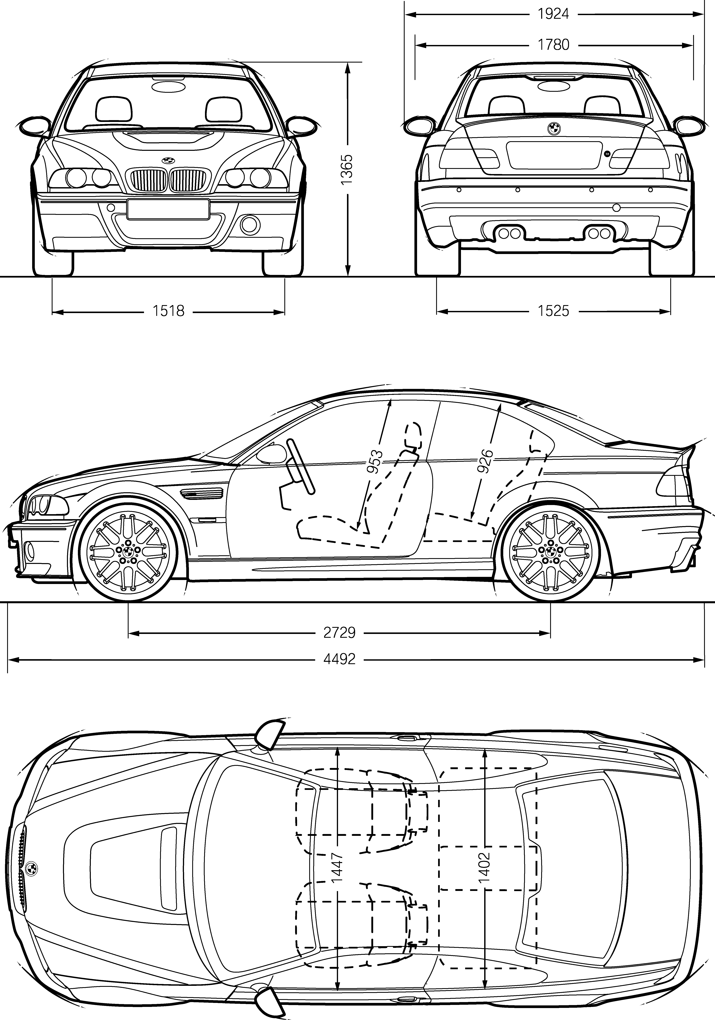
Interior and Exterior Dimensions
of the BMW M3 CSL.
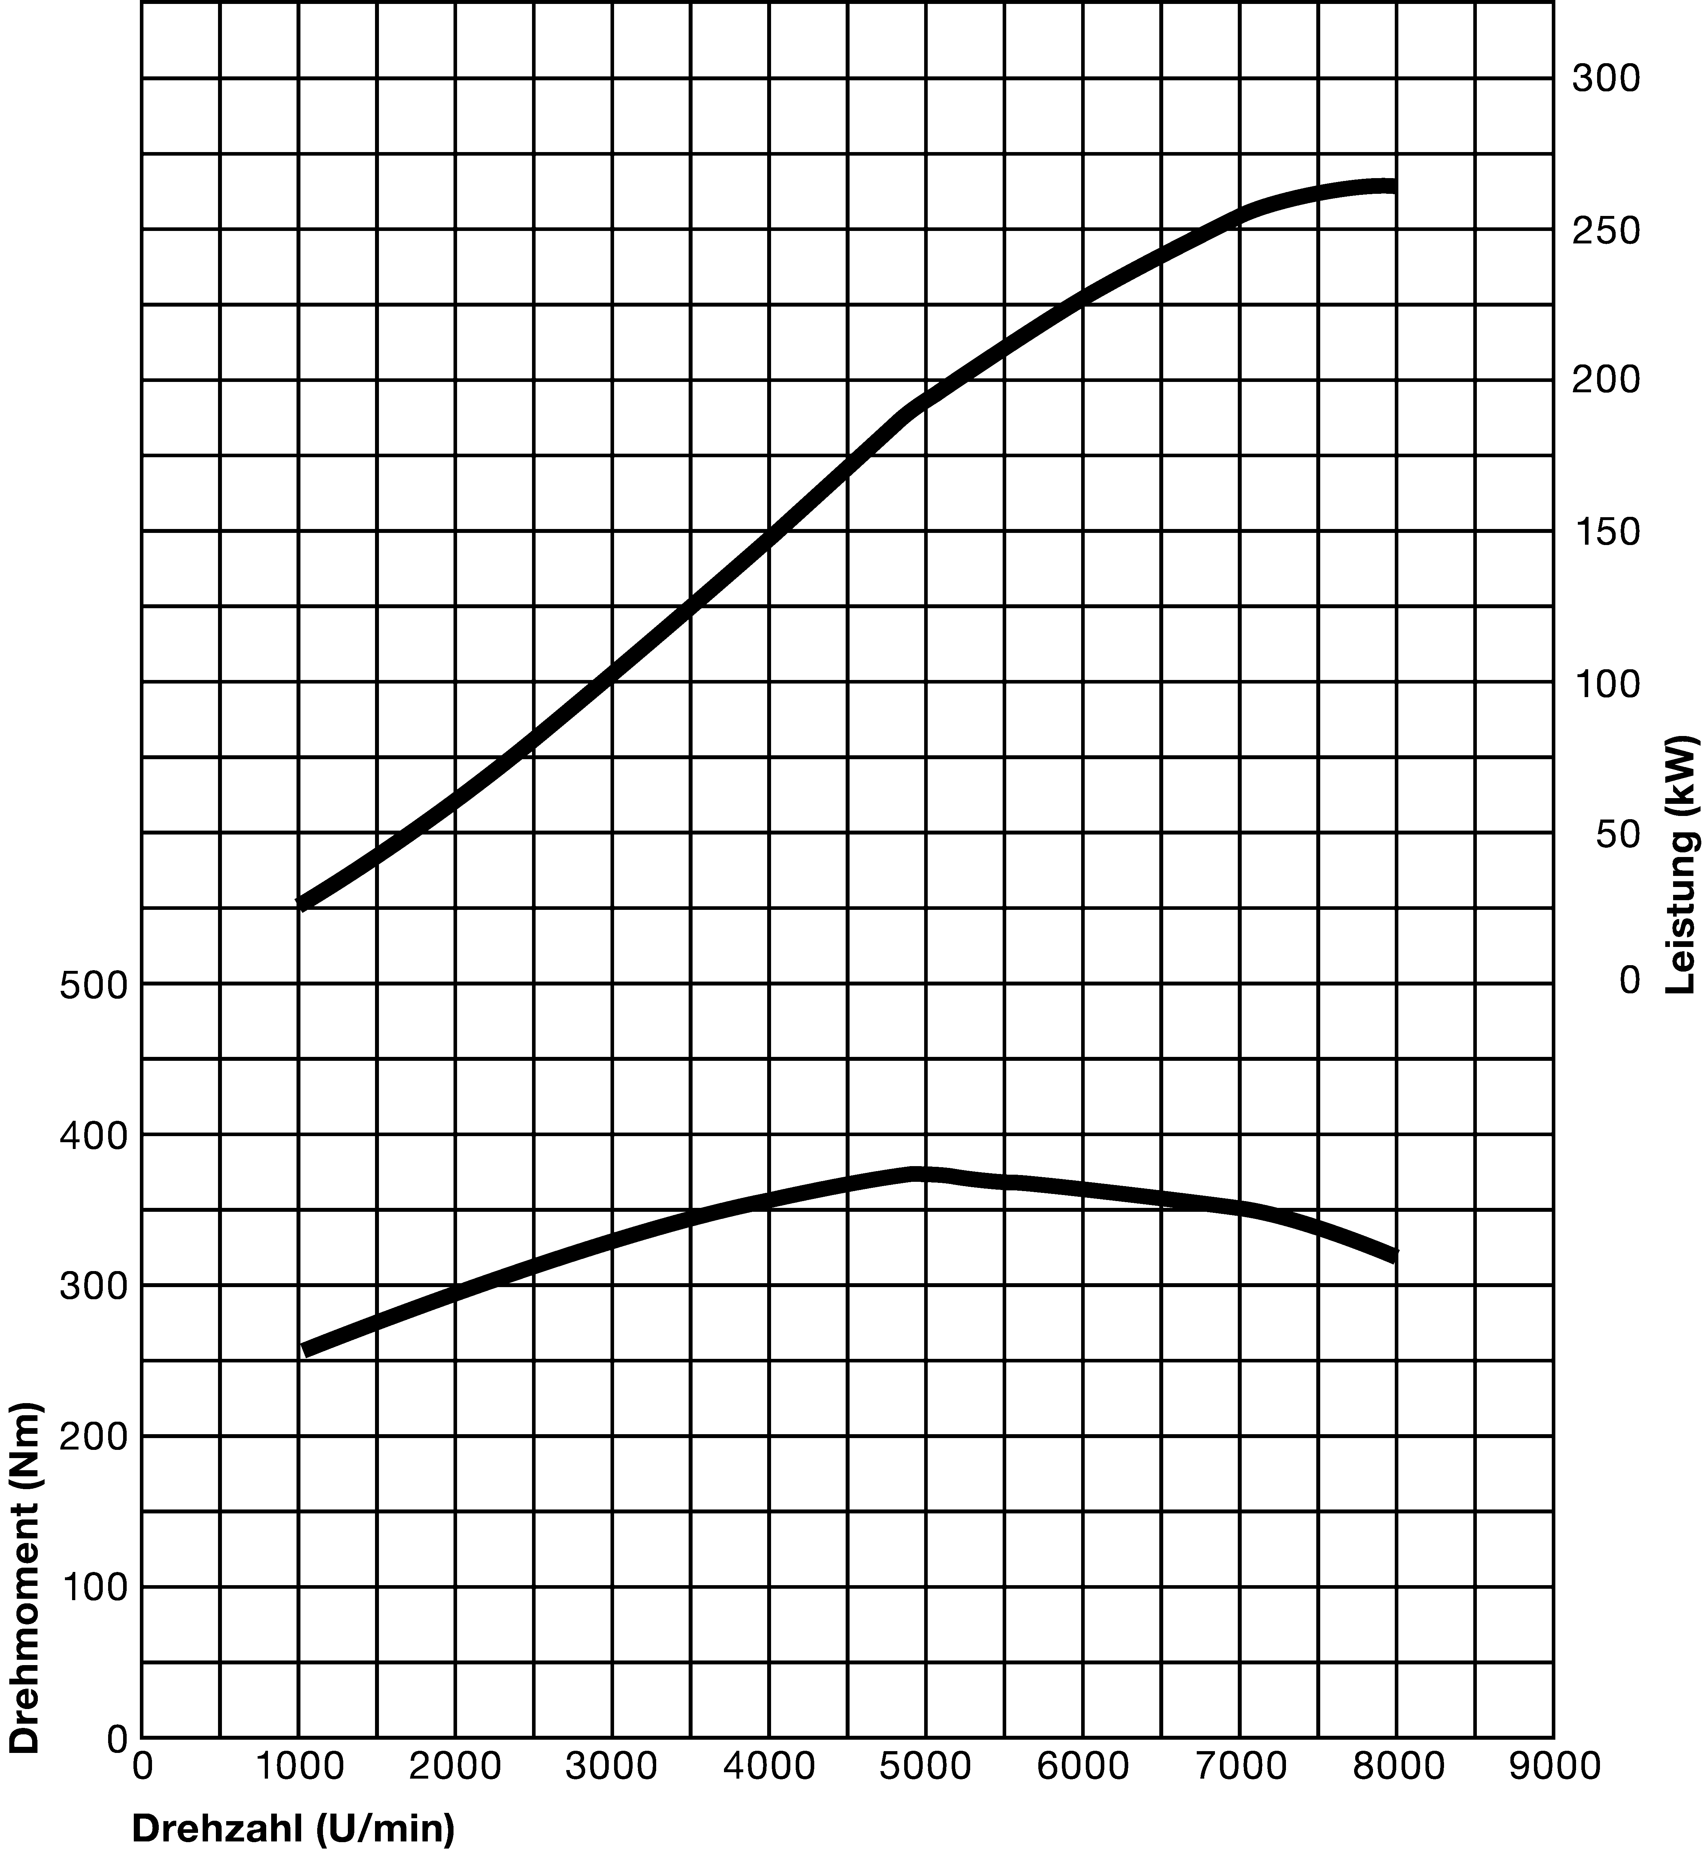
Torque and Output Diagram
BMW M3 CSL.
Output [kW]
Torque [Nm]
Engine speed [min^{–1}]

